National Federation of the Blind
of Maryland

2023 - 2024 Convention

AGENDA

Expect Much ⸱ Give Much ⸱ Get Much!

Friday, February 16 to Sunday, February 18

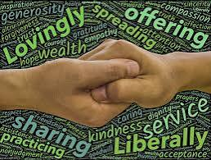
Image description: Two hands grasping the fingers of one another, surrounded by a word collage including the words: generosity, lovingly, trust, spreading, offering, compassion, sharing, practicing, kindness, dignity, service, acceptance, and nonjudgement.

The Members of the Board of Directors and the
Host Committee welcome you to the
58th Annual Convention of the
National Federation of the Blind of Maryland

Ronza Othman, President
National Federation of the Blind of Maryland

Justin Young, Chairperson
Convention Logistics Committee

Scott White, Chairperson
Convention Host Committee

Mildred Rivera, President
TLC Chapter

Latonya Phipps, President
Baltimore County Chapter

Christopher Danielsen, President
Greater Baltimore Chapter

Qualik Ford, President
Maryland Association of Blind Students

Garret Mooney, President
Maryland Parents of Blind Children

Welcome

Welcome to the 58th annual convention of the National Federation of the Blind of Maryland! This year’s convention will be held in Towson at the Sheraton Baltimore North Hotel.

Sheraton Baltimore North Hotel
903 Dulaney Valley Road, Towson, MD 21201
410-321-7400

A detailed description of the layout of the hotel can be found later in this agenda. When you check into the hotel, you will be asked to confirm your departure date. If you decide to leave earlier than the departure date you confirm when you check in, there may be an additional fee.

Special Information for First-Time Attendees

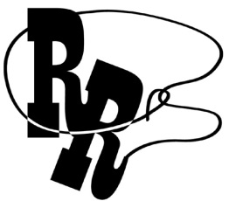
All first-time convention attendees are cordially invited to attend a First-Timers Orientation from 8 to 9:30 p.m., on Thursday, February 8. The Ambassadors Committee will walk you through the events that will take place throughout the weekend, explain processes such as door prizes and voting, as well as make sure every first-time convention attendee is matched with a mentor. This orientation will be held virtually, the codes to join via web conference or via conference call are below.

Zoom Meeting ID: 624 813 8327
One-Number Conference Call: 339-209-4083

Diversity, Equity, Inclusion, and Social Conduct
We are committed to providing a safe and harassment-free environment for everyone. Thank you for cultivating an atmosphere in which participants from diverse backgrounds can learn, network, and share with each other in an environment of mutual respect. We are committed to diversity, equity, inclusion, and the free expression of ideas. These principles have been outlined in our code of conduct, which can be found at
NFB.org/About-Us/History-and-Governance/Code-Conduct.

We recognize a shared responsibility to create and uphold an atmosphere that benefits everyone. Prohibited behaviors include harassment, unwelcome sexual attention, and inappropriate use of the NFBMD convention space and platforms. Prohibited behavior or misuse of our space and platforms will not be tolerated and may result in removal from the convention and/or other consequences.

For assistance, or to report an incident at the convention,
please call 585-770-4073 or
email convention@nfbmd.org for immediate attention.

Formal reports can be submitted to the NFB national office at: NFB.org/About-Us/History-and-Governance/Code-Conduct/
Report-Form
All formal reports will be thoroughly investigated according to the
code of conduct. We thank you for contributing to the integrity
of our community and the high expectations we strive to maintain.

Pre-Registration and On-Site Registration
Registration activities take place in the Fitzgerald North Foyer, which is outside of the F. Scott Fitzgerald Ballroom (Fitzgerald Ballroom), located on the Plaza Level (first floor), Friday between 1 and 6 p.m.; Saturday between 8 and 8:25 a.m., and 12 and 12:15 p.m.; and Sunday between 8:30 and 8:50 a.m. All convention attendees — both local and from out of town — are asked to register.

- Those who pre-registered for the convention may pick up their registration packets in the area designated pre-registration.

- Those who did not pre-register may go to the area designated registration. Please have your check, credit card, Zelle, or cash ready to pay the onsite registration fee of $30 per person.

Convention registration is a requirement for voting, door prize eligibility, and other convention activities. All registrants will receive wrist bands, which will indicate voting eligibility. Additionally, discounted rates for hotel rooms are contingent on proof of registration.

Fun with Friends Convention Child Care Activities
All child care (for children ages 6 weeks to 9 years) will take place in the Duncan Room on the second level. Hours are: Friday 8:30 a.m. to 4 p.m.; and Saturday 8:15 a.m. to 5:15 p.m., and 6:30 to 10 p.m., or at conclusion of the banquet, whichever is earlier (lunch and dinner will be provided). Contact Garret Mooney at james.garret.mooney@gmail.com for details.

Exhibit Hall
The exhibit hall is located in the Fitzgerald West Foyer and in Fitz A on the plaza level. The exhibit hall will operate on Friday from 11 a.m. to 6 p.m.

Special Attention Items
- Banquet tickets may be purchased for $60 at the on-site registration area. We will accept cash, credit cards, Zelle, and checks. No tickets will be available after 12 p.m., on Saturday. At the banquet ticket exchange table, you may make arrangements to reserve a specific seat for yourself or for a group of up to 10 people. On the evening of the banquet, tickets will be required to enter the ballroom and will be collected at the tables.
Tickets may be exchanged for vegetarian or meat meals at the banquet ticket exchange table prior to 2 p.m., on Saturday.
- Individuals with dietary restrictions must submit those requests in advance, as such meals must often be ordered and/or prepared off-site. Requests related to dietary restrictions should be sent to president@nfbmd.org by January 31, 2024.
- Requests for reasonable accommodations — other than Braille and large print agendas, which will be available for all — must be submitted in advance, as such accommodations often require advanced arrangements. Requests for accommodations should be sent to president@nfbmd.org by January 31, 2024.
- Banquet ticket exchange will be located in the Fitzgerald North Foyer, on the plaza level, outside the Fitzgerald Ballroom on Saturday between 1:20 and 2 p.m.
- General sessions will be in the Fitzgerald Ballroom on the plaza level.
- Boxed lunches will be resold if not picked up by 12:30 p.m., on Friday. Those interested in boxed lunches on Friday should visit the Fitzgerald North Foyer. Those who fail to pick up their boxed lunches by
12:30 p.m., on Friday will forfeit them and will not receive a refund.
- Tickets for other meals may be purchased on a first-come, first-served basis from the registration table. The costs are:
  - Dinner and a Play: $30
  - Senior Issues Luncheon: $35
  - Parents Luncheon: $35
  - Students Luncheon: $35
  - Banquet: $60
- Qualik Ford and Juhi Narula are the co-chairs of the Door Prize Committee. Please turn in your door prizes to Qualik and/or Juhi as soon as possible. You must be registered for the convention and be present when your name is called in order to win a door prize. Door prizes will be awarded during the general sessions on Saturday and Sunday and during the convention banquet.
- Joel Zimba is the chairman of the National Funding Support Committee, which manages our Bake and Experience Auction. Please consider bringing baked goods and donating experiences such as dinners, cooking lessons, etc., for this auction.

- The Student Division will host a Fire Sale for individually wrapped baked items, e.g., single cupcakes, brownies, and cookies.
- We will have a cane walk with individualized cane travel instruction by an NOMC on Friday at 5 p.m. To reserve a slot for your child or for yourself, please contact Garret Mooney at james.garret.mooney@gmail.com.
- On Sunday, you must check out of your room before 11 a.m. Please note, the convention is not scheduled to adjourn until 1 p.m. After check-out, you may store your luggage by dropping it off at the Warfield Ballroom on the plaza level between 7:30 and 9 a.m., Sunday. Please be sure your luggage is clearly labeled with your name, address, and telephone number. All luggage must be picked up by 1:30 p.m., or 15 minutes after adjournment, whichever is earlier.

- If you are leaving the Sheraton Baltimore North Hotel on an NFB of Maryland bus, please bring your luggage to the Warfield Ballroom on the plaza level between 7:30 and 9 a.m., Sunday. Your luggage will be tagged and held, and then loaded onto the busses at 1 p.m. Please be sure your luggage is clearly labeled with your name, address, and telephone number.
- There are two guide dog relief areas: one in the courtyard adjacent to the hotel registration/check-in desk and the other is just outside the Fitzgerald North Foyer. Please be mindful that both areas are down a short flight of stairs, and you will need to prop the door for the Fitzgerald North Foyer in order to be able to get back into the hotel from that entrance. An ADA accessible guide dog relief area is available at the main hotel entrance to the right of the portico.
Organization Information

National Federation of the Blind of Maryland
1800 Johnson Street, Suite N1, Baltimore, MD 21230
443-426-4110; President@nfbmd.org

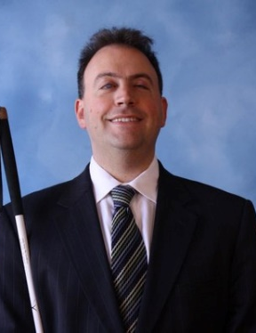 | 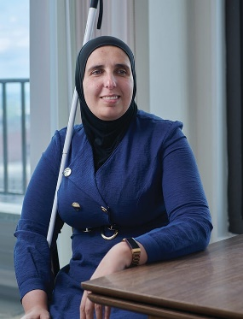
Image: Mark Riccobono  President  National Federation of the Blind | Image: Ronza Othman  President  National Federation of the Blind of Maryland

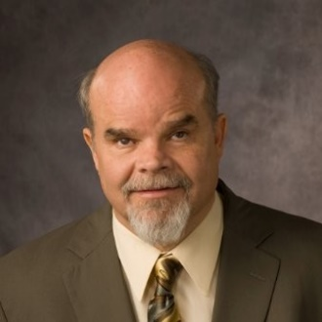
Image: Kevan Worley
National Representative & President
Colorado Center for the Blind Board of Directors;
Principle, Worley Enterprises

Officers:

Ronza Othman, President, Baltimore
Deborah Brown, First Vice President, Rockville
Christopher Danielsen, Second Vice President, Baltimore
Judy Rasmussen, Secretary, Kensington
Jenivieve White, Treasurer, Owings Mills

Board of Directors:

Qualik Ford, Halethorpe
Sharon Maneki, Columbia
Garret Mooney, Baltimore
Mildred Rivera, Lutherville
Melissa Riccobono, Baltimore
Marguerite Woods, Baltimore

Past Presidents:
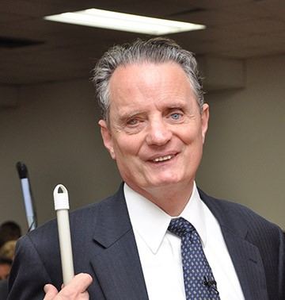 | 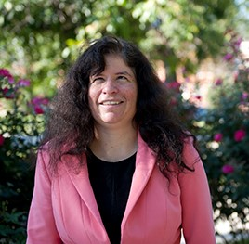 | 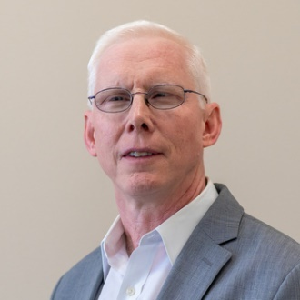 | 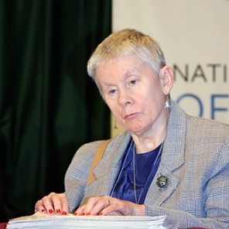
Marc Maurer | Melissa Riccobono | Michael Gosse | Sharon Maneki

Our Credo
The National Federation of the Blind knows that blindness is not the characteristic that defines you or your future. Every day we raise the expectations of blind people, because low expectations create obstacles between blind people and our dreams. You can live the life you want; blindness is not what holds you back!

The National Federation of the Blind Pledge
I pledge to participate actively in the efforts of the National Federation of the Blind to achieve equality, opportunity, and security for the blind; to support the policies and programs of the federation; and to abide by its constitution.

About the National Federation of the Blind of Maryland
The National Federation of the Blind of Maryland (NFBMD), an affiliate of the National Federation of the Blind (NFB), is an organization of blind people and their family and friends. We believe in the full capacity of blind people; we have the power, influence, diversity, and determination to help transform our dreams into reality. Our members work together for a brighter tomorrow by raising the expectations for blind people everywhere so that blind persons can live the lives they want.

Who We Are
The National Federation of the Blind of Maryland is a 501c(3) nonprofit comprised of blind people of all ages, their families and friends. Our strong local chapters and divisions, and well-trained leaders help newly blind people adjust to vision loss and promote the full participation and integration of blind people in our communities. We bring our collective experiences together to effect change at the state and national level.

What We Do
- Assist blind and low-vision persons to acquire the skills of independence
- Help blind and low-vision persons to develop confidence in themselves through our many service activities
- Teach blind and low-vision persons the skills of leadership through active participation in conventions, chapter meetings, and civic activities
- Encourage blind and low-vision seniors to continue their active and meaningful lifestyles
- Prepare blind and low-vision students for productive tax-paying careers through academic and training scholarships
- Inform people with diabetes about options for coping with vision loss
- Support parents and friends of blind and low-vision children with information about the capabilities of the blind
- Protect and promote the civil rights of blind and low-vision persons through public education and legislative action
- Advocate for policies that eliminate discrimination and guarantee equal access to educational programs and high-quality rehabilitation
- Educate the public through seminars, community activities and our publications

Thank You, Convention Sponsors

We extend profuse thanks to the following convention sponsors.

Blind Industries and Services of Maryland, Title Level Sponsor
Vanda Pharmaceuticals, Equality Level Sponsor
Maryland Accessible Communications / Communications Facilitator, Independence Level Sponsor
AdNet/AccountNet, Inc., Independence Level Sponsor
Brown, Goldstein and Levy LLP, Opportunity Level Sponsor
Friends of the Maryland State Library for the Blind and Print Disabled, Opportunity Level Sponsor
WZBA-FM 100.7 The Bay, Opportunity Level Sponsor
3D PhotoWorks, Freedom Level Sponsor
Democracy Live, Freedom Level Sponsor
Morgan Stanley Wealth Management, Freedom Level Sponsor
Sipbound Corporation, Freedom Level Sponsor

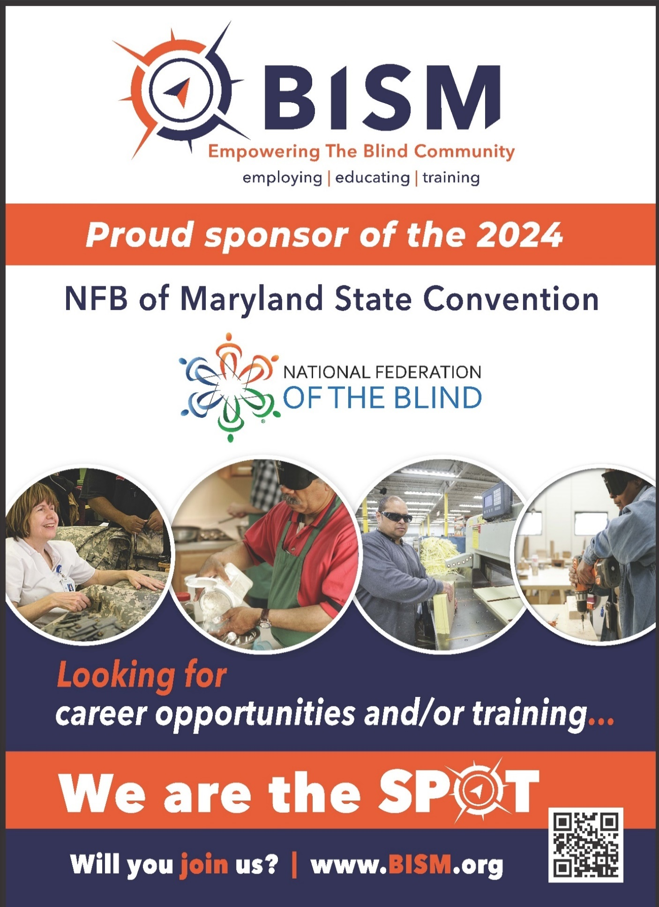
Full page ad for BISM: Empowering the Blind Community. Employing. Educating. Training. Proud sponsor of the NFB of Maryland State Convention. National Federation of the Blind logo. There are 4 images of blind people working hands-on with various materials. "Looking for career opportunities and/or training... We are the spot. Will you join us?" www.BISM.org
Navigating the Sheraton Baltimore North
The Sheraton Baltimore North Hotel is located at 903 Dulaney Valley Road, across the street from the Towson Town Center. Meeting rooms and common areas are located on the first and second floors. Guest rooms are on the third floor and above. The gym and pool are also on the third floor.

Plaza Level (first floor):
As you come into the tiled lobby of the hotel through the main entrance doors, directly in front of you is a large carpeted square seating area with chairs. To the right of the central carpeted area is the front desk.

On the far side of the carpeted area, directly opposite the main door, is another entry/exit to: a smoking area; a flight of stairs going down with trash cans on either side at the top of the steps; and at the bottom of the stairs, a grassy area appropriate for dog relief. (Please don’t forget to use a baggie!) This exit is also the closest one to Towson Town Center.

To the left of the central carpeted area (opposite the front desk) is a divided hallway which leads to the rest of the hotel facilities on this level. Think of it as an L-shaped hallway. If you start at the main entrance and put your back to the hotel’s front desk and walk forward, you will be at the apex of the L, where there is the first staircase to the second level. Along the short leg of the L to your right is the Coffee Corner, where every day from
6:30 a.m. to 2 p.m., you can get Starbucks, pastries, salads, sandwiches, yogurt, and assorted fresh fruit and snacks. Past the Coffee Corner, you will find the elevator lobby. There are two elevators on the left and one on the right. All three elevators may be used to access the floors of guest rooms, the second floor where the meeting rooms are located, and the third floor where the fitness area and pool are located.

If you go back to the apex of the L-shaped hallway, the long leg of this hallway takes you past multiple conversation areas, and eventually leads, with a bit of a curve, to the conference facilities on the plaza level. With the lobby directly behind you, continue down this hallway. First on your left is the Business Center (for guest use), with two tables, each with a computer, and a printer between them. Next on the left of the hallway you will find some big comfy chairs facing a flat screen TV. Opposite this seating area, on the right side of the main hallway are the afore-mentioned stairs (which are around the corner from the Coffee Corner).

Further down the hall on the left is a high-top table surrounded by six chairs with plug-ins for eight devices. Directly opposite this table, on the right side of the hallway, is the beginning of Warfield’s Ballroom. Warfield’s Ballroom extends down the right side of the hallway. One entrance to Warfield’s Ballroom has a few steps in front, but the other entrance is accessible. Further down the hallway on the left are several groupings of round high-top tables and chairs.

Past Warfield’s you will be heading straight to the host stand for the Rain 903 Restaurant and Lounge, where you wait to be seated. At this point the main part of the hallway (which is no longer carpeted) opens up and slightly veers off to the left. Once you have turned left, you will pass the restaurant and then the steps that lead up to the bar on your right. Past the bar on the right side of the hallway are the restrooms. There is a wall with a flat screen display blocking direct access to the restrooms. Go around the wall on either side to find the restroom alcove with the ladies’ room on the left and the men’s room on the right. There are two water fountains between the restrooms. On the left side of the hallway opposite the wall shielding the restroom alcove are more high-top tables with chairs.

Continue past the restrooms just a short distance and find another large carpeted open area. This is the Fitzgerald West Foyer. With your back to the central hallway, there’s another entry/exit door going to/from the parking area, on your left. To your right, across the foyer is the very large
F. Scott Fitzgerald Ballroom. There are many entry/exit doors to this area, which we will use for exhibits and other meetings on Friday, general sessions on Saturday and Sunday, and the banquet on Saturday evening.

Along the far left side of the Fitzgerald Ballrooms, you will find another long hallway, called the Fitzgerald North Foyer. This is where convention registration, packet pickup, and banquet ticket exchange will be located. You must walk through the Fitzgerald West Foyer to get to the Fitzgerald North Foyer. At the end of the Fitzgerald North Foyer is a short set of stairs that lead outside to a second guide dog relief area.

At the end of the hallway that leads from the main lobby, past the Fitzgerald West Foyer on your right, is the second set of stairs, which lead to the second floor. One can walk directly under the stairs, so be careful not to bump your head.

Second Floor:
Directly across from the top of the stairs that are in the Fitzgerald Foyer area is one of the two entrances to the Duncan Room. You can only turn right at the top of the stairs. On your left you will first pass the Duncan Room, followed by the Amphitheater. After the first entrance to the Amphitheater, the hallway opens up to something like a T-intersection. If you follow the wall on the left, past the second Amphitheater entrance, you will be able to make a right into another hallway. On the left side of this hallway, you will first encounter a set of restrooms (ladies on the left and men on the right). Further down the hall on the left you will find Lindsay A, B, and C. There is nothing else in this hallway.

Back at the 3-way intersection with the stairs behind you, the Grason Room is straight ahead of you. Turn right here and on your left you will pass the Burke Room, the MacIntosh Room and the Cole Room, beyond that is the Sales and Catering Office. Along the right side of the hallway is an opening which allows you to look down on the plaza level. As you approach the end of this hallway, there is another large open space. If you follow the wall to your left, you will find the stairs that take you downstairs near the lobby around the corner from the Coffee Corner. Pass the stairs on your left and turn left into the elevator lobby, where you will find two elevators on the left and one on the right.

Third Floor:
As you leave the elevator lobby, straight ahead is the fitness center, including the pool. You will need your room key to enter this area. The hallway off to the right leads to guest rooms.

LIVE THE LIFE YOU WANT

Lyrics copied from October 2015 Presidential Release

Chorus: Live the life you want. Nobody can stop you.
Shoot for the sun and break on through.
So you're blind. You'll be fine. We've got good news!
You can live the life you want. Yes, we know the truth.

Grab a cane, get trained, gotta get movin’.
Make a change in the wage, that's what we're doin’.
Come with me, yeah

Chorus

You and me, NFB, let’s dream together.
NFB, you and me, lives on forever.
You will see, yeah.

Chorus

You can live the life you want. You’ll know the truth.

Chapters and Divisions of the National Federation of the Blind of Maryland

At Large Chapter
Marguerite Woods, president, 443-271-1668, mwoods719@gmail.com
Monthly meetings: third Tuesday at 7:30 p.m., via phone: 339-209-4083

Baltimore County Chapter
Latonya Phipps, president, 443-465-8761, Phippslatonya@gmail.com
Monthly meetings: second Wednesday at BISM

Central Maryland Chapter
Matt Yannuzzi, president, 443-851-1944, Matthew.Yannuzzi@gmail.com
Monthly meetings: first Tuesday in Columbia

Eastern Shore Chapter
Heather Guy, president, 410-430-8954, hguy403@comcast.net
Monthly meetings: second Saturday in Salisbury

Greater Baltimore Chapter
Chris Danielsen, president, 410-262-1281, Cdanielsen@nfb.org
Monthly meetings: third Saturday in Baltimore

Greater Carroll County Chapter
Brian Keseling, president, 410-855-5605, bkmaverick@gmail.com
Monthly meetings: second Saturday in Westminster

Maryland Association of Blind Students
Qualik Ford, president, 301-312-9813, qsford@outlook.com
Periodic meetings throughout the year

Maryland Association of Blind Merchants
Melba Taylor, president, 240-381-1637, m.taylor@encoreassoc.com
Periodic meetings throughout the year

Maryland Parents of Blind Children
Garret Mooney, president, 480-433-8003, james.garret.mooney@gmail.com
Periodic meetings throughout the year

National Harbor Chapter
Amber Woods, president, 301-978-6686, woodsamber83@gmail.com
Monthly meetings: fourth Saturday in Suitland

Senior Issues Division
Marguerite Woods, president, 443-271-1668, mwoods719@gmail.com
Periodic meetings throughout the year

Sligo Creek Chapter
Debbie Brown, president, 301-881-1892, Deborahb14@verizon.net
Monthly meetings: second Saturday primarily in Silver Spring

TLC Chapter
Millie Rivera, president, 202-494-5687, Millie.Rivera0027@gmail.com
Monthly meetings: second Tuesday in Towson

Western Maryland Chapter
Wendy Ruth, president, 301-991-8312, Wendyruth966@gmail.com
Monthly meetings: First Saturday in Cumberland

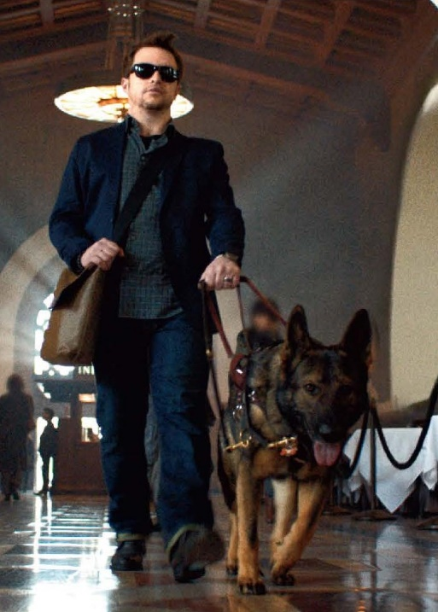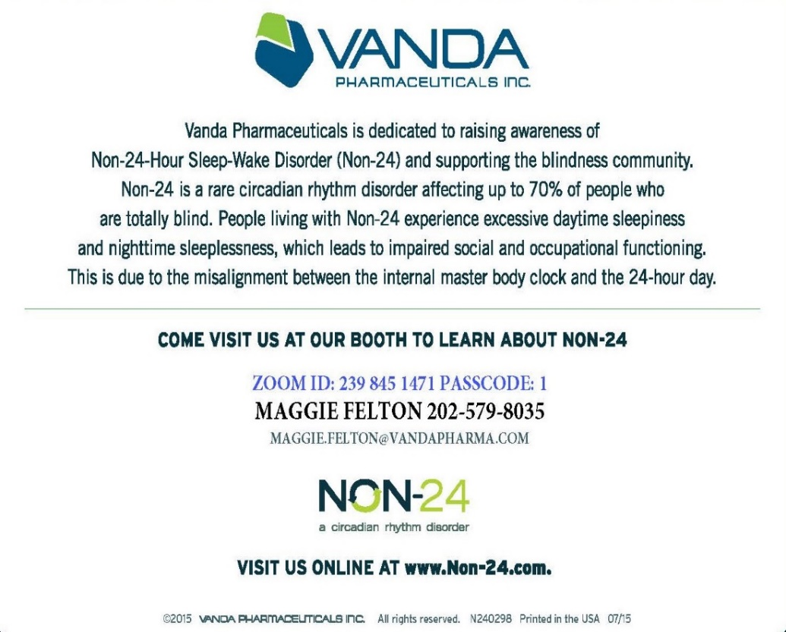
Image Description: Half-page ad from Vanda Pharmaceuticals, Inc. On the left side of the ad is a photo of a man wearing dark glasses walking through a lobby led by a guide dog. Vanda Pharmaceuticals is dedicated to raising awareness of Non-24-Hour Sleep-Wake Disorder (Non-24) and supporting the blindness community. Non-24 is a rare circadian rhythm disorder affecting up to 70% of people who are totally blind. People living with Non-24 experience excessive daytime sleepiness and nighttime sleeplessness, which leads to impaired social and occupational functioning. This is due to the misalignment between the internal master body clock and the 24-hour day. Come visit us at our booth to learn more about Non-24.Zoom ID: 239 845 1471 Passcode: 1 Maggie Felton 202-579-8035, Maggie.felton@vandapharma.com. Non-24: a circadian rhythm disorder Visit us online at www.non-24.com

GLORY FEDERATION

Blind eyes have seen the vision of the Federation way;
New white cane legislation brings the dawn of a new day;
The right of the blind to organize is truly here to stay;
Our cause goes marching on.

Chorus
Glory, glory Federation;
Glory, glory Federation;
Glory, glory Federation;
Our cause goes marching on.

To aid the blind's long struggle we have formed the NFB
To free them from their bondage of workshop and agency,
To give a hand to all the blind wherever they may be;
Our cause goes marching on.

Chorus

Stay Connected and Informed:



Follow and like the National Federation of the Blind of Maryland on Facebook: facebook.com/NationalFederationOfTheBlindOfMaryland

Stay connected with your fellow Maryland Federationists by joining our state email listserv. This list allows you to receive affiliate and national announcements, and also to start and participate in discussions regarding blindness and blindness issues. To sign up visit NFBnet.org, click on “join or drop NFB mailing lists,” and activate “NFBMD” link, and follow the instructions. Many of our local chapters now also have a listserv. Talk to your chapter president to learn how to sign up so you don’t miss important information about chapter news and events.

Visit our website at NFBMD.org. Check out our blog for the President’s Messages. Be sure to check out the Blindness Resources link, and the Know Your Rights link to keep up to date on important information. Be sure to download and print “About NFBMD,” in the “About Us” tab on NFBMD.org, for use at chapter outreach events.

Braille Spectator
The Braille Spectator is published for members of the National Federation of the Blind of Maryland and others who share an interest in the work of this organization. The Braille Spectator can be read on the web at NFBMD.org/Newsletter or can be listened to on the local channel of NFB-Newsline.

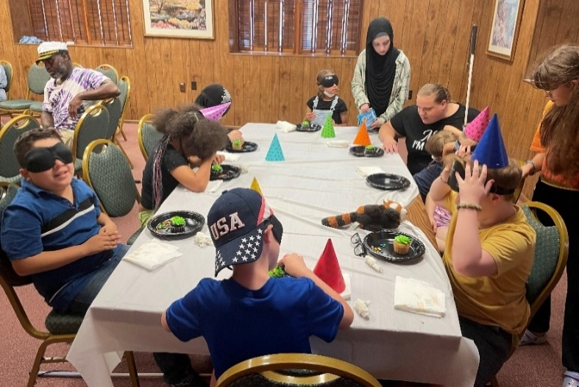
Image: NFB BELL Academy students in Baltimore celebrate Louis Braille’s birthday
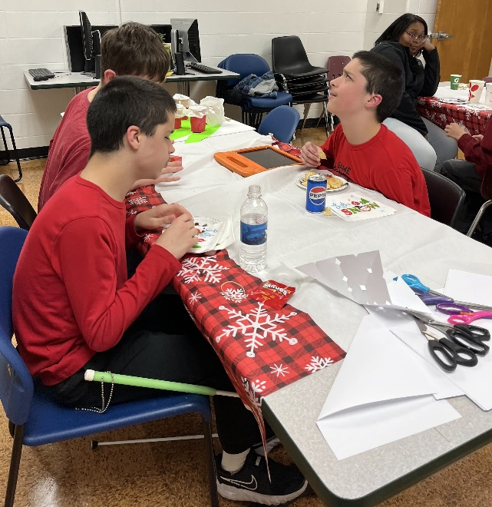
Image: NFB BELLX Academy students in Salisbury attend a holiday party.

Image: NFB BELL Academy students in Southern Maryland sit in a canoe
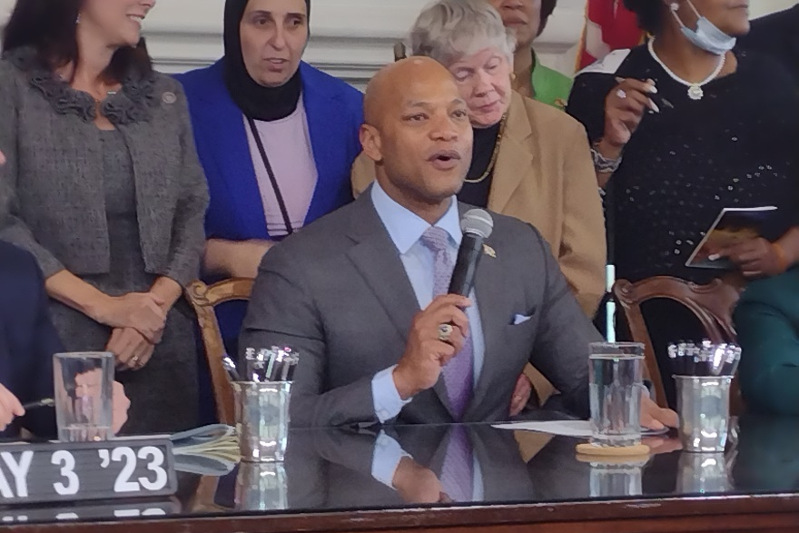
Image: Governor Moore signs Accessible Prescription Label bill into law surrounded by NFBMD members
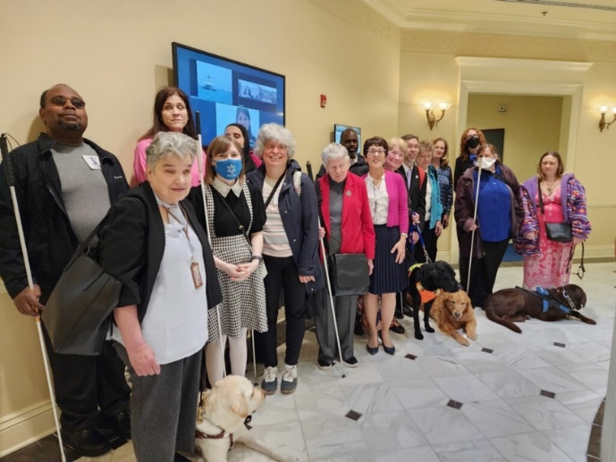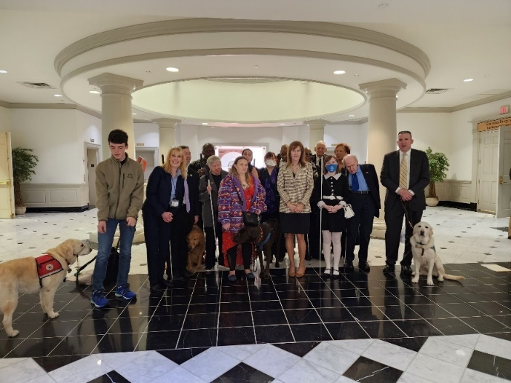
Images: NFBMD members stand with sponsor Delegate Mary Lehman at House Guide Dog Protections in Housing bill hearing (left) and sponsor Senator Mary Dulany James at Senate Guide Dog Protections in Housing bill hearing (right).
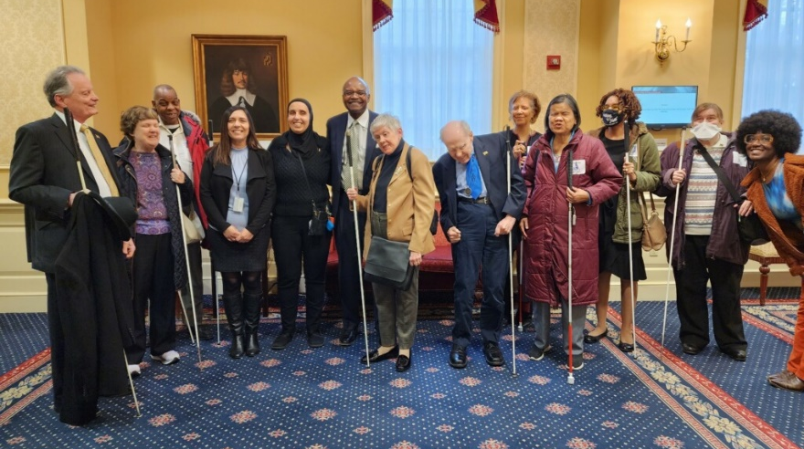
Image: NFBMD members stand with sponsor Senator Benjamin Brooks at Senate Accessible Electronic Ballot Return Voting bill hearing
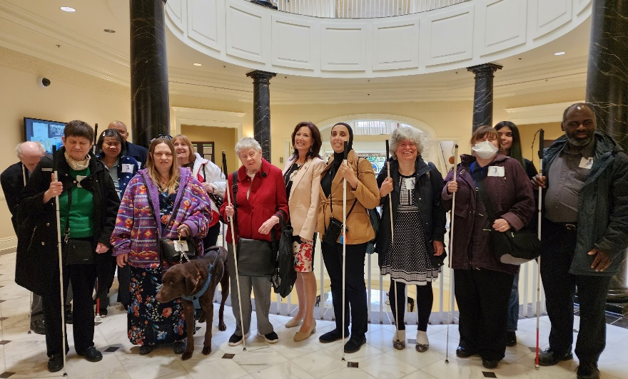
Image: NFBMD members stand with sponsor Delegate Michele Guyton at House Accessible Prescription Labels bill hearing
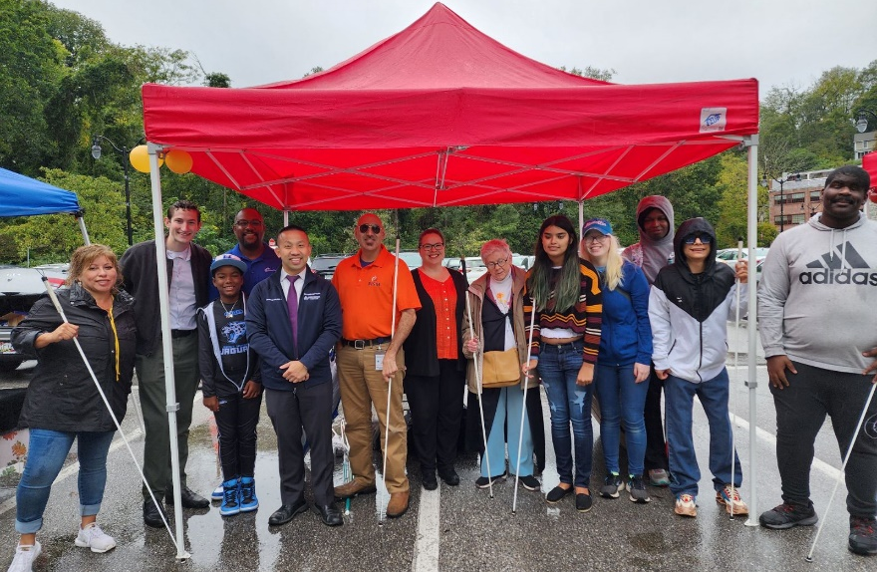
Image: NFBMD members, Senator Lam, and Delegate Feldmark receive White Cane Day proclamation at Wizarding Weekend on Magical Main to commemorate Blind Equality Achievement Month
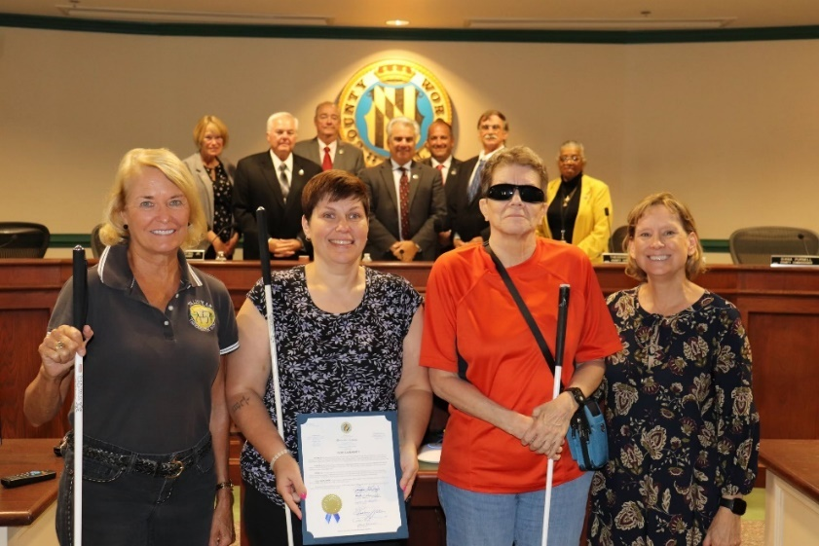
Image: NFBMD members receive White Cane Day proclamation at Worcester County Board Meeting

Committees of the National Federation of the Blind of Maryland
If you’re interested in being appointed to a particular committee, notify the NFBMD president at president@nfbmd.org or 443-426-4110.

Advocacy Committee
Sharon Maneki, chairperson

Ambassadors Committee
Judy Rasmussen and Debbie Brown, co-chairpersons

Audit Committee
Barry Hond and Justin Young, co-chairpersons

BELL Committee
Melissa Riccobono, chairperson

Braille Spectator Committee
Ronza Othman and Sharon Maneki, editors

Deaf-Blind and Hearing Loss Issues Committee
Janice Toothman and Heather Guy, co-chairpersons

Development and Fundraising Committee
Jenivieve White and Ellen Ringlein, co-chairpersons

Diversity, Equity, and Inclusion Committee
Juhi Narula and Qualik Ford, co-chairpersons

Employment Committee
Pam Goodman and Jannis Forbes, co-chairpersons

Guide Dog Issues Committee
Sherry Shirek, chairperson

Legislation Committee
Sharon Maneki, chairperson

Membership Committee
Dezman Jackson, chairperson

Nominating Committee
Ellen Ringlein, chairperson

PAC Plan Committee
John Paré and Ann-Marie Laney, co-chairpersons

Public Relations Committee
Chris Danielsen, chairperson

Resolutions Committee
Chris Danielsen, chairperson

Scholarship Committee
Mildred Rivera, chairperson

Sharon Maneki Youth Empowerment Grant Committee
Sharon Maneki, chairperson

Social Media Committee
Karen Anderson, chairperson

Spanish Services Committee
Teresa Graham, chairperson

Sports and Recreation Committee
Qualik Ford and Harvey Guary, co-chairpersons

Transportation Committee
Aloma Bouma and Sheryl Fogle-Hatch, co-chairpersons

Website and Technology Committee
John Berggren, chairperson

Youth Activity Committee
Brittany Bomboy, chairperson

Convention-Related Committees

Anna Freysz Cable Award Committee
Debbie Brown, chairperson

Convention Child Care Committee
Brittany Bomboy, chairperson

Convention Logistics Committee
Justin Young, chairperson

Convention Registration Committee
Marie Marucci, chairperson

Distinguished Educator of Blind Children Award Committee
Teresa Graham, chairperson

Door Prize Committee
Juhi Narula and Qualik Ford, co-chairpersons

Gold Cup Crab Race Committee
Juhi Narula and Jen White, co-chairpersons

Jennifer Baker Award Committee
Melissa Riccobono, chairperson

Kenneth Jernigan Award Committee
Mary Ellen Jernigan, chairperson

National Funding Support Auction Committee
Joel Zimba, chairperson

Groups of the
National Federation of the Blind of Maryland
If you’re interested in joining a particular group, contact that group’s chairperson.

Blind Crafters Group
Danielle McCann and Karen Anderson, co-chairpersons

Blind Parents Group
Faith Waybright and Melissa Riccobono, co-chairpersons

Diabetes Action Network
Eileen Ley, chairperson

Performing Arts Group
Chris Danielsen, chairperson

Significant Others and Loved Ones Group
Jenivieve White and David Waybright, co-chairpersons

Veterans Group
Ed Jackson, chairperson

Leaving A Legacy: Dream Makers Circle
You can help build a future of opportunity for the blind by becoming a member of our Dream Makers Circle. It is easier than you think. Just visit your bank and convert an account to a P.O.D. (payable on death) bank account which is payable after your passing to the National Federation of the Blind or the National Federation of the Blind of Maryland. Your legacy gift to the National Federation of the Blind or the National Federation of the Blind of Maryland can be made in the form of a will or living trust, an income generating gift, or by naming us as the beneficiary of a retirement plan, IRA, pension, or a life insurance policy. You can designate a specific amount, a percentage, or list NFB as one of several beneficiaries. For additional information, please contact Patti Chang at 410-659-9314, ext. 2422 or at pchang@nfb.org.

STRIVE
Lyrics by Barbara Elliott
Sometimes people tell me blind people should be quiet and sit down
But I say "No!" I say "No!" I say "No."
They contend that I should be content to let others lead me around,
But I say "No!" I say "No!" I say "No."
Everybody needs somebody to help sometimes, but I'm in charge of me,
Chorus: I've gotta strive, strive, strive a little farther,
Reach, reach, reach a little longer,
Work, work, work a little harder,
Hope, hope, hope a little stronger.
Watch me, watch me, watch me.
Nothin's gonna stop me, stop me, stop me.
I'm spreading my wings, soaring on a dream,
I can do anything!
I gotta be brave even when I'm afraid to do hard things.
I'll tell myself "Go!" I'll just go, I will go.
I'm not a fool; I need training and tools to live out my dreams.
So I'll say "Go!" I'll just go, I will go.
I'm not a passenger in my life. I'm gonna take control and drive.
Chorus

Convention Agenda

Friday, February 16
8:30 a.m. to 4 p.m. — Fun with Friends Childcare
Duncan Room

Brittany Bomboy, Convention Childcare Coordinator; Baltimore, Maryland

9 to 10:55 a.m. — NFBMD Board of Directors Meeting (Open to All)
Fitzgerald Ballroom B and C

11 a.m. to 11:55 a.m. — Resolutions Committee Meeting
Fitzgerald Ballroom B and C
Everyone is encouraged to attend!

Chris Danielsen, chairperson; Baltimore, Maryland

11 a.m. to 6 p.m. — Exhibits and Transition Fair
Fitzgerald West Foyer and Fitzgerald Ballroom A
Check out the latest offerings from a variety of companies and organizations that provide technology and services for the blind. Engage with providers of transition services for those age 14 to 21 in Maryland.

Jenivieve White, sponsorship and exhibits coordinator and treasurer, National Federation of the Blind of Maryland; Owings Mills, Maryland

11 a.m. to 3:55 p.m. — Annual Conference for Parents and Teachers of Blind Children: Maryland Parents of Blind Children
Lindsay A
What are the skills and tools blind students need in school and to live the lives they want? How do we best prepare transition-age students for life beyond school? How do you make sure school and rehabilitation services are appropriately addressing their needs? What can you do to support them at home and in school? Learn about resources, opportunities, blindness skills, and how to have and model a positive attitude on blindness. These are only some of the topics to be discussed at this seminar.

Garret Mooney, president, Maryland Parents of Blind Children Division; Baltimore, Maryland

11:30 a.m. — Boxed Lunch Distribution
Fitzgerald North Foyer
*You paid for a boxed lunch at pre-registration. Lunches must be picked up by 12:30 p.m., or they will be resold with no refunds.

Noon to 1:55 p.m. — Senior Issues Seminar - Older Adults, Taking Care of Ourselves: Staying Out of Probate, All About Wills, Medical Directives, and More!
Fitzgerald Ballroom B and C
Learn how to grow your independence and manage your vision loss as an older adult. Learn about how to make decisions related to estate planning and medical directives geared toward ensuring you remain independent and the decision-maker. Please join us for an informative, thought provoking, and inspiring seminar. For seniors and others facing vision loss.

Marguerite Woods, president, Maryland Senior Issues Division; Board Member, National Federation of the Blind of Maryland; Baltimore, Maryland

Noon to 1:55 p.m. — Sports and Recreation Seminar: Sound Bath and Acupuncture
Warfield Ballroom
Come to participate in a sound bath, which is a full body listening experience that intentionally uses sound to provide gentle and restorative therapeutic processes to nurture mind and body. Acupuncture is also available for those interested. Bring your own yoga mat or towel.
Donations of $20 - $40 are encouraged but not required.

Daniel Kemp, Harmony Works; Baltimore, Maryland

1 to 4 p.m. — NFB of Maryland Career Fair
Lindsay Ballroom B and C
Are you looking for a job? Are you hoping to move up in your field? Are you seeking a different opportunity? Or, are you looking to hire new talent? Prospective employers are eager to meet prospective employees and vice versa. Attend the 2024 NFB of Maryland Career Fair. Employers should sign up in advance by visiting NFBMD.org/2024JobFair. Job seekers are encouraged to sign up in advance by visiting NFBMD.org/2024JobFair, but walk-ins are permitted. Job seekers must bring resumes to share.

Pam Goodman, co-chairperson, NFBMD Employment Committee; Linthicum, Maryland; Janice Forbes, co-chairperson, NFBMD Employment Committee; Laurel, Maryland

1 to 6 p.m. — Convention Registration and Packet Pickup
Fitzgerald North foyer

2 to 3:55 p.m. — NFB of Maryland Philosophy Seminar
Fitzgerald Ballroom B and C
What is the NFB philosophy? Why does it matter? How do we apply it to our individual lives? Come to this seminar to engage in thought provoking discussions on NFB philosophy and its practicable applications.
Qualik Ford, President, Maryland Association of Blind Students; Halethorpe, Maryland; Juhi Narula, Immediate Past Vice President, Maryland Association of Blind Students; Baltimore, Maryland

2 to 3:55 p.m. — First Aid Seminar
Burke Room
Do you know how to use a fire extinguisher; how to assist a person who is choking; what to do about a severe cut or burn? What about how to detect shock, hypothermia or hyperthermia? Come to the NFBMD First Aid Seminar to learn about these topics and much more. Space is limited, and advanced registration is required. Participants will be accepted on a first come, first serve basis. Visit forms.gle/3yqN8AxQ4Hh6vp7r8 to sign up.

Christine Grassman and Braden Flax, certified CPR/First Aid/AED instructors; Falls Church, Virginia

2 to 3:55 p.m. — Advocacy Seminar: — Overcoming Technophobia
Warfield Ballroom
Want to conquer your technophobia? Come to this seminar to learn how to use your phone more effectively. Learn about gestures and ways to maximize your smart phone. Learn how to more easily use Zoom. Learn about mobile applications that are both simple and useful. Explore a variety of accessibility problems and possible solutions for them.

Sharon Maneki, Chairperson, Advocacy Committee, National Federation of the Blind of Maryland; Columbia, Maryland

4 to 5:55 p.m. — Maryland Association of Blind Students Seminar
Grason Room
Come learn about matters of interest to students including how to self-advocate in school, with potential employers, and in the world. Learn what resources are available for students. Registration from 3:45 to 4 p.m.

Qualik Ford, president, Maryland Association of Blind Students; Halethorpe, Maryland

4 to 4:55 p.m.—NFBMD BELL ACADEMY REUNION
Burke Room
Reunite with the NFB BELL Academy students from the 2023 session and prepare for the General Session NFB BELL presentation. Kids are asked to attend, and their families are welcome.

Brittany Bomboy, 2023 NFBMD BELL Coordinator; Baltimore, Maryland

4:30 to 6:30 p.m. — Bingo
Fitzgerald Ballroom B and C
Come play everyone’s favorite game - Bingo and win prizes.
Sponsored by Blind Industries and Services of Maryland, Title Sponsor

5 p.m. — NFBMD Cane Walk
Lindsay Foyer
The Maryland Parents of Blind Children will host a cane walk for children and adults.

Garret Mooney, president, Maryland Parents of Blind Children Division; Baltimore, Maryland

5 to 6:55 p.m. — Sports and Recreation Seminar: Free Swim
Sheraton Pool
The Sports and Recreation Committee invites those interested to come to the pool for an open swim. A life guard will be on hand, and participants may entertain themselves by frolicking in the pool, swimming laps, or having fun with friends. This activity is unstructured.

6 to 6:55 p.m. — Narrowing the Gap Reunion
Burke Room
NFB Narrowing the Gap Teachers will get together for in-person networking and fun.

Casey Robertson, Professor, Louisiana Tech University; Ruston, Louisiana; Karen Anderson, Coordinator of Educational Programs, National Federation of the Blind; Baltimore, Maryland

6:30 to 8:30 p.m. — Maryland Association of Blind Merchants Annual Meeting and Networking Reception
Warfield Ballroom
Come learn about matters of interest to blind merchants and those in the Business Enterprise Program.

Melba Taylor, president, Maryland Association of Blind Merchants; Bowie, Maryland

7 to 8:30 p.m. — Annual Networking Social for Families of Blind Children
Lindsay B and C
Participants of the Parents and Educators Seminar are invited to come meet and network and enjoy light snacks.

Garret Mooney, president, Maryland Parents of Blind Children Division; Baltimore, Maryland

7 to 8:55 p.m. — Dinner and a Play
Fitzgerald Ballroom B and C
The Braille is Beautiful Players will entertain and delight.

Debbie Brown, play director; first vice president, National Federation of the Blind of Maryland; Rockville, Maryland

9 to 11:30 p.m. — Crab Idol
Fitzgerald Ballroom B and C
This American Idol-style evening promises to be fun for all ages. Those wishing to perform songs can do so for $5 per person per performance. Chapters and Divisions will battle it out to determine which has the most talent. Enjoy snacks and fellowship thanks to the Maryland Association of Blind Students and Maryland Parents of Blind Children. Proceeds support NFBMD, MDABS, and MDPBC.

To sign up to perform, contact Qualik Ford or Garret Mooney.

Saturday, February 17
7 to 8:15 a.m. — At-Large Chapter Meeting
Burke Room
The At-Large Chapter will meet face-to-face. Continental breakfast will be available.

Marguerite Woods, president; Baltimore, Maryland

7 to 8:15 a.m. — Western Maryland Chapter Meeting
Cole Room
The Western Maryland Chapter will meet in person. Continental breakfast will be available.

Wendy Ruth, president; Hagerstown, Maryland

8 to 8:25 a.m. — Convention Registration and Packet Pickup
Fitzgerald North foyer

8:15 a.m. to 5:15 p.m. — Fun with Friends Childcare
Duncan Room
Brittany Bomboy, coordinator; Baltimore, Maryland

8:30 a.m. to 11 a.m. — Saturday Morning General Session

Fitzgerald Ballroom

8:30 a.m. — Call to Order and Opening Ceremonies

8:45 a.m. — Reimagining Our Internal Programs
Get on the Pac Plan
John Pare, Maryland PAC Plan co-chairperson; Baltimore, Maryland; Ann-Marie Laney, Maryland PAC Plan co-chairperson; Randallstown, Maryland

Gold Cup Crab Race
Juhi Narula, ticket agent; Baltimore, Maryland

9 a.m. — Welcoming Remarks
Mark Riccobono, President, National Federation of the Blind; Baltimore, Maryland
Ronza Othman, President, National Federation of the Blind of Maryland; Baltimore, Maryland

9:20 a.m. — Expect Much in Training, Work, and Beyond: A Report from Blind Industries and Services of Maryland
Michael Gosse, president, Blind Industries and Services of Maryland; Baltimore, Maryland

9:30 a.m. —From Idea to Law: Guide Dog Protections in Housing
Mary Lehman, Delegate, District 21, Maryland State House of Delegates; Laurel, Maryland
Sherry Shirek, Chairperson, NFBMD Guide Dog Committee; Baltimore, Maryland

9:50 a.m. — Give and Get Much: A Report from Our National Office
Kevan Worley, president, Colorado Center for the Blind Board of Directors and Principle, Worley Enterprises; Aurora, Colorado

10:20 a.m. — Expect Much: A Report from the National Association of Blind Students
Hunter Kuester, Treasurer, National Association of Blind Students; Menomoni, Wisconsin

10:30 a.m. — Rehabilitation Services for the Future
Toni March, director, Office of Blindness and Vision Services, Maryland Division of Rehabilitation Services (DORS); Baltimore, Maryland

10:40 a.m. — First Aid: Opportunities for Training for the Blind
Christine Grassman and Braden Flax, certified CPR/First Aid/AED instructors; Falls Church, Virginia

10:50 a.m. — Reports and Resolutions

11 a.m. — Adjourn

11 a.m. to 12 p.m. — Breakout: Diversity, Equity, and Inclusion Town Hall
Fitzgerald A
Join us for a town hall on diversity, equity, and inclusion. Share ideas and priorities for incorporating DEI into NFB of Maryland programs and activities.

Qualik Ford, DEI Committee Co-Chairperson; Halethorpe, Maryland

11 a.m. to 12 p.m. — Breakout: Membership Recruitment, Development, and Retention
McIntosh Room
Those interested in exploring strategies for recruiting, developing, and retaining members are encouraged to attend this workshop. Each chapter should designate at least one representative.

Danielle McCann, Membership Coordinator, National Federation of the Blind; Baltimore, Maryland; Dezman Jackson, Membership Chairperson, National Federation of the Blind of Maryland; Baltimore, Maryland

11 a.m. to 12 p.m. — Breakout: Blind Parents Meeting
Lindsay A
Share tips and tricks on how to parent using non-visual techniques. Network with other blind parents and caregivers.

Melissa Riccobono, co-chairperson; Baltimore, Maryland

11 a.m. to 12 p.m. — Breakout: Blind Young People’s Group Organizing Meeting
Burke Room
Are you a recent graduate or approaching graduation? Are you finished with your schooling and wondering what to do next? Are you new to your profession and feeling disconnected from people who’ve been in the workforce for a long time? Are you having trouble adulting? Then this meeting is for you. Come join others experiencing this same transition to explore organizing a Young Person’s Group within the NFB of Maryland.

Jeff Baer, Group Co-organizer; Potomac, Maryland; Juhi Narula, Group Co-organizer; Baltimore, Maryland

12 to 12:15 p.m. — Convention Registration and Packet Pick-Up
Fitzgerald North Foyer

12:15 to 1:45 p.m. — Luncheon: The Education of Blind and Low-Vision Students
Lindsay B and C
For parents, teachers of the blind, and those interested in matters concerning blind students.

Garret Mooney, president, Maryland Parents of Blind Children’s Division, National Federation of the Blind of Maryland; Baltimore, Maryland

12:15 to 1:45 p.m. — Luncheon: Reclaiming Independence After Vision Loss
Warfield Ballroom
For seniors and others facing vision loss.

Marguerite Woods, president, Maryland Senior Issues Division; Board Member, National Federation of the Blind of Maryland; Baltimore, Maryland

12:15 to 1:45 p.m. — Maryland Association of Blind Students Annual Business Meeting and Luncheon
Grason Room
The Maryland Association of Blind Students will hold its annual business meeting, including planning future workshops and events and holding elections.

Qualik Ford, president; Halethorpe, Maryland

1:20 to 2 p.m. — Banquet Ticket Exchange
Fitzgerald North Foyer

2 to 5 p.m. — Saturday Afternoon General Session

Fitzgerald Ballroom

2 p.m. — Call to Order

2:05 p.m. — Expect Much, Give Much, Get Much
Ronza Othman, president, National Federation of the Blind of Maryland; Baltimore, Maryland

2:45 p.m. — From Idea to Law: Guide Dog Protections in Housing
Mary Dulany James, Senator, District 34, Maryland State Senate; Havre De Grace, Maryland

2:55 p.m. — Expect Much in Education: Maryland Leads the Way for Blind Students and Teachers of Blind Students
- W. Robert Hair, superintendent, Maryland School for the Blind; Baltimore, Maryland
- Conchita Hernandez, Statewide Low Incidence Specialist, Maryland School for the Blind; Washington, DC
- Casey West Robertson, Professor, Louisiana Tech University; Ruston, Louisiana
- Karen Anderson, education programs coordinator, National Federation of the Blind; Baltimore, Maryland

3:25 p.m. — Expect Much in Employment
- Sai Techawongtham Peterson, Mental Health Therapist; Baltimore, Maryland
- Nikki Jackson, Coordinator of Employment Programs, National Federation of the Blind; Baltimore, Maryland
- Ben Danforth, Economist, Social Security Administration; Rockville, Maryland
Panel Moderators: Pam Goodman, co-chairperson, NFBMD Employment Committee; Linthicum, Maryland; Janice Forbes, co-chairperson, NFBMD Employment Committee; Laurel, Maryland

3:55 p.m. — Give Much in Retirement
Virginia Bender, Treasurer, Eastern Shore Chapter, National Federation of the Blind of Maryland; Executive Board Member, Maryland Federation of the National Association of Active and Retired Federal Employees; Salisbury, Maryland

4:05 p.m. — Emergency Mental Health Resources: 988 System
Samirah Abdul-Fattah, Community Engagement Coordinator, Behavioral Health System Baltimore; Baltimore, Maryland

4:15 p.m. — Expect Much Across the State: Maryland Department of Disabilities Programs
Carol Beatty, secretary, Maryland Department of Disability; Baltimore, Maryland
Chelsea Hayman, director, Housing Policy and Programs; Baltimore, Maryland

4:35 p.m. — Give Much, Get Much in Annapolis: Legislative Partnership Leads to Real Change
Michele Guyton, Delegate, District 42, Maryland State House of Delegates; Baltimore County, Maryland

4:45 p.m. — Reports and Resolutions

5 p.m. — Adjourn

6 p.m. — Reception and Cash Bar
Fitzgerald West Foyer

6:30 to 10 p.m. — Fun with Friends Childcare
Duncan Room
Brittany Bomboy, coordinator
*Childcare ends at 10 p.m., or 15 minutes after the banquet ends, whichever is earlier

7 p.m. — 58th Annual Convention Banquet
Fitzgerald Ballroom
Master of Ceremonies: Mark Riccobono, President, National Federation of the Blind; Baltimore, Maryland
Performance: Sligo Creek Players
Graduation Ceremony: Narrowing the Gap Teachers of Blind Students Program
Keynote Banquet Address: Kevan Worley, president, Colorado Center for the Blind Board of Directors; Principle, Worley Enterprises; Aurora, Colorado
Scholarships and Awards

Immediately after the Banquet — Maryland Gold Cup Crab Race
Race Callers: Ronza Othman and Juhi Narula

Sunday, February 18
7:30 to 9 a.m. — Luggage Collection
Warfield Ballroom
For anyone needing to store luggage due to 11 a.m. hotel check-out time, including bus passengers

7:30 to 8:45 a.m. — Training Center Information and Graduate Networking Breakfast
Lindsay B and C
Those interested in learning about adjustment to blindness training can talk with training center ambassadors and graduates. Alumni from the Louisiana Center for the Blind, Colorado Center for the Blind, BLIND, Inc., and Blind Industries and Services of Maryland can reconnect. Breakfast will be available for $12 per person payable at the door.

Coordinators: Chris Danielsen (LCB), president, Greater Baltimore Chapter; Garret Mooney (CCB), president, Maryland Parents of Blind Children; and Matt Yannuzzi (BISM), president, Central Maryland Chapter

8 to 8:30 a.m. — Nonsectarian Devotions
Fitzgerald Ballroom
Judy Rasmussen, secretary, National Federation of the Blind of Maryland; Kensington, Maryland

8:30 to 8:50 a.m. — Convention Registration and Packet Pick-Up
Fitzgerald North Foyer

9 a.m. to 1 p.m. — Sunday Morning Session
Fitzgerald Ballroom

9 a.m. — Call to Order

9:05 a.m. — Standing on the Shoulders of Giants: Celebrating Our Presidents
- Mark Riccobono, President, National Federation of the Blind; Baltimore, Maryland
- Marc Maurer, Immediate Past President, National Federation of the Blind; Past President 1984 – 1986, National Federation of the Blind of Maryland; Catonsville, Maryland
- Sharon Maneki, Past President 1986 – 2006 and 2014 – 2018, National Federation of the Blind of Maryland; Columbia, Maryland
- Michael Gosse, Past President 2006 – 2008, National Federation of the Blind of Maryland; Baltimore, Maryland
- Melissa Riccobono, Past President 2008 – 2014, National Federation of the Blind of Maryland; Baltimore, Maryland

9:55 a.m. — Our Library: High Expectations, High Achievements
John Owen, director, Maryland State Library for the Blind and Print Disabled; Baltimore, Maryland

10:05 a.m. — Expect Much in Our Children’s Future: NFB BELL Academy and STEM2U
- Brittany Bomboy, 2023 Maryland NFB BELL Academy coordinator; 2023 Maryland STEM2U Coordinator; Baltimore, Maryland
- Erin Zobell, 2024 Maryland STEM2U Coordinator and NFB BELL Academy Southern Maryland Lead Teacher; California, Maryland
- Maryland NFB BELL Academy Students
- Maryland NFB STEM2U Students

10:35 a.m. — Talk, Text, and Train
- Marguerite Woods, Board Member, National Federation of the Blind of Maryland; Baltimore Maryland
- Jane Hager, MAT Specialist, Telecommunications Access of Maryland, Maryland Department of Disabilities; Baltimore, Maryland
- Diane Ducharme, Blindshell USA; Timonium, Maryland
- Joanne Berman, Low Vision Consultant, Attorney; Easton, Maryland
- Vishnu Demir, Digital Navigation Program, University of Maryland; Baltimore, Maryland

11:05 a.m. — Audit Committee Report
Barry Hond; Audit Committee Co-Chairperson; Baltimore, Maryland

11:10 a.m. — Financial Report
Jenivieve White, treasurer, National Federation of the Blind of Maryland; Owings Mills, Maryland

11:30 a.m. — 2023 Business Meeting Minutes
Judy Rasmussen, Secretary, National Federation of the Blind of Maryland; Kensington, Maryland

11:45 a.m. — Resolutions Committee Report
Chris Danielsen, NFBMD Resolutions Committee Chairperson; Baltimore, Maryland

12:15 p.m. — Affiliate Elections

12:45 p.m. — Other Business

1 p.m. — Adjourn

A Closing Message

On behalf of the officers and Board of Directors, I’d like to take this opportunity to thank all Federationists and friends for your generous monetary donations and gifts of goods and services. We had a very successful year and an outstanding convention because of your help!

Ronza Othman, President


Image Description: A quarter page ad for AdNet: Advocates for Workplace Excellence & Equality. On the right side is an emblem with the AdNet slogan and "31 years Anniversary". The main body of the ad reads "Leader in providing professionals with Accounting/Finance, Human Resources and Legal expertise. Serving the blind, deaf and mobility impaired community in the workplace by providing Reasonable Accommodations Support Services to government and corporate entities. Contact Betsy Cerulo, CEO bcerulo@adnetp3.com 410-715-4035". The bottom left has a diverse group of professionals looking excited. The bottom right has three logos: nglcc: National LGBT Chamber of Commerce, Certified WBENC: Women's Business Enterprise, and SBA 8(a) Certified.

BRAILLE IS BEAUTIFUL

Na na na-na na na, na na na-na nah.
Na na na na nah, na na na-na nah.

Chorus:
Go on and live your life,
Don't need a bit of sight.
In the end you'll find
Braille is beautiful.
Put your fingers on the page.
Tell your friends it's all the rage.
It's all gonna be OK, yeah
Braille is beautiful!

Na na na na na na, Na na na-na nah Braille is beautiful!
Na na na-na nah, Na na na-na nah.

Verse
Louis Braille was his name. Slate 'n' stylus was his game.
They tried to stop him, but we adopted the code that paved the way.

Chorus

Na na na na na na, Na na na-na nah Braille is beautiful!
Na na na-na nah, Na na na-na nah.
Na na na-na nah, Na na na-na nah.

BRAILLE IS BEAUTIFUL!

ODE TO THE CODE

Sligo Creek, Digital Communications Consortium

Going to the school to write an IEP,
The teacher says use print, because your child can see.
The equipment is too big, and large print is too rare,
And fifteen words a minute will not get you anywhere!

Chorus:
Braille is here, Braille is here, Braile is here to stay!
We will keep on using it, we don't care what you say!
Braille is here, Braille is here, we will sing its praise.
It's the system for the blind to get a job that pays.

They say that Braille's too tough to teach the newly blind.
Its codes and its contractions discombobulate the mind.
Contractions we've learned all, and codes we've mastered, too,
For blindness has no negative effect on our IQ!

Chorus

They say that Braille’s complex. They say that it’s too slow.
They say that new technology’s the only way to go.
But we’ll keep using Braille, because it is the key
To making sure that blind folks will be literate and free.

Chorus
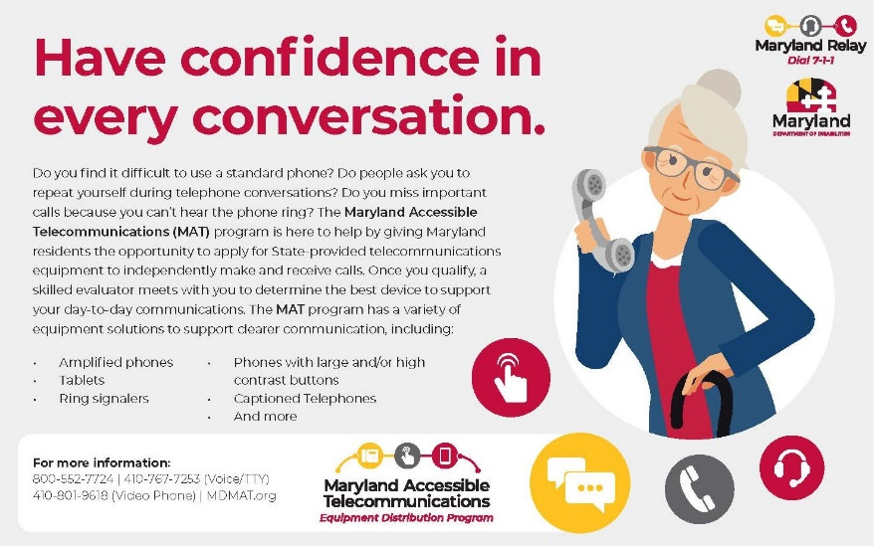

Image Description: A quarter page ad for Maryland Relay. "Maryland Relay Dial 7-1-1, Maryland Department of Disabilities". The main headline says: "Have confidence in every conversation" and the main body reads "Do you find it difficult to use a standard phone? Do people ask you to repeat yourself during telephone conversations? Do you miss important calls because you can't hear the phone ring? The [Maryland Accessible Telecommunications (MAT)] program is here to help by giving Maryland residents the opportunity to apply for State-provided telecommunications equipment to independently make and receive calls. Once you qualify, a skilled evaluator meets with you to determine the best device to support your day-to-day communications. The MAT program has a variety of equipment solutions to support clearer communication, including: amplified phones, tablets, Ring signalers, Phone with large and/or high contrast buttons, Caption telephones, and more. For more information: 800-552-7724, 410-767-7253 (Voice/TTY), 410-801-9618 (Video Phone), MDMAT.org" On the right side of the ad is a cartoon of an elderly woman holding a phone. At the bottom is the Maryland Accessible Telecommunications: Equipment Distribution Program logo.

2024 NFBMD Exhibitors
The following is a list of organizations that are participating in the 2023 - 2024 NFBMD Exhibit Hall. Check NFBMD.org for updates and additions to this list.

- National Federation of the Blind of Maryland
- Blind Industries and Services of Maryland
- Vanda Pharmaceuticals
- Maryland Technology Assistance Program
- Maryland Relay/Telecommunications Access of Maryland
- Maryland State Library for the Blind and Print Disabled
- Democracy Live
- Centers for Medicare & Medicaid Services
- Crafted Items by Terry Powers and Yasmin Reyazuddin
- En-vision America
- God Ain’t Done with Me Yet: Uniquely Blessed
- Integration Technologies Group
- JW.org
- Maryland Department of Disabilities
- Maryland Division of Rehabilitation Services (DORS)
- National Aquarium
- NFB Newsline
- PS You Are Fabulous
- Soundpro
- The Image Center of Maryland
- The Wellness DJ, LLC
- Vispero

