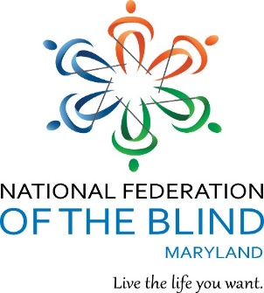


AGENDA

National Federation of the

Blind of Maryland

Fifty-Second Annual Convention

Focus on the Future

Carousel Resort Hotel & Condominiums
11700 Coastal Hwy., Ocean City, MD 21842

Friday, November 9 – Sunday, November 11, 2018

Celebrating service to the blind community and to our nation!

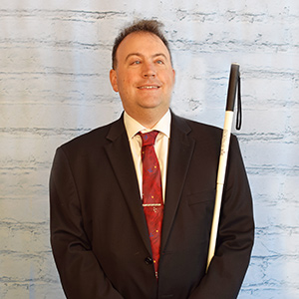
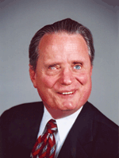

Mark Riccobono
President
National Federation of the Blind

Marc Maurer
Immediate Past President
National Federation of the Blind

Convention Greetings

NATIONAL FEDERATION OF THE BLIND OF MARYLAND
9013 Nelson Way, Columbia, MD 21045
410-715-9596; nfbmd@earthlink.net; www.nfbmd.org

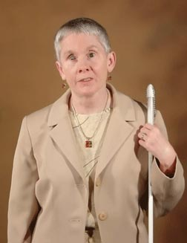
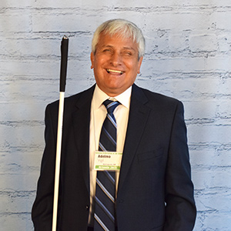

Sharon Maneki
President, National Federation
of the Blind of Maryland

Adelmo Vigil
National Representative;
President, National Federation
of the Blind of New Mexico;
Member, Board of Directors, National Federation of the Blind

Officers:
Deborah Brown, First Vice President, Rockville
Anil Lewis, Second Vice President, Baltimore
Judy Rasmussen, Secretary, Kensington
Shawn Jacobson, Treasurer, Olney

BOARD OF DIRECTORS:
Darlene Barrett, Columbia
Michelle Clark, Springdale
Ronza Othman, Baltimore
Maurice Peret, Baltimore
Melissa Riccobono, Baltimore
Marguerite Woods, Baltimore

Our Credo

The National Federation of the Blind knows that blindness is not the characteristic that defines you or your future. Every day we raise the expectations of blind people, because low expectations create obstacles between blind people and our dreams. You can live the life you want; blindness is not what holds you back!

The National Federation of the Blind Pledge

I pledge to participate actively in the efforts of the National Federation of the Blind to achieve equality, opportunity, and security for the blind; to support the policies and programs of the Federation; and to abide by its Constitution.

LIVE THE LIFE YOU WANT

Lyrics copied from October 2015 Presidential Release
Chorus: Live the life you want. Nobody can stop you.
Shoot for the sun and break on through.
So you're blind. You'll be fine. We've got good news!
You can live the life you want. Yes, we know the truth.
Grab a cane, get trained, gotta get movin'.
Make a change in the wage, that's what we're doin'.
Come with me, yeah
Chorus
You and me, NFB, let's dream together.
NFB, you and me, lives on forever.
You will see yeah
Chorus
You can live the life you want. You’ll know the truth.

About the National Federation of the Blind of Maryland
The National Federation of the Blind of Maryland (NFBMD), an affiliate of the National Federation of the Blind (NFB), is an organization of blind people and their friends. We believe in the full capacity of blind people; we have the power, influence, diversity and determination to help transform our dreams into reality. Our members work together for a brighter tomorrow by raising the expectations for blind people everywhere so that blind persons can live the life they want.

Who We Are
The National Federation of the Blind of Maryland is a 501c(3) nonprofit made up of blind people of all ages, their families and friends. Our strong local chapters and divisions, and well-trained leaders help newly blind people adjust to vision loss and promote the full participation and integration of blind people in our communities. We bring our collective experiences together to effect change at the state and national level.

What We Do
- Assist blind persons to acquire the skills of independence
- Help blind persons to develop confidence in themselves through our many service activities
- Teach blind persons the skills of leadership through active participation in conventions, chapter meetings, and civic activities
- Encourage blind seniors to continue their active and meaningful lifestyles
- Prepare blind students for productive tax-paying careers through academic and training scholarships
- Inform people with diabetes about their options for coping with vision loss
- Support parents and friends of blind children with information about the capabilities of the blind
- Protect and promote the civil rights of blind persons through public education and legislative action
- Advocate for policies that eliminate discrimination and guarantee equal access to educational programs and high quality rehabilitation
- Educate the public through seminars, community activities and our publications

Registration
Registration and packet pickup for the Convention will be held outside the Maryland/Virginia, and Delaware rooms in the Atrium on Friday 2:00p.m.-6:00 p.m.; on Saturday 8:00 a.m.-8:35 a.m. and 12:00 noon to 12:15 p.m.; and on Sunday 8:30 a.m. to 8:50 a.m.

Registration fee: $25.00 per person
Banquet: $40.00 per person
Senior Issues Division & Parents Division Luncheons: $20 per person

Banquet Ticket Exchange, Saturday 1:20-2:00 p.m. outside Maryland/Virginia rooms. Turn in banquet tickets to reserve seating at a specific table. Banquet Ticket Exchange is necessitated by the large number of persons attending the banquet.

All persons taking advantage of the reduced room rates offered by the Carousel Resort Hotels and Condominiums for this convention are required to register with the convention and to pay the registration fee of $25.00.

Door Prizes
Darlene Barrett is the chairman of the Door Prize Committee. Many of you have been hard at work gathering fabulous door prizes for this convention. Please turn in your door prizes to Darlene as soon as possible. You must be registered for the Convention and present when your name is called in order to win a door prize. Door prizes will be awarded during the general sessions on Saturday and Sunday and during the convention banquet.

Hospitality
Stop by the Hospitality Suite, Room 612, for refreshments and fellowship Saturday morning from 7:00 a.m. to 8:30 a.m. and Sunday morning from 7:00 a.m. to 8:50 a.m.

Fun with Friends Convention Child Care Activities
All child care (for children ages 6 weeks to 9 years) will take place in the Washington Room. Hours are: Friday 9:30 a.m.-5:30 p.m.; Saturday 8:30 a.m.-5:00 p.m. and 6:30-10:00 p.m. (lunch and dinner will be provided). Parents should contact Melissa Riccobono for details.

Hotel Check Out and Luggage Handling
On Sunday, you must check out of your room before 12:30 p.m. Since normal checkout is 11 a.m., you must inform the front desk that you are checking out late and have them re-key your room, because all keys are automatically disabled at 11 a.m.

If you are leaving the Carousel by an NFB of Maryland bus, please bring your luggage to the Delaware Room between 7:30 and 9 a.m. Sunday, where it will be tagged and held for storage until 12:00 noon when buses will be loaded. Since buses will be making more than one stop, we need your luggage early so that it can be identified for the correct drop-off location. Please be sure that your luggage is clearly labeled with your name, address, and telephone number.

TAP THAT

By Risky Business and the Cane Tips

I was on NFB dot org yesterday.
They said they would send me a brand new free white cane.
It came in the mail and I opened up the package.
Put it in my hand and I started to tap it
Tap that. Free white cane.

Tap that on the classroom floor.
Tap that when you're walkin' out the door.
Tap that when you're lookin' for some more …
You gotta tap that! … You gotta tap that …
free white cane.

Tap that when you're gettin' on a plane.
Tap that in the pourin' rain.
Tap that. No, there ain't no shame.
You gotta tap that! … You gotta tap that!
Free white cane. Free white cane. Free white cane.
Yeah, you gotta tap that!

About the Carousel

The Carousel Beachfront Hotel is located at 11700 Coastal Highway, Ocean City. Coastal Highway, the main route through Ocean City, runs from north to south. Cross streets are numbered; numbers increase as you travel north.

Entering the lobby of the Carousel from the main entrance, Coastal Highway is behind you and the famed Ocean City beach is directly ahead of you. Off the lobby, the front desk is on your right and elevators are on your left.

Walking through the lobby towards the beach, you will enter the Carousel’s Atrium after passing through a set of double doors. Turning left, as soon as you enter the Atrium, the Ice Rink is on your right. The Delaware, Washington, Maryland, and Virginia rooms (in that order) are on your left, and the Game Room is straight ahead of you. Turning right at the end of the Ice Rink, is the skate rentals and entrance to the ice rink.

Again, entering the Atrium, straight ahead of you is the Bistro, featuring hand-dipped as well as soft serve ice cream, ice cream bars, popcorn, cotton candy and candy. Breakfast options include Starbucks coffee, bagels, cereal, etc. New this year are homemade donuts. Lunch/dinner options include pizza, wings, hotdogs and salads. Bistro hours are 7am – 9pm. Walking to the back of the Bistro, then turning left with the Ice Rink on your left (use ramp or stairs), is the Seasons Restaurant and the Bamboo Lounge.

Starting again at the main entrance to the Atrium, and walking straight ahead, the Ice Rink will be on your left and the Indoor Swimming Pool, Whirlpool, Exercise Room and Sauna, Restrooms, the Pennsylvania Room, and the Gift Shop will all be to your right.

Combine pleasure with business at the Carousel Hotel and Resort. Enjoy breakfast, lunch or dinner in the Seasons Restaurant, a casual oceanfront dining room, open from 7:00 a.m. - 10:00 p.m.

The Carousel’s extensive recreational facilities include an Indoor Swimming Pool, Exercise Room, and Ice Rink. Sink into the Whirlpool and relax in the Sauna after a workout or spend the afternoon strolling along the beach.

Nearby Attractions

Facing towards Coastal Highway outside the main entrance, on the same side, and to the right of the hotel on Coastal Highway is The Crabcake Factory which is open for breakfast, lunch and dinner.

Facing towards Coastal Highway outside the main entrance, across the street and to the right is the Food Lion, Dunkin Donuts/Baskin Robbins, Rippons Seafood, CVS drug store, a Wawa, Dolle’s fine candies, Jule’s Fine Dining, Whiskers Pub, No. 1 Chinese Restaurant, Billy’s Subs, and 7-11.

Across the street and to the left is The Greene Turtle, Pizza Tugos and Fractured Prune. Past the Greene Turtle, to the left in the Gold Coast Mall are Rite Aid, Candy Kitchen, Three Brothers, and a movie theatre.

All of these things are within 2 blocks to the right, or to the left.

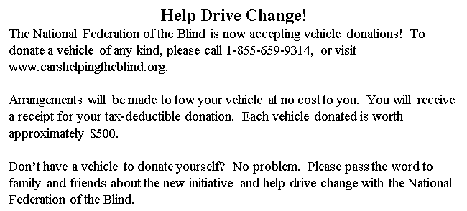
Ocean City is loaded with many fine restaurants and interesting attractions. If you wish to use paratransit transportation call 410.723.1606. Because you will be having such a grand time at our convention, you will not have time for any of them!

Chapters and Divisions of the National Federation
of the Blind of Maryland

At Large
ChapterMarguerite Woods, President, (443) 271-1668, mwoods719@gmail.com
Monthly meetings third Tuesday at 7:30 p.m. via phone (641) 715-3272 and access code is 720125

Baltimore County Chapter
Ruth Sager, President, (410) 602-9030, rsager78@gmail.com
Monthly meetings fourth Wednesday in Pikesville, MD

Central Maryland Chapter
Darlene Barrett, President, (410) 997-9664, chicagirl3@verizon.net
Monthly meetings first Tuesday in Columbia, MD

Eastern Shore Chapter
Patricia Behr, President, (410) 603-3857
Monthly meetings second Saturday in Salisbury, MD

Greater Baltimore Chapter
Ellen Ringlein, President, 443-516-7855, greaterbaltimore@nfbmd.org
Monthly meetings third Saturday in Baltimore, MD

Greater Carroll County Chapter
Brian Keseling, President, (410) 855-5605, bkmaverick@gmail.com
Meetings are the second Saturday in Westminster, MD

Greater Cumberland Chapter
Jean Faulkner, President, (301) 729-8942
Monthly meetings third Wednesday of the month in Cumberland, MD

Maryland Association of Blind Students
Ellana Crew, President, (443) 758-7211, mdabs@nfbmd.org
Holds periodic meetings throughout the year.

Maryland Association of Blind Merchants
Melba Taylor, President, (240) 381-1637, m.taylor@encoreassoc.com
Holds periodic meetings throughout the year.

Maryland Parents of Blind Children
Melissa Riccobono, President, (443) 708-3663, mdpobc@nfbmd.org
Holds a holiday party, family picnic and conducts at least one seminar during the year.

National Harbor Chapter
Michelle Clark, President, (301) 583-8585, mcikeyc@aol.com
Monthly meetings fourth Saturday in Suitland, MD

Senior Issues Division
Ruth Sager, President, (410) 602-9030, rsager78@gmail.com.
Holds periodic meetings throughout the year.

Sligo Creek Chapter
Debbie Brown, President, (301) 881-1892, Deborahb14@verizon.net
Monthly meetings second Saturday primarily in Silver Spring, MD

TLC Chapter
Scott White, (410) 452-7571, swhite@nfb.org
Meetings third Thursday in Towson, MD


The National Federation of the Blind has teamed up with GreenDrop to collect donations of clothing and household items. If you live in or near Laurel or College Park, Maryland, you can bring donations directly to Second Avenue stores for drop off. If you, or family or friends, live in Connecticut, the District of Columbia, Delaware, Maryland, New Jersey, New York, Pennsylvania, or Virginia, you can donate your unwanted items through drop-off locations or call for a pickup from your home or business. Your donation will help the blind live the life we want. For more information about the National Federation of the Blind GreenDrop program or to schedule a pickup of your unwanted items, visit www.nfbpickup.org, call 1-888-610-4NFB (4632), or email GreenDrop@nfb.org. You can also contact us if you would like to organize a household discards drive in your neighborhood, at your school, or where you work. When donating, please direct your donations specifically to the National Federation of the Blind.

Committees of the National Federation of the Blind of Maryland

Ambassadors Committee
Judy Rasmussen, Chairman

Anna Freysz Cable Award Committee
Debbie Brown, Chairman

Convention Child Care Committee
Melissa Riccobono, Chairman

Convention Registration Committee
Marie Marucci, Chairman

Deaf-Blind and Hearing Loss Issues Committee
Janice Toothman, Chairman

Distinguished Educator of Blind Children Award Committee
Sandy Bishop, Chairman

Door Prize Committee
Darlene Barrett, Chairman

Gold Cup Crab Race Committee
Rose Warner, Chairman

Hospitality Committee
Patty Ann Behr, Chairman

Jennifer Baker Award Committee
Susan Baker, Chairman

Kenneth Jernigan Award Committee
Dr. Marc Maurer, Chairman

Membership Committee
Ronza Othman, Chairman

Nomination Committee
Ellen Ringlein, Chairman

PAC Plan Committee
John G. Paré Jr., Chairman

Resolutions Committee
Jesse Hartle, Chairman

Scholarship Committee
Gabe Cazares, Chairman

National Funding Support Auction Committee
Michael Bullis, Chairman

Youth Activity Committee
Melissa Lomax, Chairman

Web Committee
Steve Brand, Chairman

NFB-NEWSLINE®

FREE SERVICE TO THOSE WHO CANNOT READ REGULAR NEWSPRINT!
Well over 300 NEWSPAPERS and MAGAZINES AVAILABLE
CALL TOLL FREE: 1-866-504-7300 for more information

Latest News: NFB-NEWSLINE® is now available on the iPhone!

Live the Life You Want with the KNFB Reader

Fast, Accurate, Efficient

With the KNFB Reader, you can read such printed items as credit card receipts, packaging labels, mail, product information, computer screens, and of course books and documents. Take a photo and the app reads the text aloud or publishes it in Braille if you have refreshable Braille display.
Learn more and purchase KNFB Reader for iPhone, Android, and Windows 10 devices at http://www.knfbreader.com

Stay Connected and Informed:

Please follow the National Federation of the Blind of Maryland on Twitter! Visit www.twitter.com/NFBMD to receive affiliate news and updates.

Friend the National Federation of the Blind of Maryland on Facebook! https://www.facebook.com/nationalfederationoftheblindofmaryland.

Stay connected with your fellow Maryland Federationists by joining our state email listserv. This list allows you to receive affiliate and national announcements, and also to start and participate in discussions regarding blindness and blindness issues. To sign up visit www.nfbnet.org, click on “join or drop NFB mailing lists,” and activate “NFBMD” link, and follow the instructions. Many of our local chapters now also have listserv. Talk to your chapter president to learn how to sign up so you don’t miss important information about chapter news and events.

Visit our website at www.nfbmd.org. Check out our blog for the President’s Messages. We welcome blogposts from all of our members. Be sure to check out the Blindness Resources link, and the Know Your Rights link, to keep up to date on important information. Be sure to download and print About NFBMD, in the About Us tab on www.nfbmd.org, for use at chapter outreach events.

BRAILLE SPECTATOR

The Braille Spectator is published for members of the National Federation of the Blind of Maryland and others who share an interest in the work of this organization. The Braille Spectator can be read on the web at www.nfbmd.org/newsletter or can be listened to on the local channel of NFB-Newsline.




We have been selected among:

The Best Lawyers in America
Maryland’s Top 50 “Super Lawyers”
The Daily Record’s Leaders in Law
Maryland’s Top 100 Women, as Fellows of the
American College of Trial Lawyers
Maryland Trial Lawyer of the Year

2018 NFB BELL GLENN DALE Promotes Independence

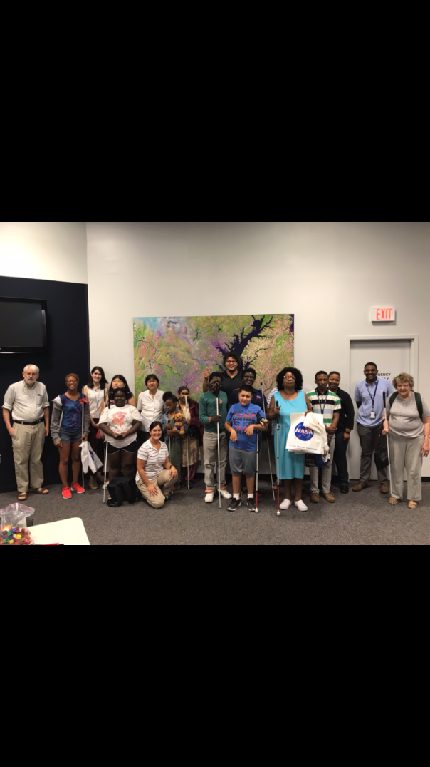
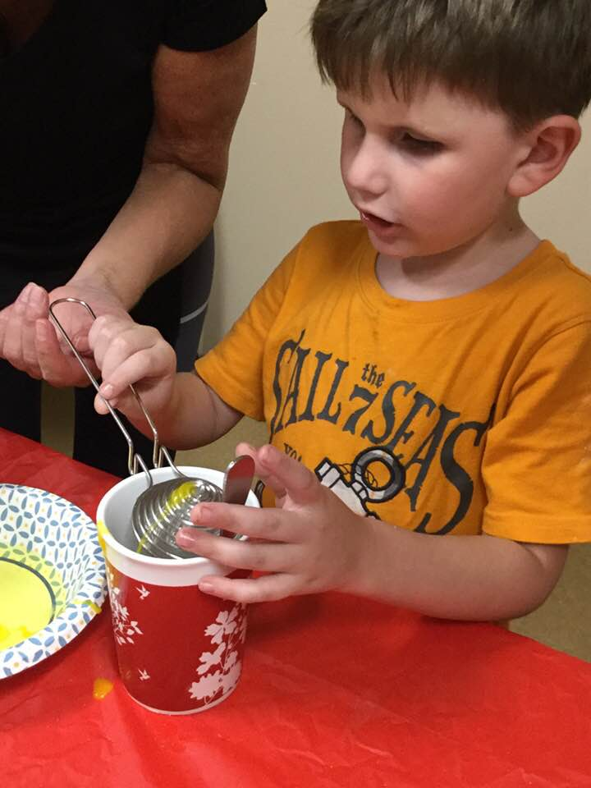
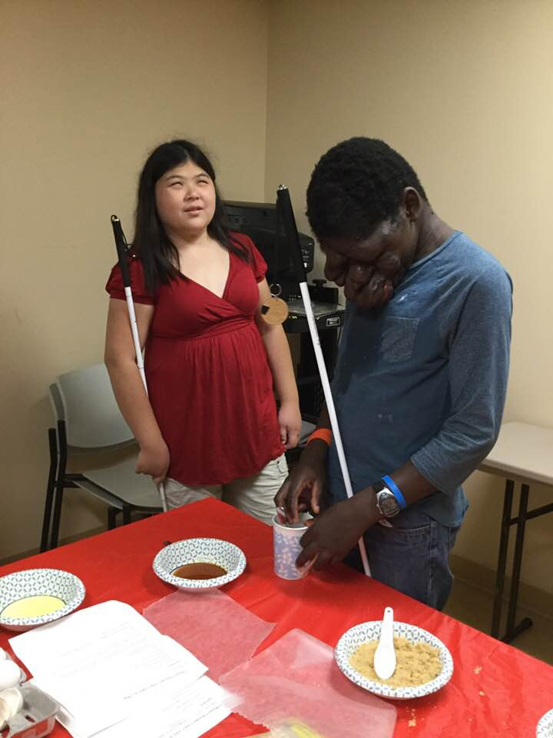
Expanding horizons while visiting NASA.
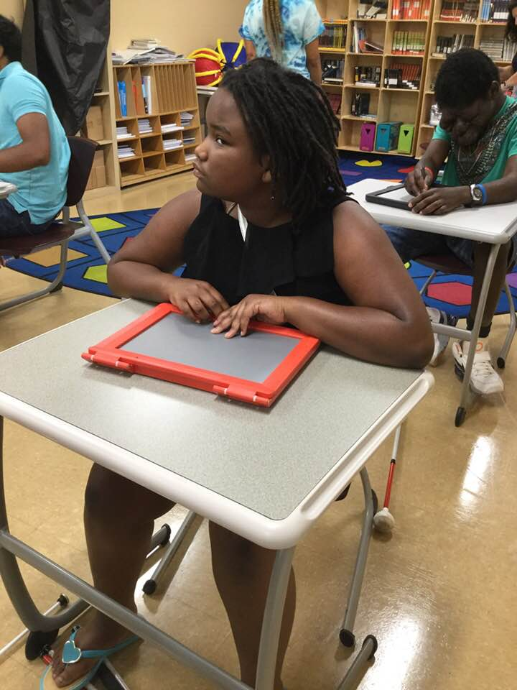
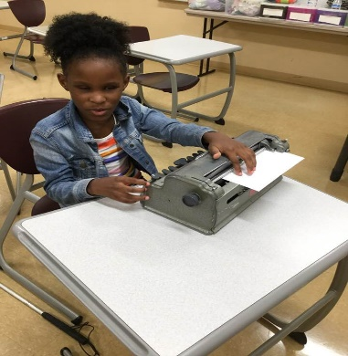
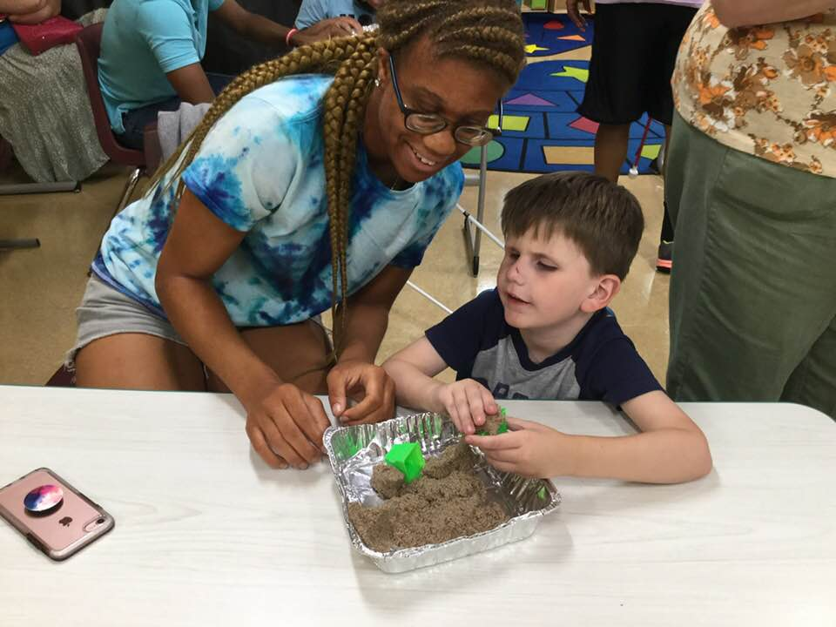
Reading Braille is an important part of every NFB BELL Academy.
Feeling what you draw on a Sketchpad enhances the experience.
Playing with sand indoors is fun!
Making great treats helps improve tactile skills.
EXPANDING OUR PROMINANCE IN MARYLAND
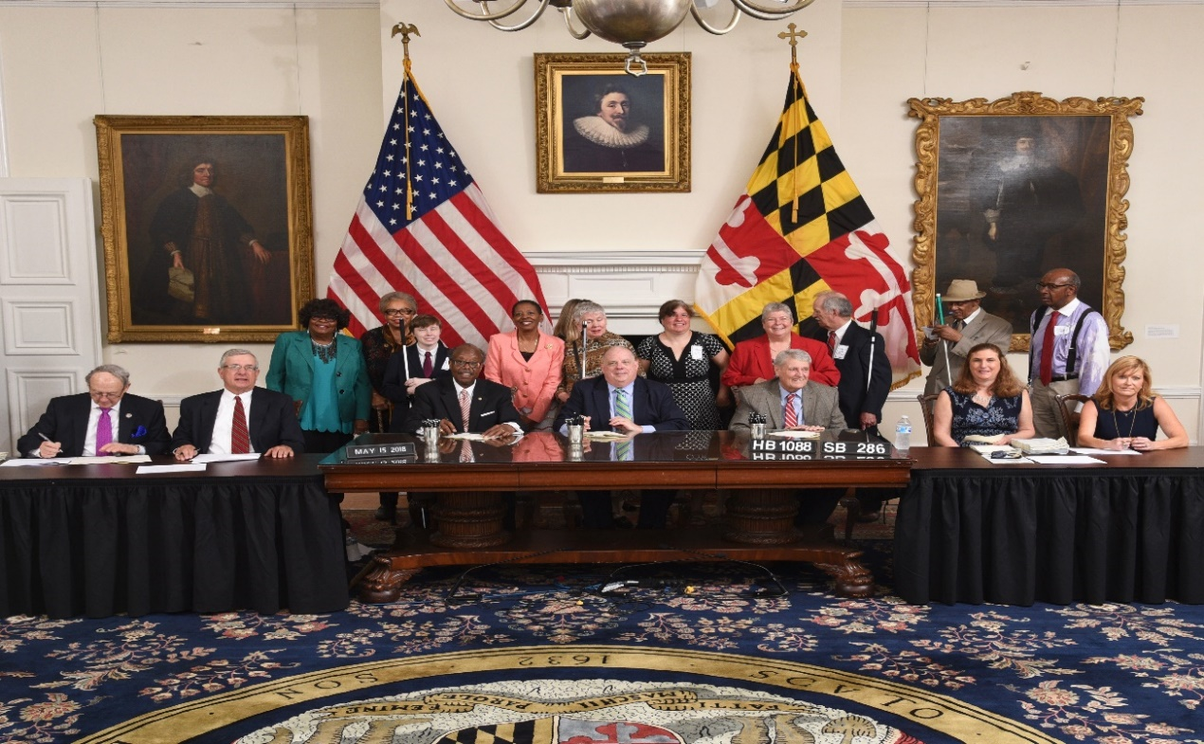

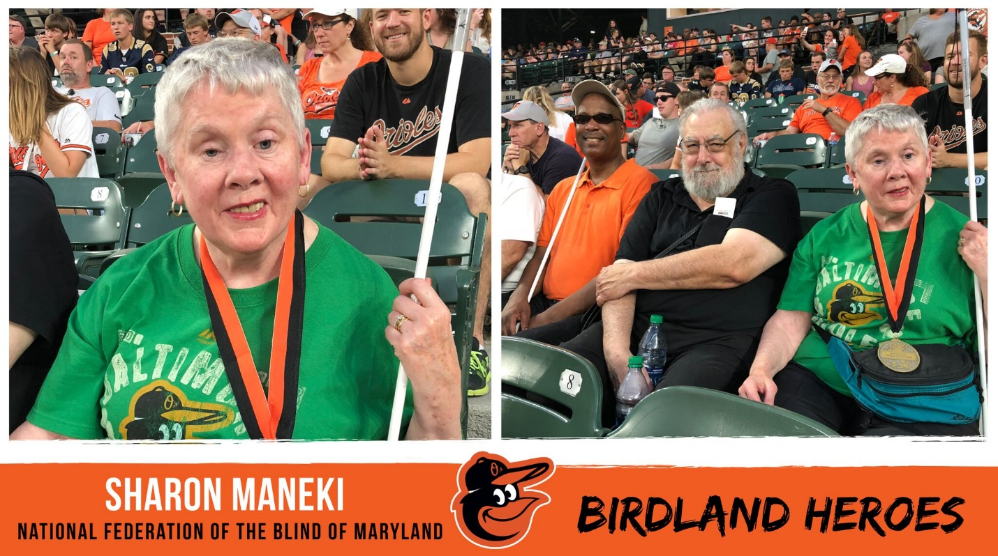
Sharon Maneki (shown on left) was recognized by the Baltimore Orioles with the Birdland Hero Community Service Award on June 29, 2018. Right photo shows Anil Lewis, Richard Scalzo and Sharon Maneki as they cheer the Orioles playing the L.A. Angels on June 29, 2018.
As Federationists and Sponsors Senator Joan Carter Conway and Delegate Bonnie Cullison looked on, Governor Hogan signed HB1088/SB286 into law on May 15, 2018. This law will establish a penalty for vendors who do not comply with accessibility requirements when doing business with state government.

2018 NFB BELL BALTIMORE
Builds Self Esteem and Confidence
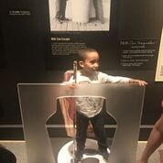
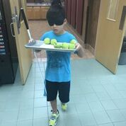
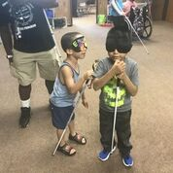
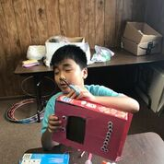
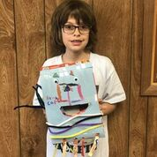
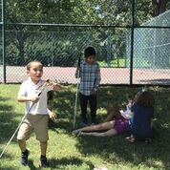
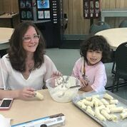
Fruit is good for you, especially when dipped in white chocolate.
Learning cane skills leads to greater independence.
Everyone needs recess!
Exploring the Harry Houdini Exhibit at the Jewish Museum of Maryland.
Using a cane while carrying a tray takes practice.

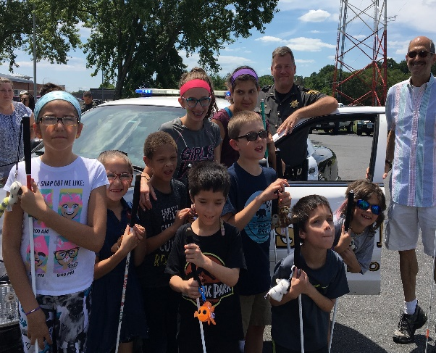
2018 NFB BELL SALISBURY Explores the Community
Students at work with their home-made Braille Buddies.
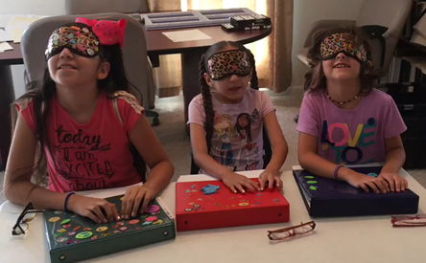
Decorating binders is fun and a good way to identify their own.
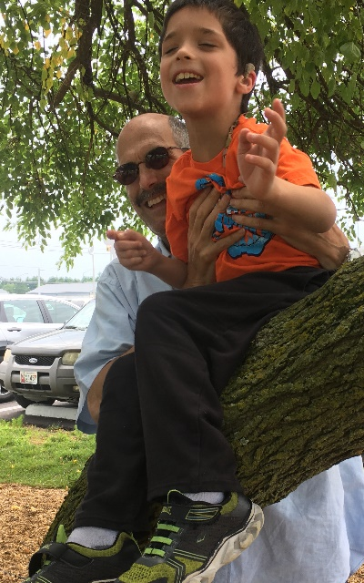
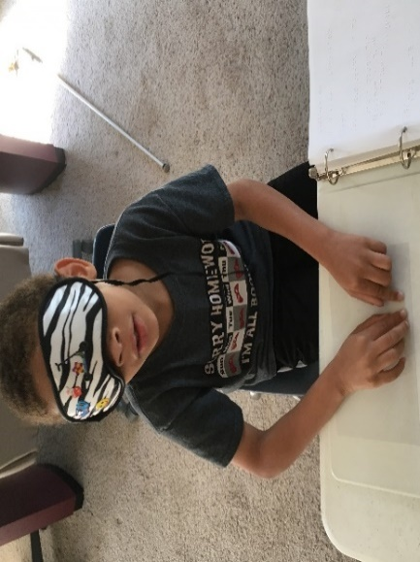
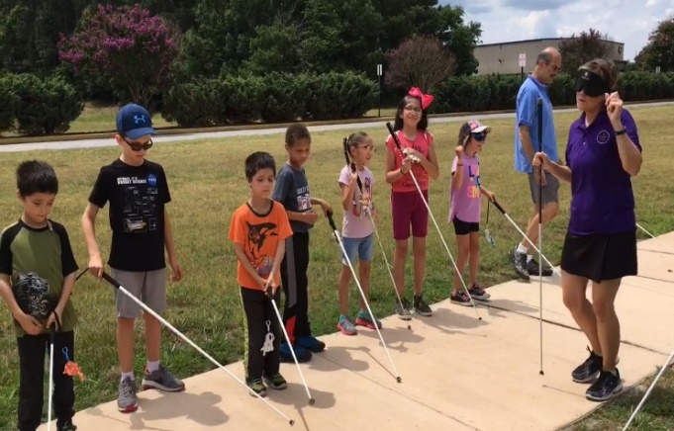
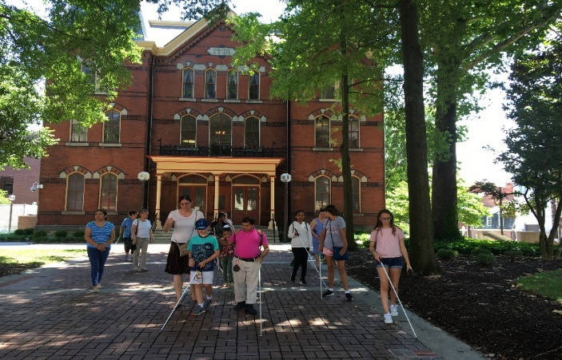
Learning about Law Enforcement at a visit to the Wicomico County Sheriff’s office.
Going on a field trip provides an added bonus of cane travel practice.
Getting a Braille letter in the mail adds to the excitement of BELL.
Climbing trees is just as fun for a blind child as it is for a sighted child.
Making friends with the Mayor of Salisbury at City Hall.

CONVENTION AGENDA

FRIDAY, NOVEMBER 9

8:00 a.m. – 5:00 p.m. Annual Conference for Parents and Teachers of Blind Children. How can all blind students participate in science? Do you need tips on how to help your child with math? Learn about the benefits of summer programs and how to help your child with other blindness skills. These are only some of the topics to be discussed at this seminar. Featured speakers at this seminar will be Dr. Cary Supalo, a pioneer blind chemist, Eric Guillory, Director of Youth Services at the Louisiana Center for the Blind, and Krystal Guillory, a long-time teacher of blind students.
Conference begins in the Delaware Room.
Conference registration begins promptly at 8:00 a.m.
See Parent Agenda for more information.

9:00 a.m. – 5:00 p.m. Teen/Tween Activities, Coordinator: Melissa Lomax, Director of Youth Services, Blind Industries and Services of Maryland, Baltimore, Maryland. Room 610.

11:30 a.m. Pick up box lunches in front of the Pennsylvania Room. Parents’ box lunches will be in the Delaware Room. You paid for and reserved a box lunch when you pre-registered.

12:00 Noon – 1:30 p.m. NFBMD Board of Directors Meeting. Everyone is encouraged to attend!
Pennsylvania Room

12:00 Noon – 6:00 p.m. Exhibits. Check out the latest offerings from a variety of companies and organizations that provide technology and services for the blind. Be sure to visit the AIRA booth so you can try it out. If you sign up at the booth you can use it for FREE for the whole weekend.
Maryland Room

1:40 p.m. – 2:40 p.m. Welcome to First-Time Convention Attendees.
Coordinator: Judy Rasmussen, Secretary, National Federation of the Blind of Maryland, Kensington, MD.
Pennsylvania Room

1:40 p.m. – 2:40 p.m. Resolutions Committee Meeting.
Jesse Hartle, Chairman, Resolutions Committee, Lutherville, MD.
Virginia Room

1:40 p.m. – 2:40 p.m. Deaf-Blind and Hearing Loss Issues Committee Meeting.
Share strategies and ideas to maintain independence. Anyone interested is invited to attend.
Janice Toothman, Chairman, Deaf-Blind and Hearing Loss Issues Committee, Bowie, MD.
Room 612

2:00 p.m. – 6:00 p.m. Convention Registration and Packet pick up.
Outside the Maryland/Virginia and Delaware rooms

2:40 p.m. – 3:40 p.m. Protecting the Rights of Guide Dog Users.
Room 612

2:40 p.m. – 4:00 p.m. Kernel Book Story Time. Learn about the NFB outlook on blindness through human-interest stories.
Facilitators: Maurice Peret, Coordinator of Career Mentoring Programs, National Federation of the Blind, Baltimore, MD and Lou Ann Blake, Assistant Director, Jernigan Institute, National Federation of the Blind, Baltimore, MD.
Pennsylvania Room

2:40 p.m. – 4:00 p.m. Have Cane Will Travel: How can GPS Apps and Hardware Help?
Karl Belanger, Access Technology Specialist, National Federation of the Blind, Baltimore, MD. Joel Zimba, Product Specialist, HumanWare USA, Baltimore, MD.
Virginia Room

4:00 p.m.– 5:00 p.m. How to Keep More of your Money for the Good Things in Life. Learn about changes to the Maryland income tax law and the benefits of an ABLE account.
Facilitators: Barry Hond, Accountant, Baltimore, MD; Albert Elia, ABLE Advisor, ABLE National Research Center, Washington, D.C.; Bette Ann Mobley, Director, Maryland ABLE, Baltimore, MD.
Pennsylvania Room

4:00 p.m.– 6:00 p.m. Let’s Play BINGO and Win Prizes! Sponsored by Blind Industries and Services of Maryland. Everyone is invited to attend!
Virginia Room

4:00 p.m. – 6:00 p.m. Maryland Association of Blind Students Annual Meeting.
Ellana Crew, President, Maryland Association of Blind Students, Baltimore, MD.
Room 612

6:00 p.m.– 8:00 p.m. Picnic and a Play. The Braille is Beautiful players will perform Santa Rides Again, an original play written by Jerry Whittle.
Debbie Brown, Play Director, Rockville, MD.
Pennsylvania Room

6:30 p.m. NFB BELL Academy Reunion.
Delaware Room

8:00 p.m. – 11:30p.m. NFB Spirit Night and Hockey “Try-Outs.” The Washington Wheelers blind hockey club will give hands-on demonstrations of hockey equipment to attendees 18 and over. You will have a chance to skate with the pros and slap some pucks! You may rent skates for $4, meet at the ice rink. Cheerleaders and spectators will gather in the area overlooking the ice rink. Enjoy snacks and fellowship. Wear your NFB swag and help cheer your fellow Federationists! Master of Ceremonies: Anil Lewis, Executive Director, NFB Jernigan Institute.

SATURDAY, NOVEMBER 10
7:00 a.m. – 8:30 a.m. Hospitality. Join us for continental breakfast.
Room 612

7:30 a.m. – 8:30 a.m. At Large Chapter Meeting.
Room 611

8:00 a.m. – 8:40 a.m. Registration and Packet-Pickup.
Outside Maryland/Virginia and Delaware rooms

8:30 a.m. – 10:00 p.m. Fun with Friends. Activities for children.
Washington Room

9:00 a.m. – 11:00 a.m. Hockey Tryouts for students under 18.
Ice-skating rink

SATURDAY MORNING SESSION

All general sessions will be held in the Maryland/Virginia Rooms.

8:40 a.m. Opening Ceremonies. Call to order and Invocation. An Eastern Shore Welcome.

8:55 a.m. Champion Braille Readers: Competing in the National Braille Challenge and in the National Braille Readers-are-Leaders Contest.

9:05 a.m. Ensuring our Future by Supporting our National Funds: White Cane, SUN, Kenneth Jernigan, and Jacobus tenBroek.
Dr. Marc Maurer, immediate Past President, National Federation of the Blind, Catonsville, MD.
Greetings from the National President, Mark Riccobono, National Federation of the Blind, Baltimore, MD.
Gold Cup Crab Race, Rose Warner, Ticket Agent, Baltimore, MD.

9:25 a.m. Raising Expectations Across America: A Report from the National Office.
Adelmo Vigil, Member, Board of Directors National Federation of the Blind; President NFB of New Mexico, Alamogordo, New Mexico.

9:55 a.m. Taking the Road Less Traveled in the National Federation of the Blind. Sharon Maneki, President, National Federation of the Blind of Maryland, Columbia, MD.

10:30 a.m. Get on the PAC Plan Today!
John Paré, Executive Director of Advocacy and Policy, National Federation of the Blind, Maryland PAC Plan Chairman, Baltimore, MD.

10:45 a.m. Rehabilitation and Employment: Keys to a Brighter Future.
Nikki Jackson, CORE (Comprehensive Orientation, Rehabilitation, and Empowerment) Manager, Blind Industries and Services of Maryland, Baltimore, MD.

11:00 a.m. When Will the Maryland State Board of Elections Restore the Secret Ballot to Disabled Voters?
David McManus, Chairman, Maryland State Board of Elections, Annapolis, MD.

11:15 a.m. Questions and Discussion.

11:35 a.m.The Blind Can Play Hockey, Too.
John Guzik, Player, Washington Wheelers.

11:50 a.m. Questions and Discussion.

12:00 Noon. Adjourn.

12:00 Noon -12:15 p.m. Convention Registration and Packet Pick-up.
Outside Maryland/Virginia and Delaware rooms

12:00 Noon -1:45 p.m. Luncheon - The Education of Blind or Visually Impaired Students. For parents and vision teachers.
Melissa Riccobono, President, Parents of Blind Children Division, National Federation of the Blind of Maryland, Baltimore, MD.
Pennsylvania Room

12:00 Noon -1:45 p.m. Luncheon - Reclaiming Independence after Vision Loss. For seniors and others facing vision loss.
Ruth Sager, President, Senior Issues Division, National Federation of the Blind of Maryland, Baltimore, MD.
Delaware Room

12:00 Noon -1:45 p.m. Luncheon – The Benefits of Self Employment and Entrepreneurship. For blind and visually impaired self-starters.
Melba Taylor, President, Maryland Association of Blind Merchants, Bowie, MD.
Seasons Restaurant

1:20 p.m. - 2:00 p.m. Banquet Exchange.
Outside Virginia Room

SATURDAY AFTERNOON SESSION
2:00 p.m. Call to Order.

2:05 p.m. Predicting the Next 50 Years at MSLBPH: More Books, More Technology, More Programs.
Leslie Bowman, Director, Maryland State Library for the Blind and Physically Handicapped, Baltimore, MD.

2:20 p.m. Questions and Discussion.

2:25 p.m. New Leadership Means New Opportunities.
W. Robert Hair, Superintendent and CEO, Maryland School for the Blind, Baltimore, MD.

2:40 p.m. Questions and Discussion.

2:50 p.m. Expanding a Core NFB Value: Mentoring.
Maurice Peret, Coordinator of Career Mentoring Programs, National Federation of the Blind, Baltimore, MD.

3:00 p.m. Developing Expertise in Blindness to Meet the Present and Future Needs of Blind Consumers.
Toni March, Director, Office of Blindness and Vision Services, Maryland Division of Rehabilitation Services (DORS), Baltimore, MD.

3:15 p.m. More Opportunities Through Leadership and Philosophy.
Anil Lewis, Executive Director, NFB Jernigan Institute; Chairman, Maryland State Rehabilitation Council, Baltimore, MD.

3:25 p.m. Questions and Discussion.

3:30 p.m. Living the Lives They Want: How Do Blind and Sighted Spouses Make It Work?
Adelmo and Soledad Vigil, Alamogordo, New Mexico; Eric and Krystal Guillory, Ruston, LA; Ken and Ellen Ringlein, Baltimore, MD; Aaron Carpenter and Melissa Sheeder, Baltimore, MD.

4:05 p.m. Questions and Discussion.

4:10 p.m. Eliminating Accessibility Barriers in Maryland State Government and Beyond.
Carol Beatty, Secretary, Maryland Department of Disabilities (MDOD), Baltimore, MD.

4:20 p.m. Questions and Discussion.

4:25 p.m. The Future is Ours.
Mark Riccobono, President, National Federation of the Blind, Baltimore, MD.
Ronza Othman, Member, Board of Directors, National Federation of the Blind of Maryland, Baltimore, MD.
Tarik Williams, Member, Board of Directors, National Association of Blind Students, Tucson, AZ.
Marguerite Woods, Member, Board of Directors, National Federation of the Blind of Maryland; President, National Federation of the Blind of Maryland At Large Chapter, Baltimore, MD.

5:00 p.m. Adjourn.

6:00 p.m. Reception and Cash Bar.
Carousel Atrium

7:00 p.m. 52nd Annual Convention Banquet.
Master of Ceremonies: Mark Riccobono, President, National Federation of the Blind, Baltimore, MD.
Keynote Banquet Address: Adelmo Vigil, Member, Board of Directors, National Federation of the Blind; President, NFB of New Mexico, Alamogordo, NM.
Scholarships and Awards.
Pennsylvania Room

Immediately after the banquet. Maryland Gold Cup Crab Race.
Race Callers, Sharon Maneki and Rose Warner.

SUNDAY, NOVEMBER 11
7:00 a.m. -8:50 a.m. Convention Hospitality.
Room 612

7:30 a.m. – 8:30 a.m. Maryland Parents of Blind Children Board Meeting.
Melissa Riccobono, President, Baltimore, MD.
Washington Room

7:30 a.m. – 9:00 a.m. Luggage Collection (for bus passengers only).
Delaware Room

8:00 a.m. – 8:30 a.m. Nonsectarian Devotions.
Lloyd and Judy Rasmussen, Sligo Creek Chapter, National Federation of the Blind of Maryland, Kensington, MD.
Maryland/Virginia Rooms

8:30 a.m. – 8:50 a.m. NFB BELL Academy Participants Final Rehearsal.
Washington Room

8:30 a.m. – 8:50 a.m. Convention Registration and Packet Pick up.
Outside Maryland/Virginia Rooms

SUNDAY MORNING SESSION
9:00 a.m. Call to order and Invocation.

9:05 a.m. Designing a Brighter Future through the NFB Braille Enrichment Literacy and Learning (BELL) Academy.
Melissa Riccobono, NFB BELL Academy Coordinator for Maryland, Baltimore, MD.
Student presentations and introduction of volunteers.

9:20 a.m. Recognizing Our Veterans: The Human Side of Military Service.
Panel moderator Ed Jackson Member of the Board of Directors, Greater Baltimore Chapter of the National Federation of the Blind of Maryland, Baltimore, MD. Other participants to be announced.

9:35 a.m. Investing in Future Leaders: Youth Summer Programs and Convention Activities.
Melissa Lomax, Director of Youth Services, Blind Industries and Services of Maryland, Baltimore, MD.
Youth speakers to be announced.

9:50 a.m. Competing on Terms of Equality: The Benefits of AIRA .
Ronza Othman, Acting Director, EEO Compliance Group, Office of Equal Opportunity and Civil Rights, Centers for Medicare & Medicaid Services, Baltimore, MD.
Paul Schroeder, Vice President of Public Policy and Strategy, AIRA Tech Corp., Washington D.C.

10:10 a.m. . Questions and discussion.

10:15 a.m. Turning Dreams into Reality: My Journey as a Pioneer Chemist.
Dr. Cary Supalo, Research Developer, Educational Testing Service (ETS), Princeton, NJ.

10:30 a.m. Questions and discussion.

10:35 a.m. Can I Have an ABLE Account if I am Forty-Fifty-Sixty Years Old?
Albert Elia, ABLE Advisor, ABLE National Research Center, Washington, D.C.

10:50 a.m. Questions and discussion.

10:55 a.m. Affiliate Elections.

11:20 a.m. Resolutions and Business Meeting.

12:00 Noon Adjourn.

A CLOSING MESSAGE
On behalf of the officers and Board of Directors, I take this opportunity to thank all Federationists and friends for your generous donations of funds, goods and services. We had a most successful year and a super convention because of your help! Sharon Maneki, President

Free AIRA Site Access at National Federation of the Blind of Maryland Convention

The National Federation of the Blind has partnered with AIRA to provide free AIRA Site Access to NFB members during our 2018 state convention. AIRA subscribers who are National Federation of the Blind members can use the service at our convention for free without having minutes deducted from their plans. In addition, those interested in AIRA have the unique opportunity to try out the service for free while at our convention. AIRA may be used at the Carousel Hotel and at the Ocean Square Shopping Center at 11805 Coastal Hwy, Ocean City, MD 21842 which contains a Dunkin Donuts, Food Lion, as well as other shops and eateries.

AIRA allows blind individuals to connect via live video to a trained agent through a mobile app or wearable glasses to get real-time visual information or assistance. Learn more about AIRA and special pricing available for NFB members at go.aira.io/NFB.

How it Works
Before you head to convention or as soon as you get there, download the free AIRA app from the App Store, and create a guest account if you are not already an AIRA subscriber. Also, make sure your phone’s GPS feature is enabled. When you enter the convention Site Access location, your phone will receive a notification letting you know that the space you are in is part of the AIRA Network. When you connect with an agent, he or she will also confirm that you are now covered by the network, and no minutes will be deducted from your account.

When you leave or enter convention areas that are covered by the Site Access network, you will be informed by the AIRA agent.
To learn more about AIRA and the special plan available exclusively to NFB members, visit go.aira.io/NFB.



BRAILLE IS BEAUTIFUL

Na na na-na na na, na na na-na nah.
Na na na na nah, na na na-na nah.

Chorus:
Go on and live your life,
Don't need a bit of sight.
In the end you'll find
Braille is beautiful.
Put your fingers on the page.
Tell your friends it's all the rage.
It's all gonna be OK, yeah
Braille is beautiful!

Na na na na na na, Na na na-na nah Braille is beautiful!
Na na na-na nah, Na na na-na nah.

Verse
Louis Braille was his name. Slate 'n' stylus was his game.
They tried to stop him, but we adopted the code that paved the way.

Chorus

Na na na na na na, Na na na-na nah Braille is beautiful!
Na na na-na nah, Na na na-na nah.
Na na na-na nah, Na na na-na nah.

BRAILLE IS BEAUTIFUL!

We Extend Profuse Thanks to the Following Convention Sponsors:
Blind Industries and Services of Maryland, Title Sponsor
Sprint, Independence Sponsor
Brown, Goldstein and Levy LLP, Equality Sponsor
ES&S, Equality Sponsor
Friends of the Maryland State Library for the Blind and Physically Handicapped, Opportunity Sponsor
Maryland Technology Assistance Program, Opportunity Sponsor

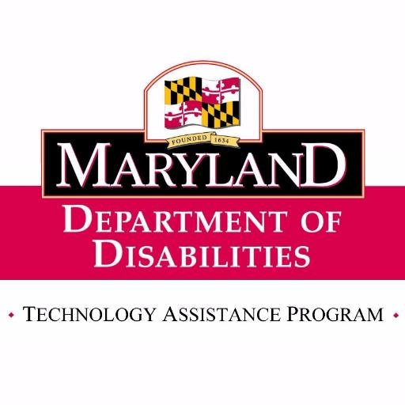
Maryland Technology Assistance Program
The Maryland Technology Assistance Program (MDTAP) is a program of the Maryland Department of Disabilities. Our mission is to enhance the lives of all Marylanders with disabilities, older Marylanders, and their families by helping support access to assistive technology (AT) devices and services.​​

For information about obtaining loans and other MDTAP services, go to www.mdtap.org.

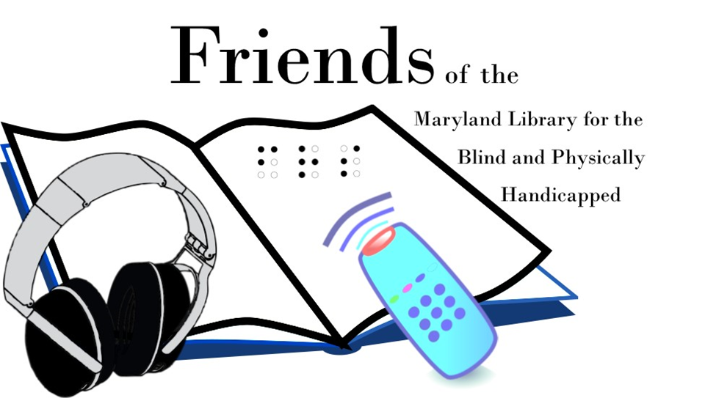
The Maryland State Library for the Blind and Physically Handicapped is committed to Making Maryland Accessible by providing reading materials in Braille, Large Print, and digital formats. As a Network Library of the National Library Service and a division of the Maryland State Library, LBPH strives to be a cornerstone of the blind community through partnerships, outreach, and advocacy. For information on accessible reading material, please call 410-230-2424. For more information on outreach and programming opportunities, please call 410-230-2430. Visit our Facebook Page: www.facebook.com/mdlbph or follow us on Twitter @md_lpbh.


Sprint Vision:
Putting the power
of independence
in your hand
Delivers user-friendly accessible devices, offers affordable plans with extraordinary customer service.
 Promotional service plans
 Free directory assistance
 Free KNFB Reader Enterprise*
 Accessible website:
sprint.com/vision
 Sprint Accessibility Care:
- 855-885-7568
- accessibility@sprint.com

* App with new line activation or eligible upgrade.
Offers and coverage not available everywhere or for all phones/networks. Restrictions apply. See www.sprint.com/vision for details. © 2018 Sprint. All rights reserved.

