NATIONAL FEDERATION OF THE BLIND OF MARYLAND

ANNUAL STATE CONVENTION, FEBRUARY 13-16, 2025

Lead, Love, Live

MARYLAND ORGANIZATION OF PARENTS OF BLIND CHILDREN

ANNUAL CONFERENCE AND LUNCHEON

Support, Prepare, Release

Board of Directors
President, Garret Mooney
First-Vice President, Teresa Graham
Second-Vice President, Christine Day
Secretary, Melissa Sheeder
Treasurer, Stephanie Cascone
Board Member, Brittany Bomboy
Board Member, Monica Rao
Board Member, Domonique Sanders
Board Member, Melissa Riccobono
Board Member, Joey Breiannis

Welcome
Thank you for joining us for our annual conference for parents and educators! We have a very exciting weekend planned for you. Do not forget to sign up your children for day care. Please contact Garret Mooney for details: (480) 433-8003.

Registration and Membership
You can register for our seminar and business meeting by visiting the link Below:

https://docs.google.com/forms/d/1PQS5DuWZWGOgKWmLMdkF2boWZCPIVvkXx9U6atVOPnE/edit

Also, do not forget to pay your membership dues. Dues cost $15 and include the whole family. You can pay your membership dues by visiting the link below:

https://www.nfbmd.org/join

Additional Activities

White Cane Walk
This year parents can sign their child up for a one-on-one lesson with a certified orientation and mobility instructor. Parents can even sign up for their own lesson to learn the basics of cane travel so they can reenforce good habits at home. Lessons will last for approximately 30 minutes. Sign up now:
https://docs.google.com/forms/d/e/1FAIpQLSeXdrklbIFOlSj_1IyBFBKs5WdvgMV3EfVdxvsG9ECB4E6GgQ/viewform?usp=sf_link

Child Care/Teens and Tweens
This year we will have childcare and a teens and tweens program. Child care is for ages six weeks to 10 years-old. Teens and tweens is for children from 11 years-old to 17 years-old. We understand there are exceptions to these requirements, and we will evaluate those exceptions on a case-by-case basis. To register your child please fill out the form at the below link:
https://docs.google.com/forms/d/e/1FAIpQLScdSj1DKnmzEQZjauOLIi84cy3C-qctQPkMqUgk_buSfY7v8w/viewform?usp=sf_link

Quick Access QR Code
Use the following QR Code to easily Access the above links:

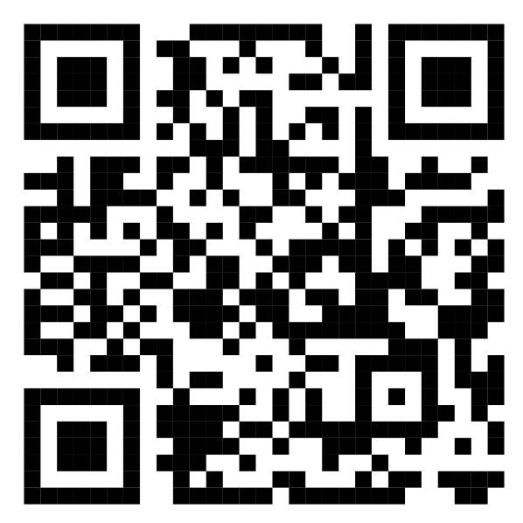

SCHEDULE FOR FRIDAY FEBRUARY 14, 2024
Annual Conference for Parents and Teachers of Blind Children
Support, Prepare, Release
Location: Seaside 1 & 2

11:00 AM to 5:00 PM Annual Conference for Parents and Teachers of Blind Children

10:30 AM—Pre-Registration
Participants can come to our seminar before it starts and register for our event. Parents are also encouraged to network with others. Families can come speak with us about IEPs, technology, and other issues of concern.

11:00 AM—Opening Remarks and Board Introductions
Garret Mooney, President Maryland Organization of Parents of Blind Children

11:15 AM—Advocating, learning, and enforcing the Law
Garret Mooney, president Maryland Organization of Parents of Blind Children

12:00 PM—Lunch
We will have box lunches brought to our meeting for those who purchased a box lunch.

12:45 PM—Advocating, Learning, and Enforcing the Law
Garret Mooney, president Maryland Organization of Parents of Blind Children

1:30 PM—Teaching, Providing, and using Technology at Home and in the classroom
Carley Mullin, CM Training Services L.L.C

2:15 PM—Embracing, Understanding, and Touring Resources for Our Children
Melisa Riccobono, Board Member Maryland Organization of Parents for Blind Children

3:30 PM—Embolden, Coaching, and Liberating Our Children
Marisol Carmona, Program Specialist Perkins transitional Center

4:15 PM—Model, Care, Exhale
Nadia Graham, Vice-president Maryland Association of Blind Students
Tim Olukanni, President Georgia Association of Blind Students
Emily Smith, Braille Instructor Blind Industries and services for Maryland

4:45 PM—Trail blaze, Family, and Exist with the NFB
Teresa Graham, First-Vice President Maryland Organization of Parents of Blind Children
Derrick Day, Member National Federation of the Blind of Maryland
Norma Crosby, Board Member National Federation of the Blind

7:00 PM—Annual Networking Social
Participants of the Parents and Educators Seminar are invited to come play games, network, and enjoy light snacks.

SCHEDULE FOR Saturday FEBRUARY 15
Luncheon: The Education of Blind and Low-Vision Students
Support, Prepare, Release
Location: Atlantic 2A

We are so excited to have our Luncheon! Please enjoy the presentations and do not forget to post on social media about your favorite convention moments.

12:15 PM to 1:45 PM—Luncheon: The Education of Blind and Low-Vision Students

12:15 PM—Opening Remarks
Garret Mooney, President Maryland Organizations of Parents of Blind Children
Ronza Othman, President National Federation of the Blind of Maryland

12:25 PM—Support, Prepare, Release: a Keynote Address
Marisol Carmona, Program Specialist Perkins Transitional Center

12:50 PM—Presentation of Educator of the Year
Teresa Graham, First-Vice President Maryland Organization of Parents of Blind Children and Chair of Educator of the Year Committee

1:15 PM—Treasurer Report
Stephanie Cascone, Treasurer Maryland Organization of Parents of Blind Children
1:25 PM—Presidential Report
Garret Mooney, Maryland Organization of Parents of Blind Children
1:35 PM—Elections
Sharon Maneki, Chair of Nominating Committee
1:45 PM—Adjournment

Thank you to all our speakers and guests who participated in our seminar and business meeting from around the state of Maryland and the country. Thank you to all of the volunteers who helped run the seminar. It could not have been a success without you.

It was such a wonderful opportunity to meet new friends and catch up with old ones. We wish everyone safe travel home.

Board of Directors
Maryland Organization of Parents of Blind Children

