National Federation of the Blind of Maryland 2026 Convention Agenda

Pilots of Progress:
60 Years Strong,
Soaring to New Horizons!


Thursday, February 12 to Sunday, February 15

Image description: A small white plane with red and gold details angled as if taking off with President Othman seated in the cockpit. A small round image to the left shows President Othman sitting inside the plane with her hands on the control stick. The background is a soft sky with clouds.

Host Chapter welcome you to the 60th Annual Convention of the National Federation of the Blind of Maryland

Ronza Othman, President
National Federation of the Blind of Maryland

Justin Young, Chairperson
Convention Logistics Committee

Heather Davis, President
Eastern Shore Chapter

Welcome

Welcome to the 60th annual convention of the National Federation of the Blind of Maryland! This year’s convention will be held in Ocean City at the Ashore Resort and Beach Club.

Ashore Resort and Beach Club
10100 Coastal Highway, Ocean City, MD 21842
410-524-3535

A detailed description of the layout of the hotel can be found later in this agenda. When you check into the hotel, you will be asked to confirm your departure date. If you decide to leave earlier than the departure date you confirm when you check in, there may be an additional fee. You may be asked to provide proof of convention registration to receive the convention hotel rate.

Special Information for First-Time Attendees
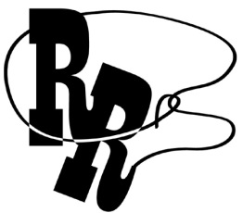
All first-time convention attendees are cordially invited to attend a First-Timers Orientation from 8 to 9:30 p.m. on Wednesday, February 4. The Ambassadors Committee will walk you through the events that will take place throughout the weekend, explain processes such as door prizes and voting, as well as make sure every first-time convention attendee is matched with a mentor. This orientation will be held virtually, the codes to join via web conference or via conference call are below.
Zoom Meeting ID: 624 813 8327
One-Number Conference Call: 339-209-4083

Diversity, Equity, Inclusion, and Social Conduct
We are committed to providing a safe and harassment-free environment for everyone. Thank you for cultivating an atmosphere in which participants from diverse backgrounds can learn, network, and share with each other in an environment of mutual respect. We are committed to diversity, equity, inclusion, and the free expression of ideas. These principles have been outlined in our code of conduct, which can be found at
NFB.org/About-Us/History-and-Governance/Code-Conduct.
We recognize a shared responsibility to create and uphold an atmosphere that benefits everyone. Prohibited behaviors include harassment, unwelcome sexual attention, and inappropriate use of the NFBMD convention space and platforms. Prohibited behavior or misuse of our space and platforms will not be tolerated and may result in removal from the convention and/or other consequences.
For assistance, or to report an incident at the convention,
please call 585-770-4073 or
email convention@nfbmd.org for immediate attention.
Formal reports can be submitted to the NFB national office at: NFB.org/About-Us/History-and-Governance/Code-Conduct/
Report-Form
All formal reports will be thoroughly investigated according to the
code of conduct. We thank you for contributing to the integrity
of our community and the high expectations we strive to maintain.

Packet Pickup, Onsite Registration, and Virtual Experience Registration

Packet Pickup
Packet Pickup is available for those who preregistered online prior to the convention. Attendees are encouraged to preregister to take advantage of discounted registration, meals, and transportation prices. This year, those who preregistered with Blind Industries and Services of Maryland (BISM), our Title sponsor, have separate designated packet pickup times and locations.

Packet pickup will be open at the below days, times, and locations:
- Preregistered but not through BISM – Grand Foyer (Main Level outside of Tideline A and Tideline B):
  - Thursday, February 12 from 5:30 – 7 p.m.
  - Friday, February 13 from 1 – 6 p.m.
  - Saturday, February 14 from 7:45 – 8:25 a.m. and 11:45 a.m. – 12:15 p.m.
  - Sunday, February 15 from 8:30 – 8:45 a.m.
- Preregistered through BISM – Terrace Lobby (Terrace Level outside of the Atlantic ballrooms):
  - Thursday, February 12 from 5:30 – 7 p.m.
  - Friday, February 13 from 1 – 3:30 p.m.

Onsite Registration
Those who did not preregister prior to the convention may visit Onsite Registration. Onsite registration is located in the Grand Foyer (Main Level outside of Tideline A and Tideline B). We accept Zelle, cash, check, credit card, or PayPal.

Onsite Registration will be open at the below days and times:
- Friday, February 13 from 1 – 6 p.m.
- Saturday, February 14 from 7:45 – 8:15 a.m. and 11:45 a.m. – 12:15 p.m.
- Sunday, February 15 from 8:15 – 8:45 a.m.

Convention registration is a requirement for voting, door prize eligibility, and other convention activities. All registrants will receive wrist bands, which will indicate voting eligibility. Additionally, discounted rates for hotel rooms are contingent on proof of registration.

Virtual Experience Registration
Registration for the NFBMD Convention Virtual Experience will remain open through the convention. Individuals may register for the virtual experience by visiting https://nfbmd.org/convention. Virtual experience registration enables participants to win door prizes, participate in the Bake & Experience Auction, and participate in the Time of Sharing. Participants will be able to virtually attend the board meeting, resolutions committee Meeting, Dinner & a Play, all general sessions, and the banquet. Virtual Experience participants will not be able to vote or speak on the floor.

Fun with Friends: Convention Childcare Activities
All childcare (for children ages 6 weeks to 9 years) will take place in Seaside 6 on the Terrace Level (second floor). Hours are: Friday 8:30 a.m. to 5:15 p.m. and 7:15 – 9:45 p.m.; Saturday 8:15 a.m. to 5:15 p.m., and 6:45 to 10:15 p.m., or at conclusion of the banquet, whichever is earlier; and Sunday 8:45 a.m. to 1:15 p.m. or at adjournment, whichever is earlier (lunch and dinner will be provided Friday and Saturday). Contact Garret Mooney at james.garret.mooney@gmail.com for details.

Exhibit Hall
The exhibit hall is located in Atlantic 1 on the Terrace Level. The exhibit hall will operate on Friday from 11 a.m. to 6 p.m.

Special Attention Items
- Banquet tickets may be purchased for $75 at the onsite registration area. We will accept Zelle, cash, checks, credit cards, and PayPal. No tickets will be available after 12:15 p.m. on Saturday. On the evening of the banquet, tickets will be required to enter the ballroom and will be collected at the tables. Anyone who pre-registered but who has not picked up their banquet tickets by 12:15 p.m. on Saturday will forfeit them and will not receive a refund.

- You may make arrangements to reserve a specific banquet seat for yourself or for a group of up to 10 people at the banquet ticket exchange table. The banquet ticket exchange table will open on Saturday, February 14 from 1:20 – 1:50 p.m. and is located in the Grand Foyer, on the Main Level, outside Tideline A and Tideline B. Please be sure to indicate whether you purchased a vegetarian meal and any previously requested dietary needs when exchanging your tickets.

- Individuals with dietary restrictions must submit those requests in advance, as such meals must often be ordered and/or prepared off-site. Requests related to dietary restrictions should be sent to Convention@nfbmd.org by February 1, 2026.
- Requests for reasonable accommodations — other than Braille and large print agendas, which will be available for all — must be submitted in advance, as such accommodations often require advanced arrangements. Requests for accommodations should be sent to Convention@nfbmd.org by February 1, 2026.
- All business will be suspended during the Presidential Report.

- The host chapter will provide hospitality on Friday, Saturday, and Sunday morning in Cabana rooms off the Dune Deck from 7 – 8:30 a.m.

- Teens and tweens will have programming throughout the convention. Some of this programming will take place in Cabana rooms off the Dune Deck. For more information and specific schedules, contact Garret Mooney at James.Garret.Mooney@gmail.com.

- General sessions will be in Tideline A on the Main Level.

- The banquet will be in Atlantic Ballroom 1 and 2 on the Terrace Level.
- Boxed lunches will be resold if not picked up by 12:30 p.m. on Friday. Those interested in boxed lunches on Friday should visit the Terrace Lobby. Those who fail to pick up their boxed lunches by
12:30 p.m. on Friday will forfeit them and will not receive a refund.
- Tickets for other meals may be purchased on a first-come, first-serve basis from the registration table. The costs are:
  - Dinner and a Play: $38
  - Leadership Development & Networking Breakfast (all welcome): $43
  - Senior Issues Luncheon: $43
  - Parents Luncheon: $43
  - Students Luncheon: $43
  - Banquet: $75
  - Training Center Networking & Alumni Breakfast: $43

- All purchases are final and no refunds are available.

- Juhi Narula and Qualik Ford are the co-chairs of the Door Prize Committee. Please turn in your door prizes to Juhi and/or Qualik as soon as possible. Those attending in person and via the Virtual Experience are eligible to win door prizes. You must be registered for the convention and be present when your name is called in order to win a door prize. Door prizes will be awarded during the general sessions on Friday, Saturday, and Sunday and during the convention banquet.
- Joel Zimba and Erin Zobell are the co-chairs of the National Funding Support Committee, which manages our Bake and Experience Auction. Please consider bringing baked goods and donating experiences such as dinners, cooking lessons, etc., for this auction. Please email Convention@nfbmd.org by February 1, 2026 to provide information about your donation.

- All tabs related to the Bake and Experience Auction must be cashed out prior to adjournment on Sunday. We accept Zelle, cash, checks, credit cards, and PayPal. All purchases are final. Anyone who bids on and wins an auction item and fails to pay for their item prior to adjournment will be banned from bidding in the auction in the future.

- The Student Division will host a fire sale for individually wrapped baked items, e.g., single cupcakes, brownies, and cookies.
- We will have a cane walk with individualized cane travel instruction by a NOMC by appointment only. To reserve a slot for your child or for yourself, please contact Garret Mooney at james.garret.mooney@gmail.com.
- On Sunday, you must check out of your room before 11 a.m. Please note that the convention is not scheduled to adjourn until 1 p.m. After check-out, you may store your luggage by dropping it off at Seaside 5 on the Terrace Level between 7:30 and 9 a.m., Sunday. Please be sure your luggage is clearly labeled with your name, address, and telephone number. All luggage for those not using NFBMD transportation must be picked up by 1:15 p.m. or 15 minutes after adjournment, whichever is earlier.

- If you are leaving the hotel on an NFB of Maryland bus, please bring your luggage to Seaside 5 on the Terrace Level between 7:30 and 9 a.m. on Sunday. Your luggage will be tagged and held, and then loaded onto the buses at 1 p.m. Please be sure your luggage is clearly labeled with your name, address, and telephone number. Please identify when checking in your luggage if you are assigned to the New Carrollton Bus, Baltimore Bus 1, or Baltimore Bus 2.
- There are two guide dog relief areas. The first is located just outside Tideline A and Tideline B on the Main Level (outside of general session). The second is located outside the Dune Deck near the Cabana sleeping room area on the Terrace Level just beyond the Tap Room (bar); this guide dog relief area is down some steps on the beach side of the hotel, so those needing an accessible guide dog relief area will want to use the one adjacent to Tideline A and B.

Organization Information
National Federation of the Blind of Maryland
1800 Johnson Street, Suite N1, Baltimore, MD 21230
443-426-4110; President@nfbmd.org

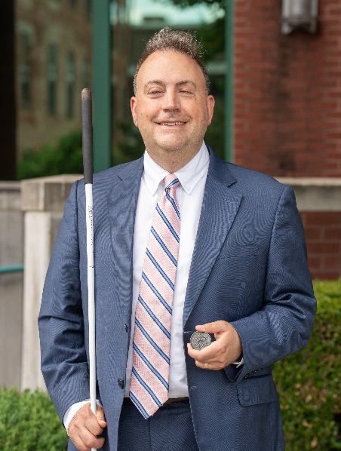 | 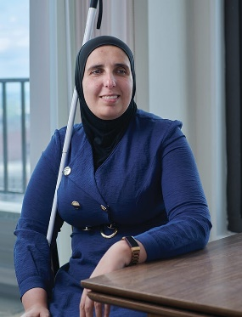
Image: Mark Riccobono  President  National Federation of the Blind | Image: Ronza Othman  President  National Federation of the Blind  of Maryland

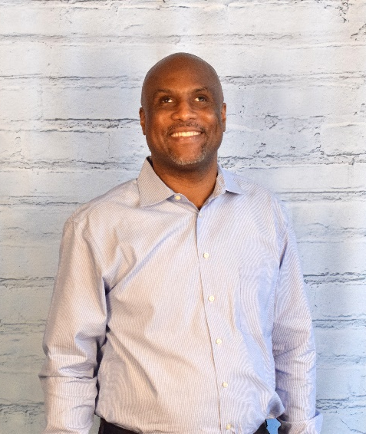
Image: Shawn Callaway
National Representative
Board Member, National Federation of the Blind;
President, National Federation of the Blind of the District of Columbia

Officers:

Ronza Othman, President, Baltimore
Deborah Brown, First Vice President, Rockville
Christopher Danielsen, Second Vice President, Baltimore
Judy Rasmussen, Secretary, Silver Spring
Jenivieve White, Treasurer, Owings Mills

Board of Directors:

Qualik Ford, Baltimore
Sharon Maneki, Columbia
Garret Mooney, Baltimore
Mildred Rivera, Lutherville
Melissa Riccobono, Baltimore
Marguerite Woods, Baltimore

Our Belief Message
The National Federation of the Blind advances the lives of its members and all blind people in the United States. We know that blindness is not the characteristic that defines you or your future. Every day we raise the expectations of blind people, because low expectations create obstacles between blind people and our dreams. Our collective power, determination, and diversity achieve the aspirations of all blind people.

The National Federation of the Blind Pledge
I pledge to participate actively in the efforts of the National Federation of the Blind to achieve equality, opportunity, and security for the blind; to support the policies and programs of the federation; and to abide by its constitution.

About the National Federation of the Blind of Maryland
The National Federation of the Blind of Maryland (NFBMD), an affiliate of the National Federation of the Blind (NFB), is an organization of blind people and their families and friends. We believe in the full capacity of blind people; we have the power, influence, diversity, and determination to help transform our dreams into reality. Our members work together for a brighter tomorrow by raising expectations for blind people everywhere so that blind people can live the lives they want.

Who We Are
The National Federation of the Blind of Maryland is a 501c(3) nonprofit comprised of blind people of all ages, their families and friends. Our strong local chapters and divisions, and well-trained leaders help newly blind people adjust to vision loss and promote the full participation and integration of blind people in our communities. We bring our collective experiences together to effect change at the state and national level.

What We Do
- Assist blind and low-vision individuals to acquire the skills of independence
- Help blind and low-vision persons to develop confidence in themselves through our many service activities
- Teach blind and low-vision persons the skills of leadership through active participation in conventions, chapter meetings, and civic activities
- Encourage blind and low-vision seniors to continue their active and meaningful lifestyles
- Prepare blind and low-vision students for productive tax-paying careers through academic and training scholarships
- Inform people with diabetes about options for coping with vision loss
- Support parents and friends of blind and low-vision children with information about the capabilities of the blind
- Protect and promote the civil rights of blind and low-vision persons through public education and legislative action
- Advocate for policies that eliminate discrimination and guarantee equal access to educational programs and high-quality rehabilitation
- Educate the public through seminars, community activities and our publications

Thank You, Convention Sponsors

We extend profuse thanks to the following convention sponsors.

Blind Industries and Services of Maryland, Title Level Sponsor
Maryland Arts Access, Diamond Jubilee Level Sponsor
Vanda Pharmaceuticals, Independence Level Sponsor
Waymo, Independence Level Sponsor
AdNet / AccountNet, Inc., Opportunity Level Sponsor
Brown, Goldstein and Levy LLP, Opportunity Level Sponsor
Friends of the Maryland State Library for the Blind and Print Disabled, Opportunity Level Sponsor
Democracy Live, Freedom Level Sponsor
Sipbound Corporation, Freedom Level Sponsor

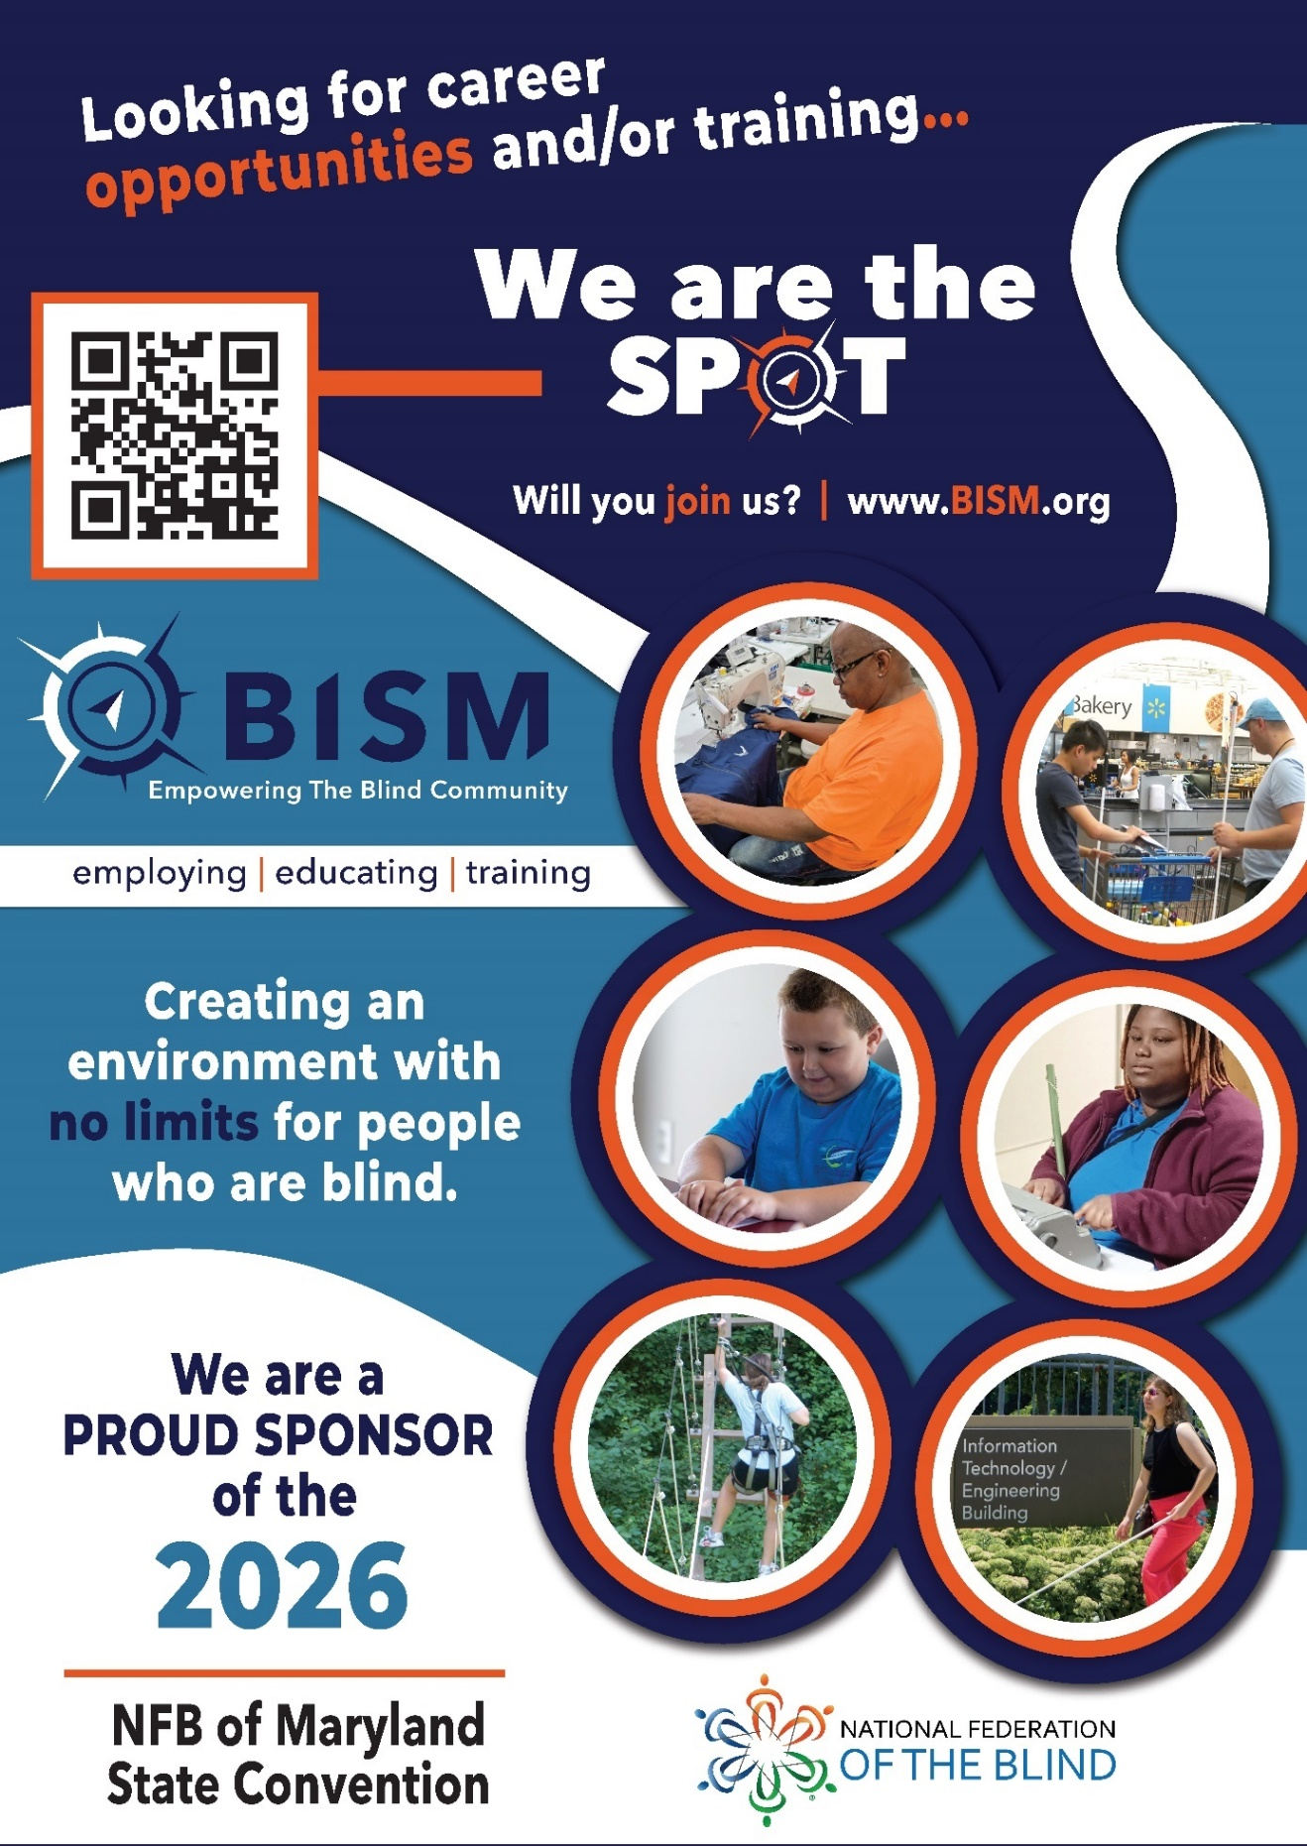
Full page BISM ad description. Text, “Looking for career opportunities and/or training... We are the spot. Will you join us? www.BISM.org “Creating an environment with no limits for people who are blind,” followed by the BISM logo, which contains the text “BISM Empowering the Blind Community.” Images: On the right side of the ad, there are six pictures of blind people reading, traveling, working. There is a QR code on top left. Text: Following the BISM logo is the text, “Employing. Educating. Training. We are a proud sponsor of the 2026 NFB of Maryland State Convention [NFB logo].

Navigating the Ashore Resort & Beach Club

The Ashore Resort and Beach Club is located at 10100 Coastal Highway. This hotel has two buildings that are connected through a hallway on the second floor. Most sleeping rooms and common spaces such as restaurants are in the Tower Building, while meeting rooms are in the Conference Center.

The first floor of both buildings is called the “Main Level,” while the second floor is called the “Terrace Level.”

As you arrive at the hotel and face it, the Conference Center will be on your left and the Tower Building will be on your right. The Conference Center and Tower Building are separated by a covered driveway on the Main Level. Individuals can cross between the two buildings at this level, but they will be outside for approximately 50 feet. Beware of traffic, as this driveway is used both as a loading and unloading zone and also for through traffic for the hotel parking lots. The two buildings are connected on the second or Terrace Level by an internal hallway.

Tower Building
There is one entrance to the Tower Building, which is not facing Coastal Highway but rather on the side of the hotel under the covered driveway. As you come into the tiled lobby of the hotel Tower Building through the entrance from the covered driveway, you will be on the Main Level. Directly to your left along the wall are the hotel check-in desks. With your back to the covered driveway doors, to your left past the check-in desks, you will find a set of three elevators to take you to the Terrace Level and to all other floors of the Tower Building. Again, standing with your back to the doors leading to the covered driveway, straight ahead and to the right, you will find the Grand Staircase that will take you to the Terrace Level. In the middle of the Main Level lobby are several conversation areas with different types of chairs and couches. Past the elevator you can find a small business center. The ATM is at the check-in desk.

If you turn and face the doors to the covered driveway, you can use these doors to get to the Conference Center by walking straight ahead about 50 feet.

On the Terrace Level of the Tower Building, you will find a hallway that connects common spaces and amenities. If you stand with your back to the elevator bank, you will find a hallway going left to right in front of you. If you go to the right, you will cross into the Conference Center. If you go to the left, you will follow a hallway with amenities along it until you come to a set of double doors to the Dune Deck. We’ll come back to the Dune Deck shortly.

As you turn left from the elevator bank, you will first encounter Ashore Things, which sells coffee, snacks, quick bites, sundries, and tourist merchandise. Past Ashore Things is the Tide Room, which is the hotel restaurant. Connected to the Tide Room and further down the hall towards the Dune Deck is the TAP Room, which is the hotel’s bar. The Tap Room has a limited food menu. The hallway outside the Tap Room leads to a set of double doors that take you to the Dune Deck.

The double doors open up into a large tiled seating area called the Dune Deck. This is an inside beach-style seating area, which once housed an indoor pool that has now been filled in. With your back to the double doors, to your far left is a set of doors that lead you to an outside deck. This deck has outdoor seating and a staircase down to the beach.

A guide dog relief area is available just at the bottom of these outside stairs on the beach. There, you will find trash cans. Please don’t forget to bring your own baggies and dispose of them in the trash cans. Those needing an accessible relief area should choose the other guide dog relief area.

Standing on the Dune Deck, directly in front of you, are a set of Cabana sleeping rooms. Some of these rooms will also be used for teen and tween activities. There are clusters of seating areas throughout the Dune Deck. There is also a low wall that surrounds much of the Dune Deck to create a hallway directly in front of the cabana rooms.

It is noteworthy that the Tap Room has a second entrance directly from the Dune Deck (just to the left of the double doors from which you entered the area), and individuals can purchase food and beverages from the bar and enjoy them on the Dune Deck while enjoying sweeping views of the Atlantic Ocean in the comfort of an inside venue.

The third through sixteenth floors of the Tower Building are sleeping rooms.

Those looking for an accessible guide dog relief area from the Tower Building should use the entrance leading to the covered driveway and walk left towards Coastal Highway. At the end of the covered driveway, turn right, and you’ll be outside the Conference Center, where there is a guide dog relief area described in more detail later.

Conference Center
The Conference Center has two floors – the Main Level and the Terrace Level. The Conference Center Main Level has two sets of doors – one is the large set of main doors that face Coastal Highway, and the second faces the covered driveway. If you enter the main doors, you will find yourself in the Grand Foyer. Registration, packet pick-up, and banquet ticket exchange will all be in the Grand Foyer.

If you put your back to the Coastal Highway set of doors, you will face Tideline A and Tideline B, which together, make the Grand Ballroom. Tideline A is on the left, and Tideline B is on the right closer to the entrance to the covered driveway. Our general sessions will be held on Friday, Saturday, and Sunday in Tideline A. Tideline A will also house the board meeting, resolutions, and several seminars. Tideline B will host Pizza and a Play and Crab Idol, but there may be times when, as space is needed, we open up the rooms to make one large room which is the Grand Ballroom. If you face the Grand Ballroom, you will find a set of stairs to the Terrace Level on your far left along the entire wall. You will find an elevator on your far right in the corner on the same wall as the main doors from Coastal Highway.

An accessible guide dog relief area is available just outside the Conference Center entrance on the Coastal Highway side of the Main Level. There, you will find some sandy areas and trash cans. Please don’t forget to bring your own baggies and dispose of them in the trash cans.

Many of our seminars and workshops, childcare, the exhibit hall, boxed lunch distribution, BISM packet pickup, and the banquet will be on the Terrace Level of the Conference Center. You can get to this level either through the elevator and staircase in the Conference Center, or through the hallway from the Tower Building.

The Terrace Level of the Conference Building can best be described as having four separate sections but they are not equal in size. This is because the different meeting room sizes create hallways that aren’t straight shots throughout this level. However, there are only two main hallways, even though one zigs and zags a little.

We will orient as though we are standing at the top of the stairs of the Conference Center on the Terrace Level and for this section, use left and right. Starting from the top of the stairs, the two sections closest to us consist of one large open space in front of us all the way to the far right (Terrace Lobby) and one block of meeting rooms to our left (Atlantic Ballroom).

The Terrace Lobby is quite large and wide open. We will use the Terrace Lobby for boxed lunch distribution, BISM packet pickup, and the pre-banquet reception. If you put the stairs behind you and walk forward through the Terrace Lobby, you will first pass the Atlantic Ballrooms on your left and eventually come across a straight hallway that only goes left. We will return to this hallway in a moment. If you continue forward to the end of the Terrace Lobby, you will find the elevator on your right in the corner and a second hallway that continues forward and then zigzags right and then left. We will return to the zigzagging hallway in a moment as well.

The left section of the Terrace Level closest to the stairs consists of three conference rooms that, together, make up the Atlantic Ballroom. We will hold our banquet in the Atlantic Ballroom. Atlantic 1, which you encounter first, has windows and is the same size as Atlantic 2a and 2b combined.

If you walk past Atlantic 1, you will encounter Atlantic 2B. We will be using Atlantic 2b for the Exhibit Hall. When you get to the end of Atlantic 2b as you walk through the Terrace Lobby, you will find a straight hallway that only goes left.

If you turn down the straight hallway, you will find on your left a second entrance to Atlantic 2b. If you keep walking down the straight hallway, Atlantic 2a will be on your left. Remember that Atlantic 2b has doors on both the Terrace Lobby and straight hallway, but Atlantic 2a can only be accessed from the straight hallway. We will use Atlantic 1, 2A, and 2B for various seminars and some of our Saturday luncheons.

When you turn down the straight hallway, you will find the third section of the Terrace Level on your right. You will walk past a restroom and some storage areas and then encounter Seaside 3, 2, and 1 in that order. Seaside 3 is just past the restroom and directly across from the straight hallway entrance to Atlantic 2B. Seaside 2 is just past Seaside 3, and Seaside 1 is at the end of the straight hallway, with its doors just across from those of Atlantic 2a.

Now, entering the zigzag hallway (with the Terrace Lobby behind you and the straight hallway to your left), you will first encounter Seaside 4. If you continue past Seaside 4, the hallway zags to the right, and you will find Seaside 5 on your right. Seaside 5 will be used for luggage storage and the legislative letter writing workshop. If you keep going past Seaside 5 to the end of that hallway, you will encounter Seaside 6, where childcare is located.

The hallway zigzags again to the left directly in front of Seaside 5, and then merges with the main hallway to the Tower Building.

LIVE THE LIFE YOU WANT
Lyrics copied from October 2015 Presidential Release

Chorus: Live the life you want. Nobody can stop you.
Shoot for the sun and break on through.
So you're blind. You'll be fine. We've got good news!
You can live the life you want. Yes, we know the truth.

Grab a cane, get trained, gotta get movin’.
Make a change in the wage, that's what we're doin’.
Come with me, yeah.

Chorus
You and me, NFB, let’s dream together.
NFB, you and me, lives on forever.
You will see, yeah.

Chorus
You can live the life you want. You’ll know the truth.

Chapters and Divisions of the National Federation of the Blind of Maryland

At-Large Chapter
Marguerite Woods, President, 443-271-1668, mwoods719@gmail.com
Monthly meetings: third Tuesday at 7:30 p.m., via phone: 339-209-4083

Baltimore County Chapter
Latonya Phipps-Cross, President, 443-465-8761, Phippslatonya@gmail.com
Monthly meetings: second Wednesday in Baltimore County at BISM and virtually

Central Maryland Chapter
Matt Yannuzzi, President, 443-851-1944, Matthew.Yannuzzi@gmail.com
Monthly meetings: first Tuesday in Columbia and virtually

Eastern Shore Chapter
Heather Davis, President, 410-430-8954, hguy403@comcast.net
Monthly meetings: second Saturday in Salisbury and virtually

Greater Baltimore Chapter
Chris Danielsen, President, 410-262-1281, Cdanielsen@nfb.org
Monthly meetings: third Saturday in Baltimore at the NFB and virtually

Greater Carroll County Chapter
Brian Keseling, President, 410-855-5605, bkmaverick@gmail.com
Monthly meetings: second Saturday in Westminster

Greater Prince George’s County Chapter
Tajuan Farmer, President, 202-255-2416, Tajuan.Farmer@gmail.com
Monthly meetings: second Tuesday in various locations in Prince George’s County and virtually

Maryland Association of Blind Merchants
Melba Taylor, President, 240-381-1637, m.taylor@encoreassoc.com
Periodic meetings throughout the year

Maryland Association of Blind Students
Qualik Ford, President, 301-312-9813, qsford@outlook.com
Periodic meetings throughout the year

Maryland Parents of Blind Children
Garret Mooney, President, 480-433-8003, james.garret.mooney@gmail.com
Periodic meetings throughout the year

Senior Issues Division
Marguerite Woods, President, 443-271-1668, mwoods719@gmail.com
Periodic meetings throughout the year

Sligo Creek Chapter
Debbie Brown, President, 301-881-1892, Deborahb14@verizon.net
Monthly meetings: second Saturday primarily in Silver Spring

TLC Chapter
Millie Rivera, President, 202-494-5687, Millie.Rivera0027@gmail.com
Monthly meetings: second Monday in Northern Baltimore County and virtually

Western Maryland Chapter
Wendy Ruth, President, 301-991-8312, Wendyruth966@gmail.com
Monthly meetings: first Saturday in Western Maryland and virtually
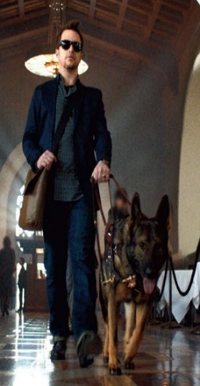

Half Page Vanda Pharmaceuticals ad description. Heading: The Vanda Pharmaceuticals logo. Images: On the left side, a man wearing dark glasses walking with a guide dog. Text: “Vanda Pharmaceuticals is dedicated to raising awareness of Non-24-Hour Sleep-Wake Disorder (Non-24) and supporting the blindness community. Non-24 is a rare circadian rhythm disorder affecting up to 70% of people who are totally blind. People living with Non-24 experience excessive daytime sleepiness and nighttime sleeplessness, which leads to impaired social and occupational functioning. This is due to the misalignment between the internal master body clock and the 24-hour day. Come visit us at our booth to learn about non-24.

Stay Connected and Informed:

Follow and like the National Federation of the Blind of Maryland on Facebook: facebook.com/NationalFederationOfTheBlindOfMaryland

Stay connected with your fellow Maryland Federationists by joining our state email listserv to receive affiliate and national announcements, plus you can participate in discussions regarding blindness and blindness issues. Sign up at NFBnet.org, select “join or drop NFB mailing lists,” and activate “NFBMD” link, and follow the instructions.

Many of our local chapters now also have a listserv. Talk to your chapter President to learn how to sign up so you don’t miss important news and events.

Visit our website at NFBMD.org. Check out our blog for the President’s Messages. Be sure to check out the Blindness Resources link, and the Know Your Rights link to keep up to date on important information. Be sure to download and print “About NFBMD,” in the “About Us” tab on NFBMD.org, to use as handouts at chapter outreach events.

Braille Spectator
The Braille Spectator is published for members of the National Federation of the Blind of Maryland and others who share an interest in the work of this organization. The Braille Spectator can be read on the web at NFBMD.org/Newsletter or can be listened to on the local channel of NFB-Newsline.

Memorable Moments: Snapshots in Maryland
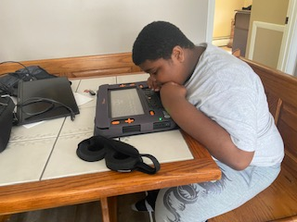
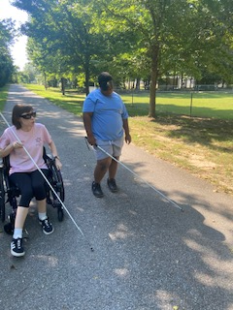

Above Images: NFB BELL student explores Monarch device (left). Student and Mentor travel down park path (right).

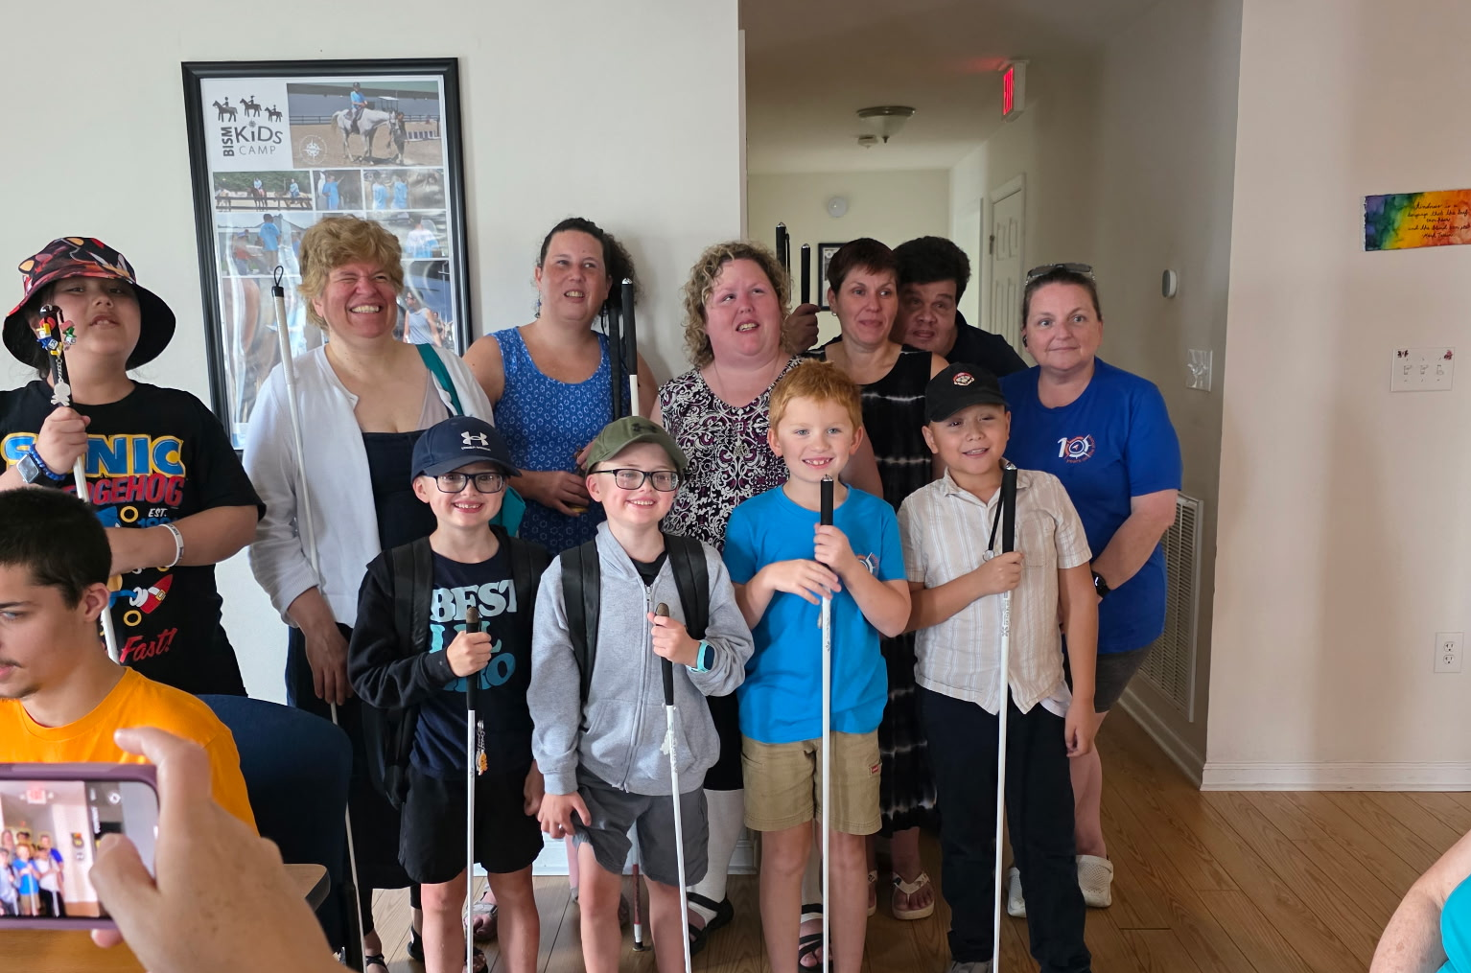
Above Image: Six mentors and five students with white canes smile together

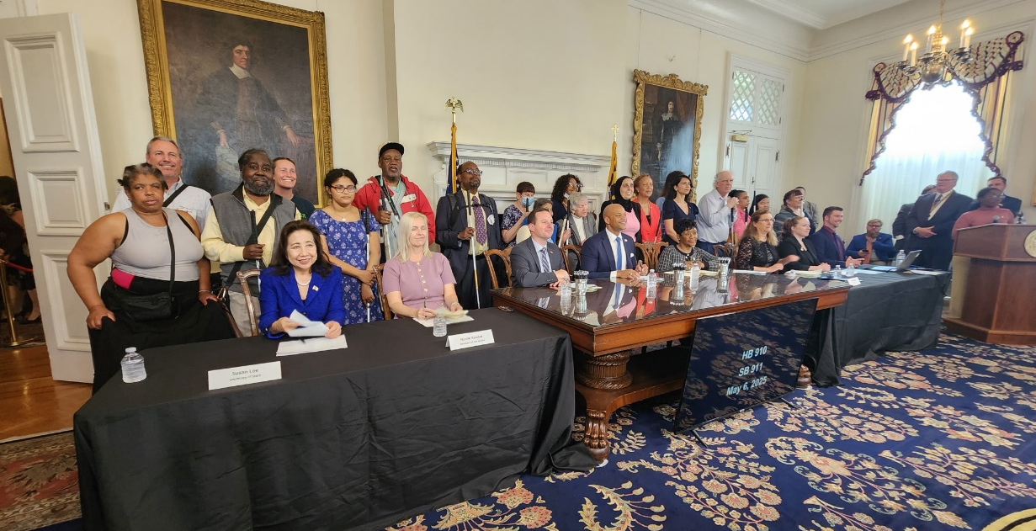
Image: Governor’s bill signing in May 2025 for HB910/SB911 the Property Tax – Exemption for Blind Individuals – Alteration with Governor Moore, Sponsors, and NFBMD members

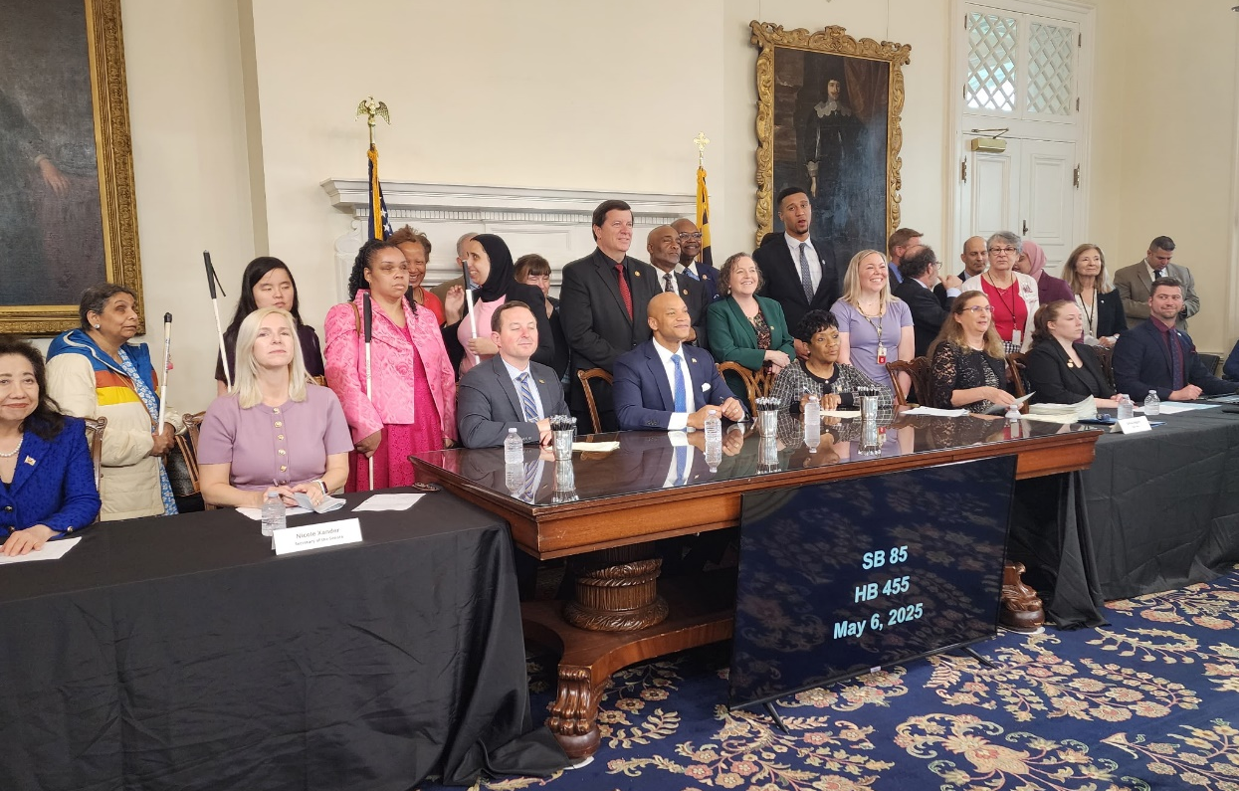
Image: Governor’s bill signing in May 2025 SB84/HB455 Braille Flag Memorial Act of 2025 with Governor Moore, Sponsors, and NFBMD members
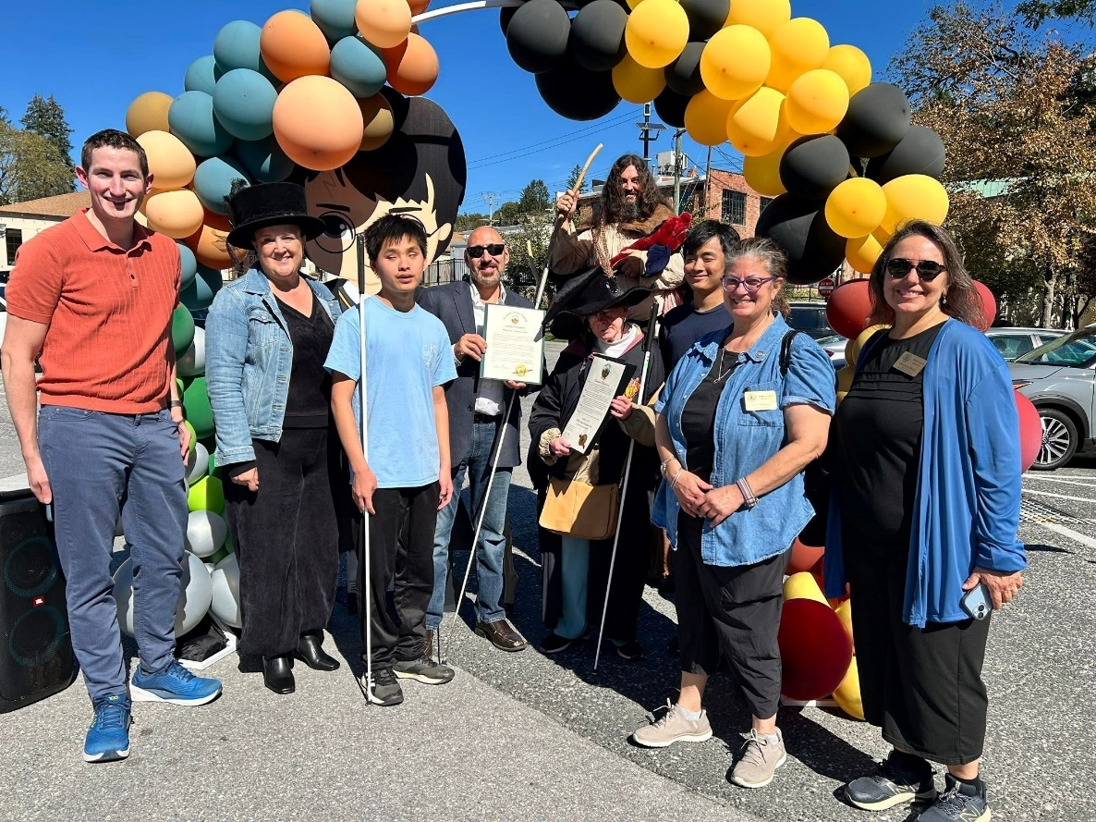
Image: NFBMD members host Wizarding Weekend on Magical Main in Old Ellicott City to commemorate Blind Equality Achievement Month and White Cane Awareness Day.
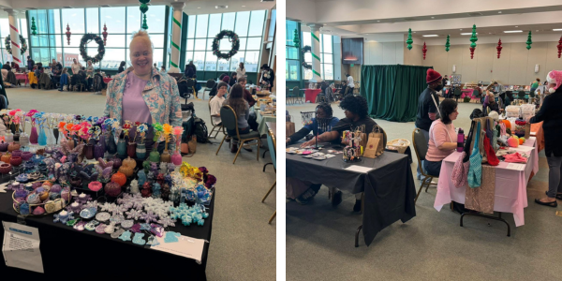
Image: NFB Winter Market tables with members displaying crafts, clothing, and homemade gifts.

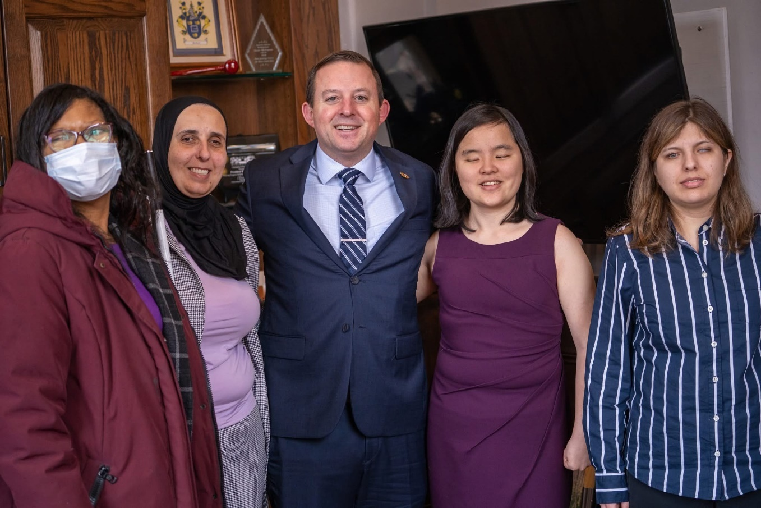
Images above and below: NFBMD members with Maryland representatives

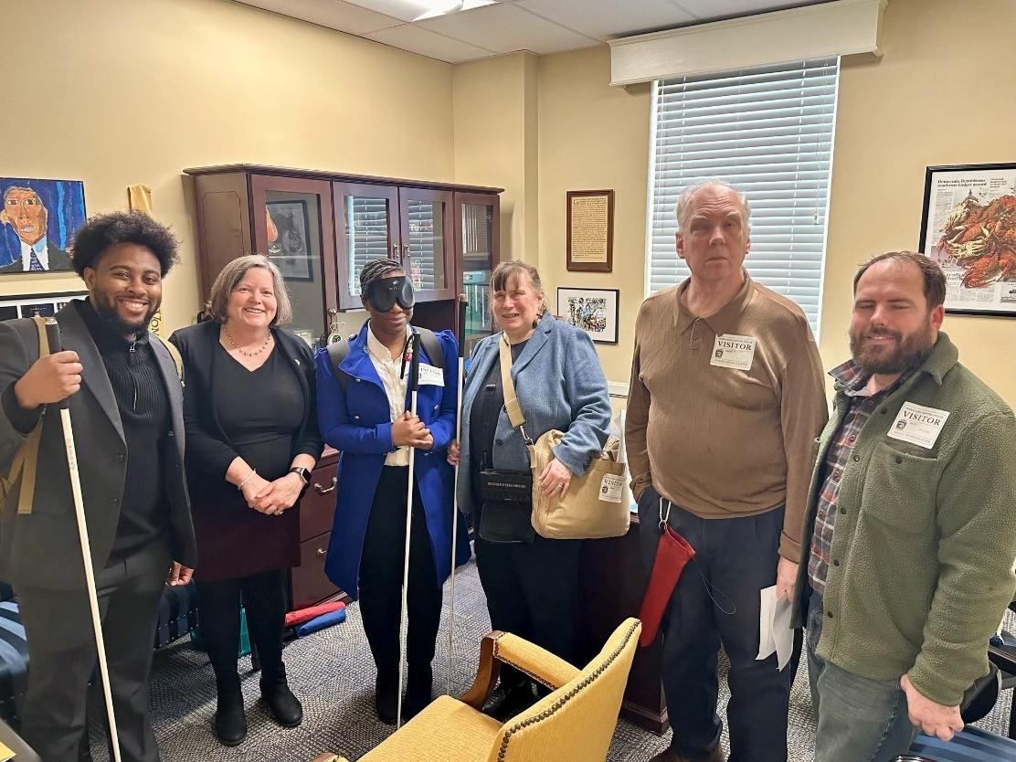

GLORY FEDERATION

Blind eyes have seen the vision of the Federation way;
New white cane legislation brings the dawn of a new day;
The right of the blind to organize is truly here to stay;
Our cause goes marching on.

Chorus
Glory, glory Federation;
Glory, glory Federation;
Glory, glory Federation;
Our cause goes marching on.

To aid the blind's long struggle we have formed the NFB
To free them from their bondage of workshop and agency,
To give a hand to all the blind wherever they may be;

Our cause goes marching on.
Chorus

Committees of the National Federation of the Blind of Maryland
If you’re interested in being appointed to a particular committee, notify the NFBMD President at President@nfbmd.org or 443-426-4110.

Advocacy Committee
Sharon Maneki and Melissa Riccobono, Co-chairpersons

Ambassadors Committee
Judy Rasmussen and Debbie Brown, Co-chairpersons

Audit Committee
Justin Young, Chairperson

NFB BELL Committee
Erin Zobell, Chairperson

Braille Spectator Committee
Ronza Othman, editor

Crab Feast Committee
Millie Rivera, Chairperson

Deaf-Blind and Hearing Loss Issues Committee
Heather Davis and Janice Toothman, Co-chairpersons

Development and Fundraising Committee
Qualik Ford and Justin Young, Co-chairpersons

Diversity, Equity, and Inclusion Committee
Juhi Narula and Qualik Ford, Co-chairpersons

Employment Committee
Pam Goodman and Judy Rasmussen, Co-chairpersons

Guide Dog Users Committee
Sherry Shirek, chairperson

Legislation (Federal) Committee
Sharon Maneki and Debbie Brown, Co-chairpersons

Legislation (State) Committee
Ronza Othman, Chairperson

Makers Market Committee
Danielle McCann, Chairperson

Membership Committee
Dezman Jackson and Ellen Ringlein, Co-chairpersons

Nominating Committee
Marguerite Woods, Chairperson

PAC Plan Committee
John Paré and Ann-Marie Laney, Co-chairpersons

Public Relations Committee
Chris Danielsen, Chairperson

Resolutions Committee
Chris Danielsen, Chairperson

Scholarship Committee
Juhi Narula, Chairperson

Sharon Maneki Youth Empowerment Grant Committee
Sharon Maneki, Chairperson

Social Media Committee
Karen Anderson and Stephanie Cascone, Co-chairpersons

Spanish Services Committee
Teresa Graham, Chairperson

Sports and Recreation Committee
Qualik Ford and Derique Simon, Co-chairpersons

Transportation Committee
Aloma Bouma and Cheryl Fogle-Hatch, Co-chairpersons

Website and Technology Committee
John Berggren and Graham Mehl, Co-chairpersons

Youth Activity Committee
Erin Zobell, Chairperson

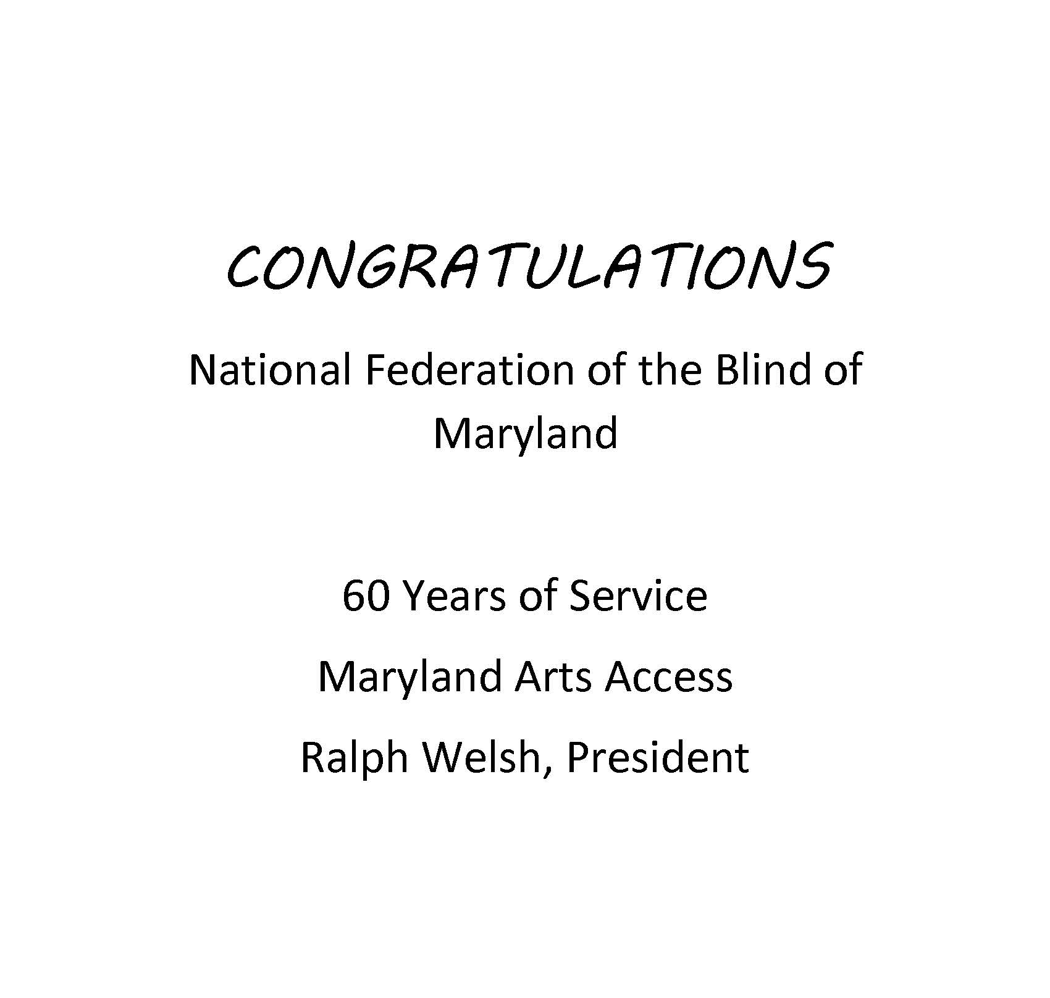
Three quarter page ad for Maryland Arts Access: Text, “Congratulations National Federation of the Blind of Maryland, 60 years of service. Maryland Arts Access Ralph Welsh, President”

Convention-Related Committees

Anna Freysz Cable Award Committee
Debbie Brown, Chairperson

Convention Childcare Committee
Brittany Bomboy, Chairperson

Convention Logistics Committee
Justin Young, Chairperson

Convention Registration Committee
Marie Marucci and Bre Brown, Co-chairpersons

Distinguished Educator of Blind Children Award Committee
Teresa Graham, Chairperson

Door Prize Committee
Juhi Narula and Qualik Ford, Co-chairpersons

Gold Cup Crab Race Committee
Juhi Narula and Jenivieve White, Co-chairpersons

Jennifer Baker Award Committee
Melissa Riccobono, Chairperson

Kenneth Jernigan Award Committee
Mary Ellen Jernigan, Chairperson

National Funding Support Auction Committee
Joel Zimba and Erin Zobell, Co-chairpersons

Groups of the National Federation of the Blind of Maryland
If you’re interested in joining a particular group, contact that group’s chairperson.

Blind Crafters Group
Danielle McCann and Karen Anderson, Co-chairpersons

Blind Parents Group
Melissa Riccobono, Chairperson

Blind Young Persons Group
Jeff Baer and Juhi Narula, Co-chairpersons

Diabetes Action Network
Eileen Ley, Chairperson

Performing Arts Group
Chris Danielsen, Chairperson

Significant Others and Loved Ones Group
Jenivieve White and David Waybright, Co-chairpersons

Veterans Group
Ed Jackson, Chairperson

Leaving A Legacy: Dream Makers Circle
You can help build a future of opportunity for the blind by becoming a member of our Dream Makers Circle. It is easier than you think.
Just visit your bank and convert an account to a P.O.D. (payable on death) bank account which is payable after your passing to the National Federation of the Blind or the National Federation of the Blind of Maryland.
Your legacy gift to the National Federation of the Blind or the National Federation of the Blind of Maryland can be made in the form of a will or living trust, an income generating gift, or by naming us as the beneficiary of a retirement plan, IRA, pension, or a life insurance policy. You can designate a specific amount, a percentage, or list NFB as one of several beneficiaries.
For additional information, please contact Patti Chang at 410-659-9314, ext. 2422 or at pchang@nfb.org.

STRIVE
Lyrics by Barbara Elliott

Sometimes people tell me blind people should be quiet and sit down
But I say "No!" I say "No!" I say "No."
They contend that I should be content to let others lead me around,
But I say "No!" I say "No!" I say "No."
Everybody needs somebody to help sometimes, but I'm in charge of me.
Chorus: I've gotta strive, strive, strive a little farther,
Reach, reach, reach a little longer,
Work, work, work a little harder,
Hope, hope, hope a little stronger.
Watch me, watch me, watch me.
Nothin's gonna stop me, stop me, stop me.
I'm spreading my wings, soaring on a dream,
I can do anything!
I gotta be brave even when I'm afraid to do hard things.
I'll tell myself "Go!" I'll just go, I will go.
I'm not a fool; I need training and tools to live out my dreams.
So I'll say "Go!" I'll just go, I will go.I'm not a passenger in my life. I'm gonna take control and drive.
Chorus

Convention Agenda

Thursday, February 12

5:30 to 7 p.m. — Packet Pickup
Grand foyer
*Pre-registrants who did not register through BISM; on-site registration is not available at this time.

5:30 to 7 p.m. — Packet Pickup for BISM
Terrace Lobby
*Pre-registrants who registered through BISM only; on-site registration is not available at this time.

5:30 to 6:25 p.m. — NFBMD Deaf-Blind and Hearing Loss Issues Committee Meeting
Seaside 4
Heather Davis, Co-chairperson; Salisbury, Maryland
Janice Toothman, Co-chairperson; Bowie, Maryland

6:30 to 7:25 p.m. — NFBMD Membership Training
Atlantic 2A
Ronza Othman, President, NFBMD; Baltimore, Maryland
Dezman Jackson, Co-chairperson, Membership Committee; Baltimore, Maryland
Ellen Ringlein, Co-chairperson, Membership Committee; Baltimore, Maryland
*All chapter and division presidents and membership coordinators are expected to attend this training.

6:30 to 7:25 p.m. — NFBMD Guide Dog Users Committee Meeting
Seaside 4
Sherry Shirek, chairperson; Baltimore, Maryland
Leah Mattern, Coordinator; Baltimore, Maryland

7:30 to 9:30 p.m. — NFBMD Board of Directors Meeting (Open to All)
Tideline A

Friday, February 13
7:15 to 8:45 a.m. — Scholarship Breakfast
(Invitation Only)
Juhi Narula, Chairperson, Scholarship Committee; Baltimore, Maryland

8 to 8:30 a.m. — Maryland Parents of Blind Children Conference Registration
Atlantic 2B Foyer
Garret Mooney, President, Maryland Organization of Parents of Blind Children; Baltimore, Maryland

8:15 a.m. to 4:45 p.m. — Fun with Friends: Childcare
Seaside 6
Brittany Bomboy, Convention Childcare Coordinator; Baltimore, Maryland

8:30 to 9 a.m. — Maryland Parents of Blind Children Conference Kick-off
Atlantic 2B
Garret Mooney, President, Maryland Organization of Parents of Blind Children; Baltimore, Maryland

9 to 9:55 a.m. — NFBMD Resolutions Committee Meeting
Tideline A
Chris Danielsen, Chairperson; Baltimore, Maryland
*Everyone is encouraged to attend!

10 to 10:55 a.m. — Greater Baltimore Chapter Meeting
Atlantic 2A
Chris Danielsen, President; Baltimore, Maryland

10 to 10:55 a.m. — Central Maryland Chapter Meeting
Seaside 1
Matt Yannuzzi, President; Halethorpe, Maryland

10 to 10:55 a.m. — Greater Carroll County Chapter Meeting
Seaside 2
Brian Keseling, President; Westminster, Maryland
Derrick Day, Vice President; Finksburg, Maryland

10 to 10:55 a.m. — Sligo Creek Chapter Meeting
Seaside 3
Deborah Brown, President; Rockville, Maryland

10 to 10:55 a.m. — Eastern Shore Chapter Meeting
Seaside 4
Heather Davis, President; Salisbury, Maryland

11 to 11:55 a.m. — Baltimore County Chapter Meeting
Atlantic 2A
Latonya Phipps-Cross, President; Baltimore, Maryland

11 to 11:55 a.m. — At Large Chapter Meeting
Seaside 1
Marguerite Woods, President; Baltimore, Maryland

11 to 11:55 a.m. — Western Maryland Chapter Meeting
Seaside 2
Wendy Ruth, President; Hagerstown, Maryland

11 to 11:55 a.m. — Greater Prince George’s County Chapter Meeting
Seaside 3
Tajuan Farmer, President; Bowie, Maryland

11 to 11:55 a.m. — TLC Chapter Meeting
Seaside 4
Mildred Rivera, President; Lutherville, Maryland

11 a.m. to 6 p.m. — Exhibit Hall
Atlantic 1
Check out the latest offerings from a variety of companies and organizations that provide technology and services for the blind. Meet our sponsors.
Jenivieve White, sponsorship and exhibits coordinator and NFBMD Treasurer; Owings Mills, Maryland

11:30 a.m. — Boxed Lunch Distribution
Terrace Lobby
Note: You paid for a boxed lunch at pre-registration. Lunches must be picked up by 12:30 p.m., or they will be resold with no refunds.

Noon to 12:55 p.m. — Peace of Mind Seminar: Your Money, Your Health, Your Legacy, Your Choices!
Atlantic 2A
Come to learn about wills, trusts, powers of attorney, conservatorship, leaving a legacy, and more. This seminar will explore various methods for how the blind and parents of blind children can plan for the future while maintaining independence and autonomy without jeopardizing access to government programs and supports.
Craig Borne, Estate Planning Attorney, Craig Borne Law; Towson, Maryland

1 to 1:55 p.m. — NFBMD Technology Seminar
Atlantic 2A
Come learn about new and emerging technology, how to get your hands on it, and what it can do to help you with work, play, life, and leadership. Hear from a leading expert on accessibility and innovation.
Jonathan Mosen, NFB Executive Director for Accessibility Excellence; Baltimore, Maryland

1 to 6 p.m. — Packet Pickup
Grand foyer
*Pre-registrants who did not register through BISM

1 to 3:30 p.m. — Packet Pickup for BISM
Terrace Lobby
*Pre-registrants who registered through BISM only

1 to 6 p.m. — Onsite Registration
Grand foyer

1 to 4:30 p.m. — Annual Conference for Parents and Teachers of Blind Children Plenary Session
Atlantic 2B
What are the skills and tools blind students need in school and to live the lives they want? What are the rights of blind and low-vision students and their families, and what are the legal obligations of the school system? How do we best prepare transition-age students for life beyond school? How do you make sure school and rehabilitation services are appropriately addressing their needs? What can you do to support them at home and in school? Learn about resources, opportunities, blindness skills, and how to have and model a positive attitude on blindness. These are only some of the topics to be discussed at this seminar.
Garret Mooney, President; Baltimore, Maryland

2 to 4 p.m. — BISM Bingo
Tideline B
Come play everyone’s favorite game — Bingo — and win prizes.
Sponsored by Blind Industries and Services of Maryland (Title Sponsor).

3 to 5 p.m. — Legislative Advocacy: Letter Writing Workshop
Seaside 5
Come write letters to the Maryland General Assembly about issues of importance to the blind. Assistance is available for those who want it.
Sharon Maneki, Board Member, NFBMD; Columbia, Maryland
Melissa Riccobono, Board Member, NFBMD; Baltimore, Maryland
Chris Danielsen, Second Vice President, NFBMD; Baltimore, Maryland

3:30 to 5:30 p.m. — NFBMD Senior Issues Division and NFBMD Advocacy Committee Joint Seminar: Free Services, Tax Breaks, and Other Services You Didn’t Know About from the Maryland Comptroller’s Office
Atlantic 2A
Free tax help, $1,000 tax credit for those over 65 with low to moderate income, and other benefits, as well as information on small business tax assistance, avoiding scams, and other things to know to keep you and your money together. Open to all!
Mary Hanley, Community Engagement Officer, Eastern Shore Region, Maryland Office of the Comptroller; Salisbury, Maryland
Marguerite Woods, President, NFBMD Senior Issues Division; Baltimore, Maryland
Sharon Maneki, Co-chairperson, NFBMD Advocacy Committee; Columbia, Maryland
Melissa Riccobono, Co-chairperson, NFBMD Advocacy Committee; Baltimore, Maryland

3:30 to 5:30 p.m. — Maryland Association of Blind Students Seminar
Seaside 3
Registration from 3:15 to 3:30 p.m.
Come learn about matters of interest to students including how to self-advocate in school, with potential employers, and in the world. Learn what resources are available for students.
Qualik Ford, President, Maryland Association of Blind Students; Baltimore, Maryland

3:30 to 5:30 p.m. — NFBMD Association of Blind Merchants Seminar and Annual Meeting
Seaside 2
Join blind merchants, entrepreneurs, and those in the Business Enterprise Program to learn about changes to the BEP program, explore ways to enhance business opportunities, and strategies to protect the Randolph Shepperd Program.
Melba Taylor, President, NFBMD Association of Blind Merchants; Bowie, Maryland

4:30 to 5:30 p.m. — Maryland Organization of Parents of Blind Children Networking Hour (teachers, blindness professionals, and families are welcome)
Come network with families, blindness professionals, teachers of blind students, those who engage in special education advocacy, and others.
Garret Mooney, President; Baltimore, Maryland

5:30 to 7:20 p.m. — Pizza and a Play
Tideline B
The Braille is Beautiful Players will entertain and delight.
Debbie Brown, play director and NFBMD First Vice President; Rockville, Maryland

7:15 to 9:45 p.m. — Fun with Friends: Childcare
Seaside 6
Brittany Bomboy, Convention Childcare Coordinator; Baltimore, Maryland

7:30 p.m. to 9:30 p.m. — Friday Evening General Session
Tideline A
7:30 p.m. — Call to Order and Opening Ceremonies

7:45 p.m. — From Mission to Velocity: Supporting the Programs that Propel the Movement
Get on the Pac Plan
John Pare, Maryland PAC Plan Co-chairperson; Baltimore, Maryland
Ann-Marie Laney, Maryland PAC Plan Co-chairperson; Randallstown, Maryland

Gold Cup Crab Race
Juhi Narula, ticket agent; Baltimore, Maryland

7:55 p.m. — Cleared for Takeoff: Opening Reflections from the President
Mark Riccobono, President, National Federation of the Blind; Baltimore, Maryland

8:05 p.m. — From Aspiration to Altitude: An NFB Scholar’s Story
Mildred Rivera, 2025 NFB Scholarship Winner; NFBMD Board Member and President, TLC Chapter; Lutherville, Maryland

8:15 p.m. — Building Runways to Success: Maryland DORS in Action
Erikk Bonner, Assistant State Superintendent, Maryland Division of Rehabilitation Services, Maryland State Department of Education; Baltimore, Maryland

8:25 p.m. — On the Flight Path to Independence: Updates from Maryland OBVS
Toni March, Director, Office of Blindness and Vision Services, Maryland Division of Rehabilitation Services (DORS); Baltimore, Maryland

8:40 p.m. — From Curtain Call to Center Stage: Access Services That Let Audiences Soar
Ralph Welsh, President, Maryland Arts Access; Lutherville, Maryland

8:50 p.m. — Your Co-Pilot to Access: Way-Finding, Reader Support, and More
Betsy Cerulo, Chief Executive Officer, AdNet/AccountNet; Baltimore, Maryland

9:00 p.m. — Choose Your Runway: Where Do You Stand?
Ronza Othman, President, National Federation of the Blind of Maryland; Baltimore, Maryland

9:20 p.m. — Reports and Resolutions

9:30 p.m. — Adjourn

9:30 to 11 p.m. — Crab Idol
Tideline B
This American Idol-style evening promises to be fun for all ages. Those wishing to perform songs can do so for $5 per person per performance. Chapters and Divisions will battle it out to determine which has the most talent. Enjoy snacks and fellowship thanks to the Maryland Association of Blind Students, Maryland Parents of Blind Children, and NFBMD Eastern Shore Chapter. Proceeds support NFBMD, MDABS, and MDPBC.
To sign up to perform, contact Heather Davis, Qualik Ford, or Garret Mooney.

Saturday, February 14

7:00 to 8:15 a.m. — Breakfast: Leadership Development and Training
Atlantic 2B
Those interested in leadership development and training, including existing leaders, emerging leaders, and prospective leaders won’t want to miss this working breakfast to hone skills and network. Each member is a leader in their own right. You do not have to hold an elected or appointed position to attend – all are welcome.
Shawn Callaway, Board Member, NFB; President, NFB of the District of Columbia; Washington, DC

7:45 to 8:25 a.m. — Convention Registration and Packet Pickup
Grand foyer

8:15 a.m. to 5:15 p.m. — Fun with Friends: Childcare
Seaside 6
Brittany Bomboy, coordinator; Baltimore, Maryland

8:30 a.m. to 11 a.m. — Saturday Morning General Session
Tideline A
8:30 a.m. — Call to Order

8:35 a.m. — Soaring Forward Together on the Eastern Shore: Welcome from the 38th District
Mary Beth Carozza, Senator, Maryland 38th State Legislative District; Salisbury, Maryland

8:50 a.m. — The National Flight Plan: NFB’s National Programs in Action
Shawn Callaway, Board Member, National Federation of the Blind; President, National Federation of the Blind of the District of Columbia; Washington, DC

9:35 a.m. — Next-Gen Pilots of Progress: A Report from the National Association of Blind Students
Katy Presley, First Vice President, National Association of Blind Students; Ruston, Louisiana

9:45 a.m. — Safeguarding the Journey: Wills, Estate Planning, Health Care Decisions, and Leaving a Legacy
Craig Borne, Attorney, Craig Borne Law; Towson, Maryland

10 a.m. — New Horizons at 19,341 Feet: A Blind Climber’s Journey
Conchita Hernandez, Educational Consultant, Maryland School for the Blind; Washington, DC

10:15 a.m. — Wheels Up since 1966: Honoring 60 Years of NFB of Maryland
Sharon Maneki, Board Member, National Federation of the Blind of Maryland; Columbia, Maryland
Virginia Bickford, Member, Sligo Creek Chapter; Silver Spring, Maryland
Tom Bickford, Member, Sligo Creek Chapter; Silver Spring, Maryland

10:35 a.m. — Powered by Partnership: NFBMD and BISM Soaring Together
Michael Gosse, President, Blind Industries and Services of Maryland; Baltimore, Maryland

10:50 a.m. — Reports and Resolutions

11 a.m. — Adjourn

11 a.m. to 12 p.m. — Breakout: Sports and Recreation Committee Meeting
Atlantic 1
The NFBMD Sports & Rec Committee will meet to plan the year’s activities. Participants will also be able to try out yoga and other forms of gentle movement. Participants should bring their own yoga mats.
Linda Furiate, Yoga & Well-being Instructor; Columbia, Maryland
Qualik Ford, Co-chairperson, NFBMD Sports & Rec Committee; Baltimore, Maryland
Derique Simon, Co-chairperson, NFBMD Sports & Rec Committee; Baltimore, Maryland

11 a.m. to 12 p.m. — Breakout: NFBMD Crafters Committee
Seaside 5
Crafters and creatives: This is your jam! Join the NFBMD Crafters Committee to discuss all things crafting, including knitting, crochet, basket weaving, sculpting, and more!
Karen Anderson, Co-Chairperson, NFBMD Crafters Committee; Baltimore, Maryland

11 a.m. to 12 p.m. — Breakout: Blind Parents Group Meeting
Seaside 2
Share tips and tricks on how to parent using non-visual techniques. Network with other blind parents and caregivers.
Melissa Riccobono, Chairperson; Baltimore, Maryland

11 a.m. to 12 p.m. — Breakout: Blind Young Persons Group Workshop
Seaside 4
Come learn about and contribute to our ideas for the next year. Hear about the plan for the new young adult book club, hear how other young adults are taking leadership roles in their local chapters, and tell us your proposal for the next year of young adult activities in NFBMD.
Jeff Baer, Co-chairperson; Potomac, Maryland
Juhi Narula, Co-chairperson; Baltimore, Maryland

11:45 to 12:15 p.m. — Convention Registration and Packet Pick-Up
Grand Foyer

12:15 to 1:45 p.m. — Luncheon: The Education of Blind and Low-Vision Students – Maryland Organization Parents of Blind Children Annual Meeting
Atlantic 2B
For parents, teachers of the blind, and those interested in matters concerning blind children.
Garret Mooney, President; Baltimore, Maryland

12:15 to 1:45 p.m. — Luncheon: Reclaiming Independence After Vision Loss – NFBMD Senior Issues Division Annual Meeting
Atlantic 2A
For seniors and others facing vision loss.
Marguerite Woods, President; Baltimore, Maryland
Sponsored by Waymo

12:15 to 1:45 p.m. — Luncheon: Maryland Association of Blind Students Annual Meeting
Seaside 3
The Maryland Association of Blind Students will hold its annual business meeting, including planning future workshops and events and holding elections.
Qualik Ford, President; Baltimore, Maryland

1:20 to 1:50 p.m. — Banquet Ticket Exchange
Grand Foyer

2 to 2:55 p.m. — Seminar: Attitude is our Altitude: Living Our NFB Philosophy
Tideline B
Everyone is encouraged to attend!
Shawn Callaway, Board Member, NFB; President, NFB of the District of Columbia; Washington, DC
Qualik Ford, 2025-2026 Kenneth Jernigan Leadership in Service Fellow; Baltimore, Maryland

3 to 5 p.m. — Saturday Afternoon General Session
Tideline A

3 p.m. — Call to Order

3:05 p.m. — Pilots of Progress, 60 Years Strong, Soaring to New Horizons: A Report from the President
Ronza Othman, President, National Federation of the Blind of Maryland; Baltimore, Maryland

3:55 p.m. — Powered by Access: Books, Braille, and Beyond at LBPD
John Owen, Director, Maryland State Library for the Blind and Print Disabled; Baltimore, Maryland

4:10 p.m. — From the Classroom to the Clouds: Empowering the Next Generation at MSB
W. Robert Hair, Superintendent, Maryland School for the Blind; Baltimore, Maryland
Conchita Hernandez, Educational Consultant, Maryland School for the Blind; Washington, DC

4:25 p.m. — From Detour to Destination: Careers That Took Off After a Pivot
Panel Co-moderator: Pam Goodman, Co-chairperson, NFBMD Employment Committee; Linthicum, Maryland
Panel Co-moderator: Judy Rasmussen, Co-chairperson, NFBMD Employment Committee; Silver Spring, Maryland
- Shawn Callaway, Program Specialist, Administration on Disabilities, U.S. Department of Health and Human Services; Washington, DC
- Leah Mattern, Digital Accessibility Engineer, Tamman, Inc.; Digital Accessibility Educator & Consultant, Chax Training and Consulting; Baltimore, Maryland
- Jennifer Wenzel, Technology Product Specialist, American Printing House for the Blind; Wauwatosa, Wisconsin

4:50 p.m. — Reports and Resolutions

5 p.m. — Adjourn

6 p.m. — Reception and Cash Bar
Atlantic Foyer

6:45 to 10:15 p.m. — Fun with Friends: Childcare
Seaside 6
Brittany Bomboy, Coordinator; Baltimore, Maryland
Childcare ends at 10:15 p.m., or 15 minutes after the banquet ends, whichever is earlier.

7 p.m. — 60th Annual Convention Banquet
Atlantic Ballroom 1 and 2
Master of Ceremonies: Mark Riccobono, President, National Federation of the Blind; Baltimore, Maryland

Keynote Banquet Address: Shawn Callaway, Board Member, National Federation of the Blind; President, National Federation of the Blind of the District of Columbia; Washington, DC

Scholarships and Awards

Immediately after the Banquet — Maryland Gold Cup Crab Race
Race Callers: Ronza Othman and Juhi Narula

Sunday, February 15

7:00 to 8:30 a.m. — Breakfast: Training Center Information and Alumni Networking
Atlantic 2A
Those interested in learning about adjustment to blindness training can talk with training center ambassadors and graduates. Alumni from the Louisiana Center for the Blind (LCB), Colorado Center for the Blind (CCB), Minnesota Center for the Blind (MCB), and Blind Industries and Services of Maryland (BISM) can reconnect.
Karen Anderson, LCB Graduate; Baltimore, Maryland

7:30 to 9 a.m. — Luggage Collection
Seaside 4
For anyone needing to store luggage due to 11 a.m. hotel check-out time, including bus passengers.

7:30 to 8:45 a.m. — Christian Nonsectarian Devotions
Tideline A
Judy Rasmussen, Secretary, National Federation of the Blind of Maryland; Silver Spring, Maryland

8:30 to 8:45 a.m. — Convention Registration and Packet Pick-Up
Grand Foyer

8:45 a.m. to 1:15 p.m. — Fun with Friends: Childcare
Seaside 6
Brittany Bomboy, Coordinator; Baltimore, Maryland
Childcare ends at 1:15 p.m., or 15 minutes after general session adjournment, whichever is earlier.

9 a.m. to 1 p.m. — Sunday Morning General Session
Tideline A

9 a.m. — Call to Order

9:05 a.m. — Taking the Controls: Leadership, Service, and the Next Horizon
Moderator: Mark Riccobono, President, National Federation of the Blind; Baltimore, Maryland
- Carley Mullin, 2023-2024 Kenneth Jernigan Leadership in Service Program Participant; Baltimore, Maryland
- Juhi Narula, 2023-2024 Kenneth Jernigan Leadership in Service Program Participant; Baltimore, Maryland
- Latonya Phipps-Cross, 2025-2026 Kenneth Jernigan Leadership in Service Program Participant; Gwynn Oak, Maryland
- Qualik Ford, 2025-2026 Kenneth Jernigan Leadership in Service Program Participant; Baltimore, Maryland

9:45 a.m. — Soaring Forward Together: Maryland’s Commitment to Disability Inclusion
John Brennan, Assistant Director, Maryland Department of Disabilities; Baltimore, Maryland

10 a.m. — Charting New Territory: How the Monarch Expands Possibility
Jennifer Wenzel, Technology Product Specialist, American Printing House for the Blind; Wauwatosa, Wisconsin

10:10 a.m. — Little Pilots, Big Horizons: NFB BELL Academy in Action
Erin Zobell, Maryland Youth Programs Coordinator; California, Maryland
Garret Mooney, 2025 NFBMD BELL Coordinator; Baltimore, Maryland
Heather Davis, NFBMD Eastern Shore BELL Co-Coordinator; Salisbury, Maryland
Danielle Earl, NFBMD Eastern Shore BELL Co-Coordinator; Salisbury, Maryland
Maryland NFB BELL Academy Students
Maryland NFB STEM2U Students

10:50 a.m. — Audit Committee Report
Justin Young, Audit Committee Chairperson; Baltimore, Maryland

11 a.m. — Financial Report
Jenivieve White, Treasurer, National Federation of the Blind of Maryland; Owings Mills, Maryland

11:20 a.m. — 2025 Business Meeting Minutes
Judy Rasmussen, Secretary, National Federation of the Blind of Maryland; Silver Spring, Maryland

11:40 a.m. — Resolutions Committee Report
Chris Danielsen, Chairperson, NFBMD Resolutions Committee; Baltimore, Maryland

12:10 p.m. — Affiliate Elections
12:30 p.m. — Other Business
12:45 p.m. — Reports and Resolutions
1 p.m. — Adjourn

A Closing Message

On behalf of the Officers and Board of Directors, I’d like to take this opportunity to thank all federationists and friends for your generous monetary donations and gifts of goods and services. We had a very successful year and an outstanding convention because of your help!

Ronza Othman, President

BRAILLE IS BEAUTIFUL
Na na na-na na na, na na na-na nah.
Na na na na nah, na na na-na nah.

Chorus:
Go on and live your life,
Don't need a bit of sight.
In the end you'll find
Braille is beautiful.
Put your fingers on the page.
Tell your friends it's all the rage.
It's all gonna be OK, yeah
Braille is beautiful!

Na na na na na na, Na na na-na nah Braille is beautiful!
Na na na-na nah, Na na na-na nah.

Verse
Louis Braille was his name. Slate 'n' stylus was his game.
They tried to stop him, but we adopted the code that paved the way.

Chorus

Na na na na na na, Na na na-na nah Braille is beautiful!
Na na na-na nah, Na na na-na nah.
Na na na-na nah, Na na na-na nah.

BRAILLE IS BEAUTIFUL!

ODE TO THE CODE

Sligo Creek, Digital Communications Consortium

Going to the school to write an IEP,
The teacher says use print, because your child can see.
The equipment is too big, and large print is too rare,
And fifteen words a minute will not get you anywhere!

Chorus:
Braille is here, Braille is here, Braile is here to stay!
We will keep on using it, we don't care what you say!
Braille is here, Braille is here, we will sing its praise.
It's the system for the blind to get a job that pays.

They say that Braille's too tough to teach the newly blind.
Its codes and its contractions discombobulate the mind.
Contractions we've learned all, and codes we've mastered, too,
For blindness has no negative effect on our IQ!

Chorus

They say that Braille’s complex. They say that it’s too slow.
They say that new technology’s the only way to go.
But we’ll keep using Braille, because it is the key
To making sure that blind folks will be literate and free.

Chorus

2026 NFBMD Exhibitors
The following is a list of organizations that are participating in the 2026 NFBMD Exhibit Hall. Check NFBMD.org for updates and additions to this list.

- National Federation of the Blind of Maryland
- Blind Industries and Services of Maryland
- Maryland Arts Access
- Vanda Pharmaceuticals
- Waymo
- AdNet/AccountNet, Inc.
- Maryland State Library for the Blind and Print Disabled
- Borne to Travel, LLC
- Craig Borne Law, LLC
- Dot, Inc.
- DXDT Engineering and Research LLC - Farmer Noah Team
- E4Vis LLC
- Integration Technologies Group
- JW.org
- KayMatCa Inc
- Maryland ABLE
- Maryland Division of Rehabilitation Services (DORS)
- Maryland School for the Blind
- Needle Creations
- Telecommunications Access of Maryland
- • The Rainier Financial Group
- Think Plus
- University of Maryland - TRACE RERC
- Vispero
- The War of Crowns
- Young and Supremely Blessed, Inc.

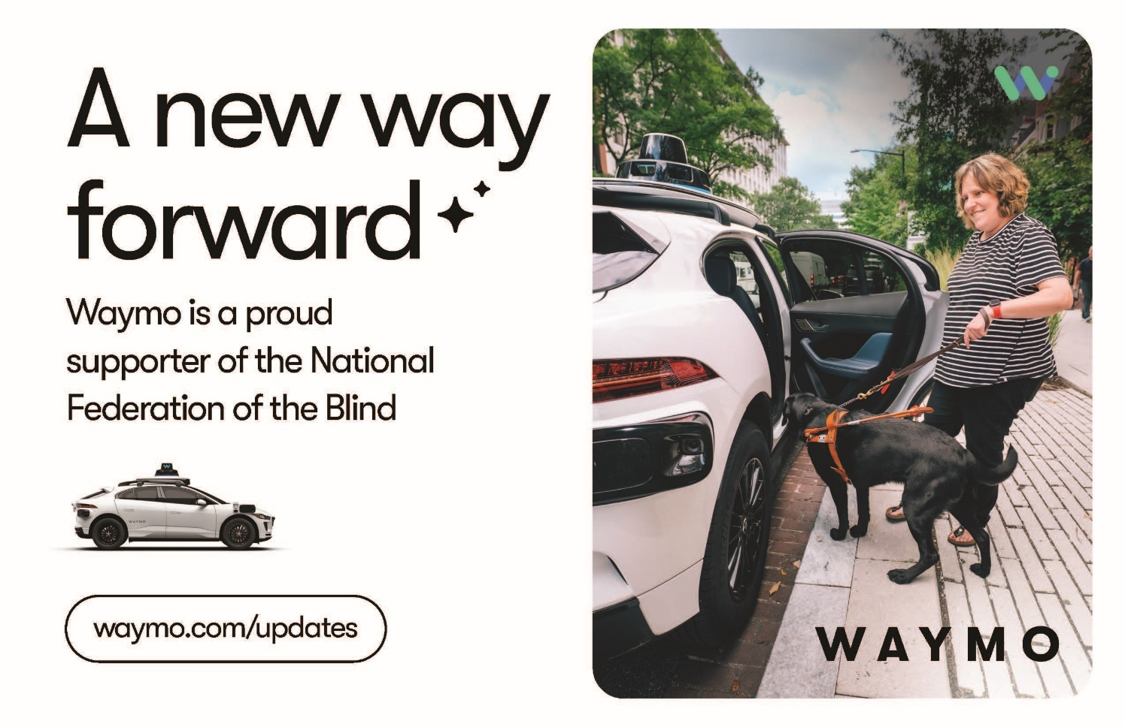

Half page for Waymo. Text says “A new way forward. Waymo is a proud supporter of the National Federation of the Blind.” A person with a guide dog approaches a white autonomous vehicle. A small car illustration with sensors with branding in bottom right corner. Waymo.com/updates
